**1.INTRODUCTION**

**Title of the project:**

“iAgro”

**Objective of the project:**

The name ‘iAgro’ indicates Intelligent Agriculture. ‘iAgro’ is a model farmer management website application. This site helps the farmers to sell their agricultural produce online and suggests best -in-practice farming processes. Hence, providing a wider market and helping them to not restrict themselves to the local market. It helps the wholesalers and retailers in buying produce from larger number of farmers. Thereby, enables the wholesalers and retailers in expanding their business. It features online shopping for fertilizers, pesticides, machinery & tools, etc. It helps the farmers to keep track of their agricultural production with features such as virtual calendar, weather forecasting, etc. and enables them to hire labourers, which in turn, will help the farm labourers to find small jobs by having a work profile in the website. As a whole, ‘iAgro’ provides a concept of virtual agricultural trade to its users.

**Modules of the project:**

* Customer account module
* Product module
* Category module
* Location module
* Production module
* Purchase request module
* Purchase order module
* Seller module
* Labourer module
* Work request module
* Article and blog module
* Dashboard Module

**Project Category:**

RDBMS (Relational Database Management System).

**Language(s) to be used:**

* Design and Interface: HTML ,CSS
* Programming language: PHP
* Scripting language: AJAX, Javascript
* Database: MySQL Server

**Hardware Requirements:**

* Operating System: Windows XP, 7 OR 8
* Processor: Intel Core Duo 2.0 GHz or more
* RAM: 1 GB or more
* Hard Disc: 80 GB or more
* Monitor: 15 inches CRT or LCD Monitor
* Keyboard: Normal or multimedia keyboard
* Mouse: Compatible Mouse

**Software Requirements:**

* XAMPP 1.8.2
* APACHE Server 5.4.19
* MySQL Server 5.4
* Adobe Dreamweaver CS 6.0
* Browser: Google Chrome, Mozilla Firefox

**Innovativeness and Usefulness:**

* Farmers can sell their produce online which can be purchased by wholesalers and retailers. Buyers can send purchase request to check the quality of the product.
* After negotiating the price for the produce, the farmer sends a purchase order. This module covers these entries and charge details also should be entered. The payments will be received from the wholesaler/retailer, once the produce is delivered to them.
* There are four types of users: farmers, wholesalers/retailers, labourers and administrator. The login ID and password is required to login to the system.
* The articles and blog sections help farmers to gain knowledge.
* Administrator can view and print all kinds of reports.
* It allows the farmers to keep track of their agricultural produce.
* It helps the farm labourers in finding jobs.

**Future scope of the project:**

* We can create Android or iOS application for this project.
* We can make use of sensor technology to measure the quality of the product.

**2.EXISTING SYSTEM AND PROPOSED SYSTEM**

**Existing System**

**Overview**

The current AgriBuzz website serves as an online platform for the agricultural community. It offers a range of features aimed at providing information and facilitating communication among farmers, agricultural experts, and enthusiasts.

**Features**

1. **Information Repository**:
   * Articles on best farming practices, crop management, and pest control.
   * Weather forecasts and updates relevant to agriculture.
   * Market prices for various crops and commodities.
2. **Community Interaction**:
   * Discussion forums where users can ask questions and share experiences.
   * User profiles with basic information about their farming activities.
3. **News and Updates**:
   * Latest news related to agriculture, including policy changes, new technologies, and success stories.
4. **Multimedia Content**:
   * Photos and videos related to farming techniques and success stories.

**Proposed System**

**Overview**

The proposed AgriBuzz website aims to enhance user engagement, improve mobile usability, incorporate advanced analytics, and introduce e-commerce capabilities to create a more comprehensive platform for the agricultural community.

**New Features**

1. **Enhanced User Interaction**:
   * Real-time chat functionality for instant communication between users.
   * Social media integration to share content directly from AgriBuzz to platforms like Facebook, Twitter, and Instagram.
2. **Improved Mobile Experience**:
   * Fully responsive design to ensure a seamless user experience on all devices.
   * Mobile app for both iOS and Android with offline content access and push notifications for updates.
3. **Data Analytics**:
   * Integrated analytics dashboard to track user engagement, popular content, and user demographics.
   * Personalized content recommendations based on user behavior and preferences.
4. **E-commerce Platform**:
   * Marketplace for users to buy and sell agricultural products, tools, and equipment.
   * Secure payment gateway and logistics support for smooth transactions and delivery.
5. **Advanced Community Features**:
   * User groups and communities based on interests, crop types, and geographic locations.
   * Expert Q&A sessions and webinars on relevant topics.
6. **Content Expansion**:
   * Expanded library of multimedia content including tutorials, webinars, and virtual farm tours.
   * User-generated content section for sharing local farming practices and innovations.
7. **Gamification**:
   * Reward system for active users contributing valuable content, participating in discussions, and helping other community members.
   * Badges and leaderboards to motivate user engagement.

**3.SOFTWARE REQUIREMENTS SPECIFICATION**

1. **Introduction:**

A **software requirements specification** (SRS) is a description of a [software system](https://en.wikipedia.org/wiki/Software_system) to be developed, laying out [functional](https://en.wikipedia.org/wiki/Functional_requirement) and [non-functional requirements](https://en.wikipedia.org/wiki/Non-functional_requirements), and may include a set of [use cases](https://en.wikipedia.org/wiki/Use_case) that describe interactions the users will have with the software.

A basic purpose of the SRS is to bridge this communication gap between client and the developer so they have a shared vision of the software being built. An SRS establishes the basis for agreement between the client and the supplier on what the software product will do. SRS provides a reference for validation of the final product. A high-quality SRS is a prerequisite to high-quality software and also reduces the development cost.

The introduction of the Software Requirements Specification (SRS) provides an overview of the entire SRS with purpose, scope, definitions, acronyms, abbreviations, references and overview of the SRS. The aim of this document is to gather and analyze and give an in-depth insight of the complete “Agri Buzz” by defining the problem statement in detail. The detailed requirements of “Agri Buzz” are provided in this document.

* 1. **Purpose:**

This Document includes software requirements for the “Agri Buzz” Project. The purpose of this document is to detail the user requirements for all the functionality in “Agri Buzz”. This document is meant to serve as a guide to the developers and users. The purpose of the requirement document is to specify and provide all the information required to design, develop and test the system. This document ensures that the person reading the document understands what she/he is looking for.

* 1. **Scope:**

The main objective of developing “Agri Buzz” application is to help farmers by providing all kinds agriculture related information in the website. “Agri Buzz” is farmer management website application which helps farmers to give best-practice farming processes. It helps farmers to improve their productivity and profitability. It enables farmers to sell their products online and farmers can purchase tools and seeds directly from seller. Farmers can view labours profile and they can hire labours.

* 1. **Definitions, Acronyms and Abbreviations:**
* **SRS:** Software Requirements System
* **OS:** Operating System
* **PHP:** PHP: Hypertext Preprocessor
* **GUI:** Graphical User Interface
* **PC:** Personal Computer
* **MB:** Mega Bytes
* **RAM:** Random Access Memory
* **MySQL:** MySQL database Server
  1. **References:**
* [www.w3schools.com](http://www.w3schools.com)
* [www.tutorialspoint.com](http://www.tutorialspoint.com)
* [www.stackoverflow.com](http://www.stackoverflow.com)
* www.highcharts.com
* Web Database Applications with PHP and MySQL By Hugh E. Williams, ‎David Lane
* An integrated approach to Software Engineering By Pankaj Jalote
  1. **Overview:**

This SRS will allow for a complete understanding of what is to be expected of the “Agri Buzz” web application to be constructed. The clear understanding of the “Agri Buzz” System and its functionality will allow for end users and will be used for the development of the future stages of the project. This system helps us to manage the records according to his requirements.

1. **Overall description:**

This section of the SRS describes all general factors of the product and its requirements.

* 1. **Product Perspective:**

In this project the farmers can sell their products online and the buyer can purchase the seeds and products through online. Buyer can send purchase request to check the quality of the product. The Payments will be received from the seller once the product delivered to the seller. The customers can buy products and equipments in this project. The article and blogs section helps farmers to improve their productivity and profitability. Administrator can view and print all kinds of reports.

* 1. **Product Features**:

This product has following features:

* The farmers can sell their productions online and the buyer can purchase various agricultural products online. Buyer can send purchase request to check the quality of the product.
* After collecting all the farm produce from the farmers, it should be sold to the wholesaler/retailer. This module covers these entries and the charge details also should be entered. The Payments will be received from the wholesaler/retailer once the product delivered to them.
* There are 4 types of users: Customer, Farmers, Workers, and Administrator. The login id and password must be required to login the system.
* The article and blog section helps farmers to improve their productivity and profitability.
* Administrator can view and print all kinds of reports.
  1. **User classes and characteristics:**

There are 4 kinds of users for the proposed system.

* **Administrators:**

Administrators are the ones who can add or administer the categories for the products, and administers the all website information’s. Administrator has full privilege of the website.

* **Sellers:**

Sellers are the farmers and they can sell their productions through online after the registration. After the registration the farmers can login to the system by entering login id and password.

* **Customer:**

Customers can buy products through online. The customer can send purchase request to check the quality of the products.

* **Worker:**

Workers can receive various work requests from multiple farmers and they can also reject or approve a request depending upon their interest.

* 1. **Design and implementation constraints:**
* The developed system should run under any platform (Unix, Linux, Mac, Windows etc.) that contains a web browser which supports PHP, JavaScript and AJAX.
* Internet connectivity is required to send mails.
* The user who is accessing the system should be authorized.
  1. **Assumptions and Dependencies:**
* The users should have basic knowledge of the computers. They must be trained well to handle the features provided by this system.
* Some of the details are required to be entered by the user and may not be generated automatically.
* Administrator is created in the system already.
* Roles and tasks are predefined.

1. **Specific requirements:**
   1. **External Interface Requirements:**
      1. **User Interfaces:**

Each part of the user interface intends to be as user friendly as possible. The fonts and buttons used will be intended to be very fast and easy to load on web pages. The pages will be kept light in space so that it won’t take a long time for the page to load.

* + 1. **Hardware Interfaces:**
* **Operating System:** Unix, Linux, Mac, Windows etc.
* **Processor:** Pentium or Higher.
* **RAM:** 312MB or Higher.
* 14”monitor
* Keyboard and mouse
  + 1. **Software Interfaces:**
* **Development tool:** PHP : Hypertext Preprocessor, JavaScript, Ajax
* **Scripting server:** Apache server
* **Data Base server:** MySQL
* **IDE:** Adobe Dreamweaver CS6.0
  + 1. **Communication Interfaces:**

Internet connection is required.

* 1. **Functional Requirements:**
     1. **Login module:**

In this module, the customer, seller, worker and the admin can login to the system by entering login id and password. The system opens main account page after the login.

* + 1. **Customer module:**

The customer can register to the website by entering profile details. The customer can purchase products which are uploaded by administrator. They can also send purchase request for purchasing farm produce which is uploaded by farmers. After quality test and price quotation, the customer can approve or reject the purchase request.

* + 1. **Seller module:**

The farmers are the sellers where they can sell their productions online. The system will display farm produces in the main page of the website.

* + 1. **Worker module:**

This module is for labours where they can register by entering their profile and experience details. The farmers can hire farm labourers in this module.

* + 1. **Dashboard module:**

Dashboard module is for administrator and employees. In the dashboard module, admin has complete settings of the website. Employees can manage all kinds of records.

* + 1. **Article module:**

In the article module, employees or admin can post news and blogs. This article module is helpful for farmers. The farmers can view the article by browsing article menu.

* + 1. **Category module:**

In this module, the administrator can create different types of categories. The system has three types of categories: i.e. Farm Produce, Agricultural Machinery & Tools, and Article types.

* + 1. **Location module:**

This is the master page where admin can add country, state, city.

* + 1. **Products module:**

This website sells two kinds of products. Admin or employees can sell products directly and it has another option where farmers can sell their productions online.

* + 1. **Billing Report:**

The system generates billing after purchasing the product. The system calculates total cost automatically. In the billing report, it displays customer contact details, billing details, and purchased product information.

* 1. **Document conventions:**

The format of this SRS is simple. Bold face and indentation is used on general topics and or specific points of interest. The remainder of the document will be written using the standard font. New Times Roman

* 1. **Intended users and Reading suggestions:**

This document is intended for software developers, document writers and for general discussions on the implementation decisions regarding the software.

* 1. **System features:**

The coding is done with following characteristics in mind:

* Ease of design to code translation
* Code efficiency
* Memory efficiency
* Response time
* Maintainability
* Security
* Simple ease to understand code
* Efficient and consistent logic

1. **Other non-functional Requirements:**
   1. **Performance Requirements:**

Performance requirements define acceptable response times for system functionality.

* The system is supposed to be having good memory space and RAM should be Above 256 MB preferably.
* The sound card and graphics card will have to be of good quality and capacity.
* The load time for user interface screens shall take no longer than three seconds.
* The log in information shall be verified within three seconds.
* Queries shall return results within three seconds.
  1. **Safety Requirements:**
* In case the customer forget their password, they can recover the password in the Forgot Password panel
* The password stores in the database in the format of encrypted password.
  1. **Security Requirements:**
* Only authenticated users can access this system.
  1. **Software quality attributes:**
* **Reliability:**

This system is designed to have very simple database just to cater the exact need of “Agri Buzz”. It is tested for all the constraints at development stage.

* **Availability:**

This system will only available till the system on which it is installed is running.

* **Security:**

This system is provided with authentication without which no user can pass. So only the legitimate users are allowed to use the application. If the legitimate users share the authentication information then the system is open to outsiders.

* **Maintainability:**

There is maintenance required for the website. The database is provided by the Administrator as well as the end-use.

* **Portability:**

The system works anywhere with the internet connection.

**4.SYSTEM ANALYSIS**

**4.1 Existing System**

The existing system for agricultural information dissemination is fragmented and lacks a centralized platform. Farmers and agricultural enthusiasts rely on multiple sources such as local cooperatives, government publications, agricultural extensions, and informal networks. Key characteristics of the existing system include:

* **Local Cooperatives:** Provide region-specific advice and resources, but with limited reach.
* **Government Publications:** Offer reliable information, but often not in real-time.
* **Agricultural Extensions:** Provide on-ground support but can be inconsistent.
* **Informal Networks:** Depend on word-of-mouth, leading to potential misinformation.

**4.2 Limitations of Existing System**

The current approach to agricultural information dissemination has several limitations:

* **Fragmentation:** Information is scattered across various sources, making it difficult to access comprehensive data.
* **Timeliness:** Many sources do not provide real-time updates, which is critical for agricultural decision-making.
* **Accessibility:** Some sources are not easily accessible to all farmers, especially in remote areas.
* **Reliability:** Informal networks can spread inaccurate information, affecting farming practices.
* **Customization:** Lack of personalized information based on specific crop, region, or climate conditions.

**4.3 Proposed System: AgriBuzz Website**

The AgriBuzz website aims to address the limitations of the existing system by providing a centralized, reliable, and accessible platform for agricultural information. Key features of the proposed system include:

* **Centralized Information Hub:** Aggregates data from various reliable sources, including government agencies, research institutions, and agricultural experts.
* **Real-Time Updates:** Provides up-to-date information on weather conditions, pest outbreaks, market prices, and best practices.
* **User Accessibility:** Designed to be easily accessible via mobile and desktop devices, with a user-friendly interface.
* **Customization:** Offers personalized recommendations based on user input such as crop type, location, and current farming practices.
* **Community Interaction:** Facilitates a community forum where farmers can share experiences, ask questions, and receive advice from experts and peers.

**4.4 Feasibility Study**

The feasibility study assesses the practicality and potential success of the AgriBuzz website through various lenses:

* **Technical Feasibility:**
  + **Platform Development:** Using modern web development frameworks and technologies.
  + **Data Integration:** APIs to aggregate data from various sources and ensure real-time updates.
  + **Scalability:** Cloud-based infrastructure to handle high traffic and data storage requirements.
* **Economic Feasibility:**
  + **Initial Investment:** Costs associated with development, hosting, and maintenance.
  + **Revenue Models:** Potential revenue through advertisements, premium subscriptions, and partnerships with agricultural businesses.
* **Operational Feasibility:**
  + **User Training:** Minimal training required due to intuitive design.
  + **Support Services:** Customer support and technical assistance for users.
* **Legal Feasibility:**
  + **Data Privacy:** Compliance with data protection regulations to ensure user data privacy.
  + **Content Licensing:** Proper licensing of aggregated data from various sources.

**4.5 Use Case Analysis**

Use case analysis helps identify and describe the primary interactions users will have with the AgriBuzz website.

**Use Case 1: Accessing Real-Time Weather Updates**

* **Actor:** Farmer
* **Description:** The farmer logs into AgriBuzz to check the latest weather updates for their region to plan daily farming activities.
* **Preconditions:** The farmer has an internet connection and an account on AgriBuzz.
* **Steps:**
  1. Farmer logs into the AgriBuzz website.
  2. Navigates to the weather updates section.
  3. Views real-time weather data and forecasts.
* **Postconditions:** Farmer uses the weather information to make informed decisions about irrigation, planting, and harvesting.

**Use Case 2: Personalized Crop Recommendations**

* **Actor:** Farmer
* **Description:** The farmer inputs their crop type and location to receive tailored farming advice.
* **Preconditions:** The farmer has an account and has entered their crop and location details.
* **Steps:**
  1. Farmer logs into the AgriBuzz website.
  2. Enters or updates crop and location information.
  3. Receives personalized recommendations on best practices, pest management, and fertilization.
* **Postconditions:** Farmer implements the recommendations to improve crop yield and quality.

**Use Case 3: Community Forum Participation**

* **Actor:** Farmer, Agricultural Expert
* **Description:** The farmer posts a question about a pest issue they are experiencing, and an agricultural expert provides a solution.
* **Preconditions:** Both the farmer and the expert are registered users of AgriBuzz.
* **Steps:**
  1. Farmer logs into the AgriBuzz website.
  2. Navigates to the community forum section.
  3. Posts a question detailing the pest issue.
  4. Agricultural expert responds with potential solutions and preventive measures.
* **Postconditions:** Farmer applies the expert's advice to manage the pest issue effectively.

**Use Case 4: Market Price Monitoring**

* **Actor:** Farmer
* **Description:** The farmer checks current market prices for their produce to decide on the best time to sell.
* **Preconditions:** The farmer has access to the internet and is a registered user of AgriBuzz.
* **Steps:**
  1. Farmer logs into the AgriBuzz website.
  2. Navigates to the market prices section.
  3. Views current market prices for their produce.
* **Postconditions:** Farmer uses the market price information to make informed selling decisions to maximize profits.

**5.SYSTEM DESIGN**

**Introduction:**

* **System Analysis:**

The system analysis approach emphasises a closed look on all parts of the system. The analyst must consider all the system elements, their inputs, outputs, control, feedback and the environment when the system is being constructed.

* **System Design:** The goal of system design phase is to produce a model or representation of the system, which can be used to build the system. Here the emphasis is on translating the requirements of the system into design specification.

1. **Applicable Documents:**

The document used in system design is Software Requirement Specification Document.

1. **Functional Decomposition:**

The system can be decomposed into functional components as follows.

The Components –

* Registration component for customers, farmers and workers.
* Login component for customers, farmers, workers and administrators.
* Produce selling component for farmers.
* Agro Product selling component for administrator.
* Produce purchase request component for customers.
* Agro Product purchase component for farmers.
* Produce purchase approval component for farmers.
* Produce purchase report component for customer and administrator.
* Category, variety and item typesetting components for administrator.

1. **Program Description:**

**3.1.** **Context Flow Diagram:**

Context flow diagram is a top level data flow diagram. It only contains one process node that generalises the function of the entire system in relationship to external entities. In context diagram the entire system is treated as a single process and all its inputs, outputs, sinks and sources are identified and shown.



**3.2. Data Flow Diagram:**

A data flow diagram is a graphical representation of the flow of data through an information system. A data flow diagram can also be used for the visualization of the data processing. It is common practice for a designer to draw a context level DFD. It shows the interaction between the system and the outside entities. This context level DFD, is then exploded to show more detail of the system being modelled.

A DFD represents flow of data through a system. Data flow diagrams are commonly used during problem analysis. It views a system as a function that performs the input into the desired output. A DFD shows movement of data through the different transformations or processes in the system.

Data Flow diagrams can be used to provide the end users with the physical idea of where the data they input ultimately has an effect upon the structure of whole system from order to dispatch to restock how any system is developed can be determined through data flow diagram. The appropriate register saved in database and maintained by appropriate authorities.

**Top Level DFD – Level 1:**



**DFD Level 2:**



**DFD Level 3:**



**DFD Level 4:**



**DFD Level 5:**



**DFD Level 6:**



**DFD Level 7:­­­**



**6.DATABASE DESIGN**

**Introduction:**

* **Database:** A Database is collection of related data, which can be of any size and complexity. By using the concept of Database, we can easily store and retrieve the data. The major purpose of a database is to provide the information, which utilizes it with the information’s that the system needs according to its own requirements.
* **Database Design:** Database design is done before building it to meet needs of end-users within a given information-system that the database is intended to support. The database design defines the needed data and data structures that such a database comprises

The database is physically implemented using MySQL.

The database for “iAgro” is organized into 19 tables:

* admin
* article
* category
* city
* country
* customer
* produce
* product
* product_purchase_bill
* product_purchase_record
* purchase_order
* purchase_order_bill
* purchase_request
* seller
* selling_product
* state
* variety
* worker
* worker_request

Each entity can be described as follows along with its attributes:

1. **Database tables:**

**Structure of Table “admin”:**

|  |  |  |  |
| --- | --- | --- | --- |
| **Field Name** | **Field Type** | **Size** | **Description** |
| admin_id | int | 10 | Admin ID |
| admin_name | varchar | 25 | Admin Name |
| login_id | varchar | 20 | Login ID |
| password | varchar | 50 | Password |
| status | varchar | 10 | Status |

**Structure of Table “article”:**

|  |  |  |  |
| --- | --- | --- | --- |
| **Field Name** | **Field Type** | **Size** | **Description** |
| article_id | Int | 10 | Article ID |
| article_type | varchar | 25 | Article type |
| publish_date | date |  | Publishing date of the article |
| title | varchar | 100 | Title of the article |
| article_description | text |  | Description of the article |
| article_img1 | varchar | 100 | Image of the article |
| article_img2 | varchar | 100 | Image of the article |
| article_img3 | varchar | 100 | Image of the article |
| article_img4 | varchar | 100 | Image of the article |
| article_img5 | varchar | 100 | Image of the article |
| status | varchar | 10 | Status |

**Structure of Table “category”:**

|  |  |  |  |
| --- | --- | --- | --- |
| **Field Name** | **Field Type** | **Size** | **Description** |
| category_id | int | 10 | Category ID |
| category | varchar | 25 | Category |
| category_type | varchar | 25 | Category type |
| description | text |  | Description |
| img | varchar | 100 | Image |
| satus | varchar | 10 | Status |

**Structure of Table “city”:**

|  |  |  |  |
| --- | --- | --- | --- |
| **Field Name** | **Field Type** | **Size** | **Description** |
| city_id | Int | 10 | City ID |
| country_id | Int | 10 | Country ID |
| state_id | Int | 10 | State ID |
| City | varchar | 25 | City |
| description | text |  | Description |
| status | varchar | 10 | Status |

**Structure of Table “country”:**

|  |  |  |  |
| --- | --- | --- | --- |
| **Field Name** | **Field Type** | **Size** | **Description** |
| country_id | int | 10 | Country ID |
| country | varchar | 25 | Country |
| description | text |  | Description |
| status | varchar | 10 | Status |

**Structure of Table “customer”:**

|  |  |  |  |
| --- | --- | --- | --- |
| **Field Name** | **Field Type** | **Size** | **Description** |
| customer_id | int | 10 | Customer ID |
| customer_name | int | 25 | Customer Name |
| address | int |  | Address |
| country_id | varchar | 10 | Country ID |
| state_id | varchar | 10 | State ID |
| city_id | varchar | 10 | City ID |
| pincode | varchar | 10 | Pincode |
| contact_no | varchar | 15 | Contact number |
| mobile_no | varchar | 15 | Mobile number |
| email_id | varchar | 50 | Email ID |
| password | varchar | 25 | Password |
| customer_type | varchar | 25 | Customer Type |
| status | varchar | 10 | Status |

**Structure of Table “produce”:**

|  |  |  |  |
| --- | --- | --- | --- |
| **Field Name** | **Field Type** | **Size** | **Description** |
| produce_id | int | 10 | Produce ID |
| category_id | Int | 10 | Category ID |
| produce | varchar | 25 | Produce |
| description | text |  | Description |
| img | varchar | 100 | Image |
| status | varchar | 10 | Status |

**Structure of Table “product”:**

|  |  |  |  |
| --- | --- | --- | --- |
| **Field Name** | **Field Type** | **Size** | **Description** |
| product_id | int | 10 | Product ID |
| seller_id | int | 10 | Seller ID |
| category_id | int | 10 | Category ID |
| produce_id | int | 10 | Produce ID |
| variety_id | int | 10 | Variety ID |
| Title | varchar | 100 | Title |
| img_1 | varchar | 100 | Image of the product |
| img_2 | varchar | 100 | Image of the product |
| img_3 | varchar | 100 | Image of the product |
| img_4 | varchar | 100 | Image of the product |
| img_5 | varchar | 100 | Image of the product |
| Quantity | float | 10,2 | Quantity |
| quantity_type | varchar | 25 | Quantity type |
| description | text |  | Description |
| uploaded_date | date |  | Uploaded date |
| status | varchar | 10 | Status |

**Structure of Table “product purchase bill”:**

|  |  |  |  |
| --- | --- | --- | --- |
| **Field Name** | **Field Type** | **Size** | **Description** |
| product_purchase_bill_id | int | 10 | Product purchase bill ID |
| country_id | int | 10 | Country ID |
| state_id | int | 10 | State ID |
| city_id | int | 10 | City ID |
| customer_name | varchar | 25 | Customer Name |
| customer_address | text |  | Customer Address |
| pincode | varchar | 10 | Pincode |
| customer_contact_number | varchar | 15 | Customer Contact Number |
| purchase_date | date |  | Purchase Record |
| Status | varchar | 10 | Status |
| payment_type | varchar | 25 | Payment Type |
| payment_description | text |  | Payment Description |
| seller_id | int | 10 | Seller ID |

**Structure of Table “product_purchase record”:**

|  |  |  |  |
| --- | --- | --- | --- |
| **Field Name** | **Field Type** | **Size** | **Description** |
| purchase_record_id | int | 10 | Purchase record ID |
| product_purchase_bill_id | int | 10 | Product purchase bill ID |
| selling_product_id | int | 10 | Selling Product ID |
| quantity | int | 10 | Quantity of the product |
| cost | float | 10,2 | Cost of the product |
| Status | varchar | 10 | status |

**Structure of Table “purchase_order”:**

|  |  |  |  |
| --- | --- | --- | --- |
| **Field Name** | **Field Type** | **Size** | **Description** |
| purchase_order_id | int | 10 | Purchase Order ID |
| product_id | int | 10 | Product ID |
| purchase_request_id | int | 10 | Purchase Request ID |
| customer_id | int | 10 | Customer ID |
| seller_id | int | 10 | Seller ID |
| purchase_order_date | date |  | Date of purchase order |
| purchase_order_time | time |  | Time of purchase order |
| purchase_amt | float | 10,2 | Amount of purchase order |
| quantity | float | 10,2 | Quantity of purchase order |
| status | varchar | 10 | Status of purchase order |

**Structure of Table “purchase_order_bill”:**

|  |  |  |  |
| --- | --- | --- | --- |
| **Field Name** | **Field Type** | **Size** | **Description** |
| purchase_order_bill_id | int | 10 | Purchase order bill ID |
| purchase_order_id | int | 10 | Purchase order ID |
| payment_type | varchar | 20 | Mode of payment |
| payment_description | text |  | Description of the payment |
| paid_date | date |  | Date of payment made |
| paid_amt | float | 10,2 | Amount paid |
| status | varchar | 10 | Status of purchase order bill |

**Structure of Table “purchase_request”:**

|  |  |  |  |
| --- | --- | --- | --- |
| **Field Name** | **Field Type** | **Size** | **Description** |
| purchase_request_id | int | 10 | Purchase Request ID |
| customer_id | int | 10 | Customer ID |
| product_id | int | 10 | Product ID |
| quantity | float | 10,2 | Quantity of purchase request |
| request_date | date |  | Date of purchase request |
| request_date_expire | date |  | Expiry date of purchase request |
| note | text |  | Note on Purchase Request |
| status | varchar | 20 | Status of purchase request |

**Structure of Table “seller”:**

|  |  |  |  |
| --- | --- | --- | --- |
| **Field Name** | **Field Type** | **Size** | **Description** |
| seller_id | int | 10 | Seller ID |
| seller_name | varchar | 25 | Name of the seller |
| seller_address | text |  | Address of the seller |
| state_id | int | 10 | State ID |
| country_id | int | 10 | Country ID |
| city_id | int | 10 | City ID |
| pincode | varchar | 10 | Pincode of the seller’s location |
| contact_number | varchar | 15 | Contact Number of the seller |
| mobile_no | varchar | 10 | Mobile Number of the seller |
| email_id | varchar | 50 | E-Mail of the seller |
| password | varchar | 25 | Password to login |
| bank_name | varchar | 50 | Name of the bank |
| bank_branch | varchar | 50 | Branch Name of the bank |
| bank_IFSC | varchar | 25 | IFSC Code of seller’s bank account |
| bank_acno | varchar | 25 | Seller’s bank account number |
| status | varchar | 10 | Status of the seller |

**Structure of Table “selling_product”:**

|  |  |  |  |
| --- | --- | --- | --- |
| **Field Name** | **Field Type** | **Size** | **Description** |
| selling_prod_id | int | 10 | Selling product ID |
| category_id | int | 10 | Category ID |
| product_name | varchar | 25 | Name of the product |
| product_ description | text |  | Description of the product |
| product_img1 | varchar | 100 | Image of the product |
| product_img2 | varchar | 100 | Image of the product |
| product_img3 | varchar | 100 | Image of the product |
| product_img4 | varchar | 100 | Image of the product |
| product_img5 | varchar | 100 | Image of the product |
| quantity_type | varchar | 50 | Quantity Type |
| cost | float | 10,2 | Cost of the product on sale |
| status | varchar | 10 | Status of the product on sale |

**Structure of Table “state”:**

|  |  |  |  |
| --- | --- | --- | --- |
| **Field Name** | **Field Type** | **Size** | **Description** |
| state_id | int | 10 | Primary key |
| country_id | int | 10 | Foreign key |
| state | varchar | 25 | Name of the state |
| description | text |  | Description of the state |
| status | varchar | 10 | Status of the state |

**Structure of Table “variety”:**

|  |  |  |  |
| --- | --- | --- | --- |
| **Field Name** | **Field Type** | **Size** | **Description** |
| variety_id | int | 10 | Variety ID |
| category_id | int | 10 | Category ID |
| produce_id | int | 10 | Produce ID |
| variety | varchar | 25 | Name of the produce variety |
| description | text |  | Description about the variety |
| img | varchar | 100 | Image of the produce variety |
| status | varchar | 10 | Status of the produce variety |

**Structure of Table “worker”:**

|  |  |  |  |
| --- | --- | --- | --- |
| **Field Name** | **Field Type** | **Size** | **Description** |
| worker_id | int | 10 | Worker ID |
| name | varchar | 50 | Name of the worker |
| address | text |  | Address of the worker |
| state_id | int | 10 | State ID |
| city_id | int | 10 | City ID |
| country_id | int | 10 | Country ID |
| pincode | varchar | 10 | Pincode of the worker’s location |
| work_profile | text |  | Services provided by the worker |
| biodata | varchar | 100 | Biodata of the worker |
| contactno | varchar | 15 | Contact Number |
| date_of_birth | date |  | Date of birth of the worker |
| login_id | varchar | 100 | Worker’s login ID |
| password | varchar | 100 | Worker’s password to login |
| expected_salary | float | 10,2 | Salary range the worker expects |
| status | varchar | 10 | Status of the worker |

**Structure of Table “worker_request”:**

|  |  |  |  |
| --- | --- | --- | --- |
| **Field Name** | **Field Type** | **Size** | **Description** |
| worker_request_id | int | 10 | Worker Request ID |
| worker_id | int | 10 | Worker ID |
| seller_id | int | 10 | Seller ID |
| from_date | date |  | Date of commencement of work |
| to_date | date |  | Date of completion of work |
| task | text |  | Task to be done by the worker |
| country_id | int | 10 | Country ID |
| state_id | int | 10 | State ID |
| city_id | int | 10 | City ID |
| salary | float | 10,2 | Salary provided |
| salary_type | varchar | 20 | Type of salary |
| seller_status | varchar | 20 | Status of the seller |
| worker_status | varchar | 20 | Status of the worker |
| seller_comment | text |  | Comment by the seller |
| worker_comment | text |  | Comment by the worker |

1. **Entity-Relationship Diagram:**

An entity-relationship (ER) diagram is a specialized graphic that illustrates the [relationships between entities in a database](http://databases.about.com/od/specificproducts/a/Database-Relationships-An-Introduction-To-Foreign-Keys-Joins-And-E-R-Diagrams.htm). ER diagrams often use symbols to represent three different types of information. Boxes are commonly used to represent entities. Diamonds are normally used to represent relationships and ovals are used to represent attributes.

**ER-Diagram:**









**Database schema Diagram:** 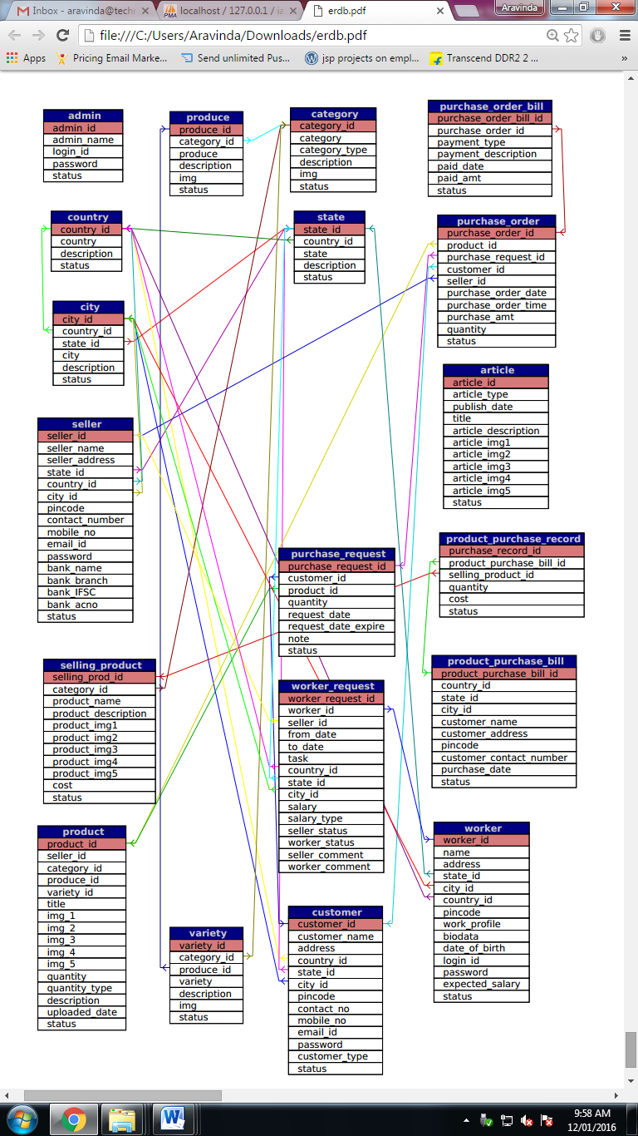

**7.IMPLEMENTATION**

**7.1 Development of the System**

**7.1.1 Planning and Requirements Gathering**

* Define project scope and objectives.
* Gather requirements from stakeholders (farmers, agricultural experts, consumers).
* Create a detailed requirements document.

**7.1.2 System Design**

* Design the system architecture (frontend, backend, database).
* Create wireframes and mockups for the user interface.
* Define data flow and user interaction diagrams.

**7.1.3 Technology Stack**

* Frontend: HTML, CSS, JavaScript (React, Angular, or Vue.js).
* Backend: Node.js, Express.js.
* Database: MongoDB or SQL database.
* Other Tools: Version control (Git), Deployment platform (Heroku, AWS).

**7.1.4 Development Phases**

1. **Frontend Development**
   * Create responsive UI components.
   * Implement user authentication and authorization.
   * Integrate APIs for dynamic data display.
2. **Backend Development**
   * Set up server and database connections.
   * Develop RESTful APIs for CRUD operations.
   * Implement business logic and data validation.
3. **Database Design**
   * Design database schema.
   * Implement relationships and indexes.
   * Optimize queries for performance.

**7.1.5 Testing**

* Unit Testing: Test individual components and modules.
* Integration Testing: Ensure that different modules work together.
* User Acceptance Testing: Gather feedback from a small group of users.

**7.1.6 Deployment**

* Set up a staging environment for final testing.
* Deploy the application to the production server.
* Monitor performance and address any issues.

**7.1.7 Maintenance and Updates**

* Regularly update the system with new features and security patches.
* Monitor user feedback and make necessary improvements.
* Ensure data backups and disaster recovery plans are in place.

**7.2 Coding Conventions**

**7.2.1 General Coding Standards**

* Follow industry-standard best practices.
* Use meaningful and descriptive variable and function names.
* Maintain consistent indentation (e.g., 2 spaces or 4 spaces).

**7.2.2 Frontend Conventions**

* Use modern ES6+ JavaScript features.
* Follow the specific conventions of the chosen frontend framework (e.g., React, Angular).
* Use CSS preprocessors (Sass, LESS) for better organization and maintainability.

**7.2.3 Backend Conventions**

* Use module-based structure to organize code.
* Handle errors and exceptions properly.
* Document API endpoints using tools like Swagger or Postman.

**7.2.4 Database Conventions**

* Use singular names for table/collection names.
* Ensure that all fields are named using snake_case or camelCase consistently.
* Implement proper indexing and normalization.

**7.2.5 Version Control**

* Use meaningful commit messages.
* Follow a branching strategy (e.g., Git Flow).
* Regularly merge and test branches to avoid conflicts.

**7.2.6 Code Review**

* Conduct regular code reviews to maintain code quality.
* Use tools like ESLint or Prettier to enforce coding standards.
* Encourage peer reviews and collaborative development.

**8.TESTING**

* **Introduction:**

Testing is the major quality control measure used during software development. It is a basic function to detect errors in the software. During the requirement analysis and design the output of the document that is usually textual and non-executable after the coding phase the computer programs are available that can be executed for testing purpose. This implies that testing not only has to uncover errors introduce during the previous phase. The goal of testing is to uncover requirement, design, coding errors in the program.

Testing determines whether the system appears to be working according to the specifications. It is the phase where we try to break the system and we test the system with real case scenarios at a point.

* **Levels of Testing:**
* **Unit Testing:**

The unit testing of the source code has to be done for every individual unit of module that was developing part of the system and some errors were found for every turn and rectified. This form of testing was use to check for the behavior signified the working of the system in different environment as an independent functional unit.

* **Integration Testing:**

From the individual parts to the cohesion of each part to make the system as a whole, there is need to test the working between the assembled modules of the system. The modules are integrated to make up the entire system. The testing process is concerned with finding errors that result from unanticipated interaction between the sub-system and system component. It is also concerned with validating the system meets its functional and non-functional requirement.

* **System Testing:**

The requirement specification document that is the entire system is to be tested to see whether it meets the requirement or not.

**Test Reports:**

* + **Test Unit: Admin Component**
  + **Adding admin:**

|  |  |  |  |  |
| --- | --- | --- | --- | --- |
| **Serial No.** | **Condition**  **To be Tested** | **Test Data** | **Expected Output** | **Remarks** |
| 1. | If any field in the form is empty. | Value of form fields. | Alert the user to enter all the fields and then proceed. | SUCCESSFUL |
| 2. | If admin name contains other than Character values. | adminname | Alert the user to enter only Characters and return to same page. | SUCCESSFUL |
| 3. | If login ID is invalid. | loginid | Alert the user to enter a valid login ID and return to the same page. | SUCCESSFUL |
| 4. | If password length is not between 8 to 16 characters. | password | Alert the user to enter a password of length between 8 to 16 characters. | SUCCESSFUL |
| 5. | If confirm password and password does not match. | cpassword, password | Alert the user to enter matching password and confirm password. | SUCCESSFUL |

* **Admin login:**

|  |  |  |  |  |
| --- | --- | --- | --- | --- |
| **Serial No.** | **Condition**  **To be Tested** | **Test Data** | **Expected Output** | **Remarks** |
| 1. | If any field in the form is empty. | Value of form fields. | Alert the user to enter all the fields and then proceed. | SUCCESSFUL |
| 2. | If the E-mail ID and Password does not match. | emailid, password | Alert user that E-mail ID and password are not matching and stay in the same page. | SUCCESSFUL |

* **Admin Change Password:**

|  |  |  |  |  |
| --- | --- | --- | --- | --- |
| **Serial No.** | **Condition**  **To be Tested** | **Test Data** | **Expected Output** | **Remarks** |
| 1. | If field in the form is empty. | Value of form fields. | Alert the user to enter the fields and then proceed. | SUCCESSFUL |
| 2. | If the E-mail ID is invalid. | loginid | Alert user to enter a valid E-mail ID and stay in the same page. | SUCCESSFUL |
| 3. | If the old password is not between the given range of 8 to 16 characters. | oldpassword | Alert the user to enter a password of length between 8 to 16 characters. | SUCCESSFUL |
| 4. | If the new password is not between the given range of 8 to 16 characters. | newpassword | Alert the user to enter a password of length between 8 to 16 characters. | SUCCESSFUL |
| 5. | If the confirm password and password does not match. | cpassword, password | Alert user that confirm password and password are not matching and stay in the same page. | SUCCESSFUL |

* + **Test Unit: Customer component**
* **Customer registration:**

|  |  |  |  |  |
| --- | --- | --- | --- | --- |
| **Serial No.** | **Condition**  **To be Tested** | **Test Data** | **Expected Output** | **Remarks** |
| 1. | If any field in the form is empty. | Value of form fields. | Alert the user to enter all the fields and then proceed. | SUCCESSFUL |
| 2. | If customer name contains other than Character values. | customername | Alert the user to enter only characters and return to the same page. | SUCCESSFUL |
| 3. | If country is not selected. | country | Alert the user to select a country. | SUCCESSFUL |
| 4. | If state is not selected. | state | Alert the user to select a state. | SUCCESSFUL |
| 5. | If PIN Code contains other than numeric values. | pincode | Alert the user to enter only numeric values. | SUCCESSFUL |
| 6. | If contact number contains other than numeric values. | cntctnum | Alert the user to enter only numeric values. | SUCCESSFUL |
| 7. | If mobile number contains other than numeric values. | mblnum | Alert the user to enter only numeric values. | SUCCESSFUL |
| 8. | If E-mail ID is invalid. | emailid | Alert the user to enter a valid E-mail ID and return to the same page. | SUCCESSFUL |
| 9. | If password length is not between 8 to 16 characters. | Password | Alert the user to enter a password of length between 8 to 16 characters. | SUCCESSFUL |
| 10. | If confirm password and password does not match. | cpassword, password | Alert the user to enter matching password and confirm password. | SUCCESSFUL |
| 11. | If the customer type is not selected. | customertype | Alert the user to select a customer type and return to the same page. | SUCCESSFUL |

* **Customer Update:**

|  |  |  |  |  |
| --- | --- | --- | --- | --- |
| **Serial No.** | **Condition**  **To be Tested** | **Test Data** | **Expected Output** | **Remarks** |
| 1. | If any field in the form is empty. | Value of form fields. | Alert the user to enter all the fields and then proceed. | SUCCESSFUL |
| 2. | If customer name contains other than Character values. | customername | Alert the user to enter only characters and return to the same page. | SUCCESSFUL |
| 3. | If country is not selected. | country | Alert the user to select a country. | SUCCESSFUL |
| 4. | If state is not selected. | state | Alert the user to select a state. | SUCCESSFUL |
| 5. | If city is not selected. | city | Alert the user to select a city. | SUCCESSFUL |
| 6. | If PIN Code contains other than numeric values. | pincode | Alert the user to enter only numeric values. | SUCCESSFUL |
| 7. | If contact number contains other than numeric values. | cntctnum | Alert the user to enter only numeric values. | SUCCESSFUL |
| 8. | If mobile number contains other than numeric values. | mblnum | Alert the user to enter only numeric values. | SUCCESSFUL |
| 9. | If E-mail ID is invalid. | emailid | Alert the user to enter a valid E-mail ID and return to the same page. | SUCCESSFUL |
| 10. | If password length is not between 8 to 16 characters. | Password | Alert the user to enter a password of length between 8 to 16 characters. | SUCCESSFUL |
| 11. | If confirm password and password does not match. | cpassword, password | Alert the user to enter matching password and confirm password. | SUCCESSFUL |
| 12. | If the customer type is not selected. | customertype | Alert the user to select a customer type and return to the same page. | SUCCESSFUL |

* **Customer login:**

|  |  |  |  |  |
| --- | --- | --- | --- | --- |
| **Serial No.** | **Condition**  **To be Tested** | **Test Data** | **Expected Output** | **Remarks** |
| 1. | If any field in the form is empty. | Value of form fields. | Alert the user to enter all the fields and then proceed. | SUCCESSFUL |
| 2. | If the E-mail ID and Password does not match. | emailid, password | Alert user that E-mail ID and password are not matching and stay in the same page. | SUCCESSFUL |

* **Customer Change Password:**

|  |  |  |  |  |
| --- | --- | --- | --- | --- |
| **Serial No.** | **Condition**  **To be Tested** | **Test Data** | **Expected Output** | **Remarks** |
| 1. | If field in the form is empty. | Value of form fields. | Alert the user to enter the fields and then proceed. | SUCCESSFUL |
| 2. | If the E-mail ID is invalid. | loginid | Alert user to enter a valid E-mail ID and stay in the same page. | SUCCESSFUL |
| 3. | If the old password is not between the given range of 8 to 16 characters. | oldpassword | Alert the user to enter a password of length between 8 to 16 characters. | SUCCESSFUL |
| 4. | If the new password is not between the given range of 8 to 16 characters. | newpassword | Alert the user to enter a password of length between 8 to 16 characters. | SUCCESSFUL |
| 5. | If the confirm password and password does not match. | cpassword, password | Alert user that confirm password and password are not matching and stay in the same page. | SUCCESSFUL |

* **Customer forgot password:**

|  |  |  |  |  |
| --- | --- | --- | --- | --- |
| **Serial No.** | **Condition**  **To be Tested** | **Test Data** | **Expected Output** | **Remarks** |
| 1. | If field in the form is empty. | Value of form fields. | Alert the user to enter the fields and then proceed. | SUCCESSFUL |
| 2. | If the E-mail ID is invalid. | emailid | Alert user to enter a valid E-mail ID and stay in the same page. | SUCCESSFUL |

* + **Test Unit: Worker component:**
  + **Worker Registration:**

|  |  |  |  |  |
| --- | --- | --- | --- | --- |
| **Serial No.** | **Condition**  **To be Tested** | **Test Data** | **Expected Output** | **Remarks** |
| 1. | If any field in the form is empty. | Value of form fields. | Alert the user to enter all the fields and then proceed. | SUCCESSFUL |
| 2. | If worker name contains other than Character values. | name | Alert the user to enter only characters and return to the same page. | SUCCESSFUL |
| 3. | If country is not selected. | country | Alert the user to select a country. | SUCCESSFUL |
| 4. | If state is not selected. | state | Alert the user to select a state. | SUCCESSFUL |
| 5. | If PIN Code contains other than numeric values. | pincode | Alert the user to enter only numeric values. | SUCCESSFUL |
| 6. | If E-mail ID is invalid. | loginid | Alert the user to enter a valid E-mail ID and return to the same page. | SUCCESSFUL |
| 7. | If password length is not between 8 to 16 characters. | Password | Alert the user to enter a password of length between 8 to 16 characters. | SUCCESSFUL |
| 8. | If confirm password and password does not matc h. | cpassword, password | Alert the user to enter matching password and confirm password. | SUCCESSFUL |
| 9. | If the expected salary contains other than numeric values. | expectedsalary | Alert the user to select a expected salary and return to the same page. | SUCCESSFUL |

* **Worker Login:**

|  |  |  |  |  |
| --- | --- | --- | --- | --- |
| **Serial No.** | **Condition**  **To be Tested** | **Test Data** | **Expected Output** | **Remarks** |
| 1. | If any field in the form is empty. | Value of form fields. | Alert the user to enter all the fields and then proceed. | SUCCESSFUL |
| 2. | If the E-mail ID and Password does not match. | emailid, password | Alert user that E-mail ID and password are not matching and stay in the same page. | SUCCESSFUL |

* **Worker Change Password:**

|  |  |  |  |  |
| --- | --- | --- | --- | --- |
| **Serial No.** | **Condition**  **To be Tested** | **Test Data** | **Expected Output** | **Remarks** |
| 1. | If field in the form is empty. | Value of form fields. | Alert the user to enter the fields and then proceed. | SUCCESSFUL |
| 2. | If the E-mail ID is invalid. | loginid | Alert user to enter a valid E-mail ID and stay in the same page. | SUCCESSFUL |
| 3. | If the old password is not between the given range of 8 to 16 characters. | oldpassword | Alert the user to enter a password of length between 8 to 16 characters. | SUCCESSFUL |
| 4. | If the new password is not between the given range of 8 to 16 characters. | newpassword | Alert the user to enter a password of length between 8 to 16 characters. | SUCCESSFUL |
| 5. | If the confirm password and password does not match. | cpassword, password | Alert user that confirm password and password are not matching and stay in the same page. | SUCCESSFUL |

* **Worker forgot password:**

|  |  |  |  |  |
| --- | --- | --- | --- | --- |
| **Serial No.** | **Condition**  **To be Tested** | **Test Data** | **Expected Output** | **Remarks** |
| 1. | If field in the form is empty. | Value of form fields. | Alert the user to enter the fields and then proceed. | SUCCESSFUL |
| 2. | If the E-mail ID is invalid. | emailid | Alert user to enter a valid E-mail ID and stay in the same page. | SUCCESSFUL |

* **Worker Request:**

|  |  |  |  |  |
| --- | --- | --- | --- | --- |
| **Serial No.** | **Condition**  **To be Tested** | **Test Data** | **Expected Output** | **Remarks** |
| 1. | If field in the form is empty. | Value of form fields. | Alert the user to enter the fields and then proceed. | SUCCESSFUL |
| 2. | If the start date is not selected. | fromdate | Alert user to enter the start date and stay in the same page. | SUCCESSFUL |
| 3. | If the termination date is not selected. | tilldate | Alert user to enter the termination date and stay in the same page. | SUCCESSFUL |
| 4. | If country is not selected. | country | Alert the user to select a country. | SUCCESSFUL |
| 5. | If state is not selected. | state | Alert the user to select a state. | SUCCESSFUL |
| 6. | If city is not selected. | city | Alert the user to select a city. | SUCCESSFUL |
| 7. | If salary contains other than numeric characters. | salary | Alert the user to enter only numerical values. | SUCCESSFUL |
| 8. | If incentive type is not selected. | salarytype | Alert the user to select the incentive type. | SUCCESSFUL |

* + **Test Unit : Seller Component**
* **Seller Registration:**

|  |  |  |  |  |
| --- | --- | --- | --- | --- |
| **Serial No.** | **Condition**  **To be Tested** | **Test Data** | **Expected Output** | **Remarks** |
| 1. | If any field in the form is empty. | Value of form fields. | Alert the user to enter all the fields and then proceed. | SUCCESSFUL |
| 2. | If seller name contains other than Character values. | Sellername | Alert the user to enter only characters and return to the same page. | SUCCESSFUL |
| 3. | If country is not selected. | Country | Alert the user to select a country. | SUCCESSFUL |
| 4. | If state is not selected. | State | Alert the user to select a state. | SUCCESSFUL |
| 5. | If city is not selected. | city | Alert the user to select a city. | SUCCESSFUL |
| 6. | If PIN Code contains other than numeric values. | pincode | Alert the user to enter only numeric values. | SUCCESSFUL |
| 7. | If contact number contains other than numeric values. | contactnumber | Alert the user to enter only numeric values. | SUCCESSFUL |
| 8. | If mobile number contains other than numeric values. | mbnumber | Alert the user to enter only numeric values. | SUCCESSFUL |
| 9. | If E-mail ID is invalid. | emailid | Alert the user to enter a valid E-mail ID and return to the same page. | SUCCESSFUL |
| 10. | If bank name contains values other than characters. | bankname | Alert the user to enter only characters for Bank name. | SUCCESSFUL |
| 11. | If bank branch name contains values other than characters. | branch | Alert the user to enter only characters for bank branch name. | SUCCESSFUL |
| 12. | If bank account number contains values other than numbers. | bankacnumber | Alert the user to enter only numeric values for bank account number. | SUCCESSFUL |

* **Seller update:**

|  |  |  |  |  |
| --- | --- | --- | --- | --- |
| **Serial No.** | **Condition**  **To be Tested** | **Test Data** | **Expected Output** | **Remarks** |
| 1. | If any field in the form is empty. | Value of form fields. | Alert the user to enter all the fields and then proceed. | SUCCESSFUL |
| 2. | If seller name contains other than Character values. | Sellername | Alert the user to enter only characters and return to the same page. | SUCCESSFUL |
| 3. | If country is not selected. | Country | Alert the user to select a country. | SUCCESSFUL |
| 4. | If state is not selected. | State | Alert the user to select a state. | SUCCESSFUL |
| 5. | If city is not selected. | city | Alert the user to select a city. | SUCCESSFUL |
| 6. | If PIN Code contains other than numeric values. | pincode | Alert the user to enter only numeric values. | SUCCESSFUL |
| 7. | If contact number contains other than numeric values. | contactnumber | Alert the user to enter only numeric values. | SUCCESSFUL |
| 8. | If mobile number contains other than numeric values. | mbnumber | Alert the user to enter only numeric values. | SUCCESSFUL |
| 9. | If E-mail ID is invalid. | emailid | Alert the user to enter a valid E-mail ID and return to the same page. | SUCCESSFUL |
| 10. | If bank name contains values other than characters. | bankname | Alert the user to enter only characters for Bank name. | SUCCESSFUL |
| 11. | If bank branch name contains values other than characters. | branch | Alert the user to enter only characters for bank branch name. | SUCCESSFUL |
| 12. | If bank account number contains values other than numbers. | bankacnumber | Alert the user to enter only numeric values for bank account number. | SUCCESSFUL |

* **Seller Login:**

|  |  |  |  |  |
| --- | --- | --- | --- | --- |
| **Serial No.** | **Condition**  **To be Tested** | **Test Data** | **Expected Output** | **Remarks** |
| 1. | If any field in the form is empty. | Value of form fields. | Alert the user to enter all the fields and then proceed. | SUCCESSFUL |
| 2. | If the E-mail ID and Password does not match. | emailid, password | Alert user that E-mail ID and password are not matching and stay in the same page. | SUCCESSFUL |

* **Seller Change Password:**

|  |  |  |  |  |
| --- | --- | --- | --- | --- |
| **Serial No.** | **Condition**  **To be Tested** | **Test Data** | **Expected Output** | **Remarks** |
| 1. | If field in the form is empty. | Value of form fields. | Alert the user to enter the fields and then proceed. | SUCCESSFUL |
| 2. | If the E-mail ID is invalid. | loginid | Alert user to enter a valid E-mail ID and stay in the same page. | SUCCESSFUL |
| 3. | If the old password is not between the given range of 8 to 16 characters. | oldpassword | Alert the user to enter a password of length between 8 to 16 characters. | SUCCESSFUL |
| 4. | If the new password is not between the given range of 8 to 16 characters. | newpassword | Alert the user to enter a password of length between 8 to 16 characters. | SUCCESSFUL |
| 5. | If the confirm password and password does not match. | cpassword, password | Alert user that confirm password and password are not matching and stay in the same page. | SUCCESSFUL |

* + **Test Unit : Variety Component**

|  |  |  |  |  |
| --- | --- | --- | --- | --- |
| **Serial No.** | **Condition**  **To be Tested** | **Test Data** | **Expected Output** | **Remarks** |
| 1. | If field in the form is empty. | Value of form fields. | Alert the user to enter the fields and then proceed. | SUCCESSFUL |
| 2. | If category is not selected. | category | Alert the user to select a category. | SUCCESSFUL |
| 3. | If produce is not selected. | produce | Alert the user to select a produce. | SUCCESSFUL |
| 4. | If variety contains values other than characters. | variety | Alert the user to enter only characters for variety. | SUCCESSFUL |
| 5. | If image is not selected. | img | Alert the user to select an image. | SUCCESSFULS |

* **Testing Unit: Selling Product Component**

|  |  |  |  |  |
| --- | --- | --- | --- | --- |
| **Serial No.** | **Condition**  **To be Tested** | **Test Data** | **Expected Output** | **Remarks** |
| 1. | If any field in the form is empty. | Value of form fields. | Alert the user to enter all the fields and then proceed. | SUCCESSFUL |
| 2. | If category is not selected. | category | Alert the user to select a category. | SUCCESSFUL |
| 3. | If product name contains values other than characters. | productname | Alert the user to enter only characters for product name. | SUCCESSFUL |
| 4. | If image is not selected. | img1 | Alert the user to select an image. | SUCCESSFUL |
| 5. | If cost contains values other than numeric values. | cost | Alert the user to enter only numeric values for cost. | SUCCESSFUL |

* **Test Unit: Purchase Request component**

|  |  |  |  |  |
| --- | --- | --- | --- | --- |
| **Serial No.** | **Condition**  **To be Tested** | **Test Data** | **Expected Output** | **Remarks** |
| 1. | If any field in the form is empty. | Value of form fields. | Alert the user to enter all the fields and then proceed. | SUCCESSFUL |
| 2. | If product contains values other than characters. | product | Alert the user to enter only characters for product. | SUCCESSFUL |
| 3. | If quantity contains values other than numeric values. | quantity | Alert the user to enter only numeric values for quantity. | SUCCESSFUL |
| 4. | If the date of request is not selected. | requestdate | Alert the user to select the date of request. | SUCCESSFUL |
| 5. | If the date of expiry is not selected. | expirydate | Alert the user to select the date of expiry. | SUCCESSFUL |

* **Testing Unit: Product Purchase Bill Component**

|  |  |  |  |  |
| --- | --- | --- | --- | --- |
| **Serial No.** | **Condition**  **To be Tested** | **Test Data** | **Expected Output** | **Remarks** |
| 1. | If any field in the form is empty. | Value of form fields. | Alert the user to enter all the fields and then proceed. | SUCCESSFUL |
| 2. | If customer name contains other than Character values. | customername | Alert the user to enter only characters and return to the same page. | SUCCESSFUL |
| 3. | If country is not selected. | country | Alert the user to select a country. | SUCCESSFUL |
| 4. | If state is not selected. | state | Alert the user to select a state. | SUCCESSFUL |
| 5. | If city is not selected. | city | Alert the user to select a city. | SUCCESSFUL |
| 6. | If PIN Code contains other than numeric values. | pincode | Alert the user to enter only numeric values. | SUCCESSFUL |
| 7. | If contact number contains other than numeric values. | contact number | Alert the user to enter only numeric values. | SUCCESSFUL |

* + **Test Unit: Product component**

|  |  |  |  |  |
| --- | --- | --- | --- | --- |
| **Serial No.** | **Condition**  **To be Tested** | **Test Data** | **Expected Output** | **Remarks** |
| 1. | If any field in the form is empty. | Value of form fields. | Alert the user to enter all the fields and then proceed. | SUCCESSFUL |
| 2. | If category is not selected. | category | Alert the user to select a category. | SUCCESSFUL |
| 3. | If produce is not selected. | produce | Alert the user to select a produce. | SUCCESSFUL |
| 4. | If variety is not selected. | variety | Alert the user to select a variety. | SUCCESSFUL |
| 5. | If image is not selected. | img1 | Alert the user to select an image. | SUCCESSFUL |
| 6. | If quantity contains values other than numeric values. | quantity | Alert the user to enter only numeric values for quantity. | SUCCESSFUL |
| 7. | If quantity type is not selected. | quantitytype | Alert the user to select a quantity type. | SUCCESSFUL |

* + **Test Unit: Produce component**

|  |  |  |  |  |
| --- | --- | --- | --- | --- |
| **Serial No.** | **Condition**  **To be Tested** | **Test Data** | **Expected Output** | **Remarks** |
| 1. | If any field in the form is empty. | Value of form fields. | Alert the user to enter all the fields and then proceed. | SUCCESSFUL |
| 2. | If category is not selected. | category | Alert the user to select a category. | SUCCESSFUL |
| 3. | If produce is not selected. | produce | Alert the user to select a produce. | SUCCESSFUL |
| 4. | If image is not selected. | img | Alert the user to select an image. | SUCCESSFUL |

* + **Test Unit: Country component**

|  |  |  |  |  |
| --- | --- | --- | --- | --- |
| **Serial No.** | **Condition**  **To be Tested** | **Test Data** | **Expected Output** | **Remarks** |
| 1. | If any field in the form is empty. | Value of form fields. | Alert the user to enter all the fields and then proceed. | SUCCESSFUL |
| 2. | If country contains values other than characters. | country | Alert the user to enter only characters for country name. | SUCCESSFUL |

* + **Test Unit: State component**

|  |  |  |  |  |
| --- | --- | --- | --- | --- |
| **Serial No.** | **Condition**  **To be Tested** | **Test Data** | **Expected Output** | **Remarks** |
| 1. | If any field in the form is empty. | Value of form fields. | Alert the user to enter all the fields and then proceed. | SUCCESSFUL |
| 2. | If state contains values other than characters. | state | Alert the user to enter only characters for state name. | SUCCESSFUL |

* + **Test Unit: City component**

|  |  |  |  |  |
| --- | --- | --- | --- | --- |
| **Serial No.** | **Condition**  **To be Tested** | **Test Data** | **Expected Output** | **Remarks** |
| 1. | If any field in the form is empty. | Value of form fields. | Alert the user to enter all the fields and then proceed. | SUCCESSFUL |
| 2. | If country is not selected. | country | Alert the user to select a country. | SUCCESSFUL |
| 3. | If state is not selected. | state | Alert the user to select a state. | SUCCESSFUL |
| 4. | If city contains values other than characters. | city | Alert the user to enter only characters for city name. | SUCCESSFUL |

* + **Test Unit: Category component**

|  |  |  |  |  |
| --- | --- | --- | --- | --- |
| **Serial No.** | **Condition**  **To be Tested** | **Test Data** | **Expected Output** | **Remarks** |
| 1. | If any field in the form is empty. | Value of form fields. | Alert the user to enter all the fields and then proceed. | SUCCESSFUL |
| 2. | If category contains values other than characters. | category | Alert the user to enter only characters for category name. | SUCCESSFUL |
| 3. | If image is not selected. | img | Alert the user to select an image. | SUCCESSFUL |

* + **Test Unit: Article component**

|  |  |  |  |  |
| --- | --- | --- | --- | --- |
| **Serial No.** | **Condition**  **To be Tested** | **Test Data** | **Expected Output** | **Remarks** |
| 1. | If any field in the form is empty. | Value of form fields. | Alert the user to enter all the fields and then proceed. | SUCCESSFUL |
| 2. | If article type is not selected. | articletype | Alert the user to select an article type. | SUCCESSFUL |
| 3. | If the date of publishing is not selected | publishdate | Alert the user to select the date of publishing the article. | SUCCESSFUL |
| 4. | If image is not selected. | img1 | Alert the user to select an image. | SUCCESSFUL |

* + **Test Unit: Selling Product component**

|  |  |  |  |  |
| --- | --- | --- | --- | --- |
| **Serial No.** | **Condition**  **To be Tested** | **Test Data** | **Expected Output** | **Remarks** |
| 1. | If any field in the form is empty. | Value of form fields. | Alert the user to enter all the fields and then proceed. | SUCCESSFUL |
| 2. | If seller name is not selected. | sellername | Alert the user to select the name of the seller. | SUCCESSFUL |
| 3. | If category is not selected | category | Alert the user to select the category. | SUCCESSFUL |
| 4. | If produce is not selected. | produce | Alert the user to select the produce. | SUCCESSFUL |
| 5. | If variety is not selected. | variety | Alert the user to select the variety. | SUCCESSFUL |
| 6. | If image is not selected. | img1 | Alert the user to select an image. | SUCCESSFUL |
| 7. | If quantity contains values other than numeric values. | quantity | Alert the user to enter only numeric values for quantity. | SUCCESSFUL |
| 8. | If the quantity type is not selected. | quantitytype | Alert the user to select a quantity type. | SUCCESSFUL |

**9.FUTURE ENHANCEMENT AND CONCLUSION**

### Future Enhancements

1. **Enhanced User Interface (UI) and User Experience (UX) Design:**
   * Implement a more intuitive and visually appealing UI.
   * Optimize mobile responsiveness to ensure a seamless experience across all devices.
   * Personalize the user experience by offering custom dashboards based on user preferences and activities.
2. **Advanced Analytics and Insights:**
   * Integrate AI and machine learning to provide predictive analytics for crop yields, market prices, and weather patterns.
   * Offer detailed insights and reports tailored to different stakeholders like farmers, distributors, and investors.
3. **Community Features:**
   * Develop a robust forum or community section where users can ask questions, share experiences, and collaborate on projects.
   * Introduce a mentorship program where experienced farmers can guide newcomers.
4. **E-commerce Integration:**
   * Launch a marketplace where users can buy and sell agricultural products, tools, and services.
   * Provide secure payment gateways and logistics support to ensure smooth transactions.
5. **Educational Resources and Training:**
   * Expand the library of educational materials including video tutorials, webinars, and articles.
   * Offer certification courses on various agricultural topics to help users enhance their skills and knowledge.
6. **Real-time Weather Updates and Alerts:**
   * Integrate real-time weather forecasting and alert systems to help farmers make informed decisions.
   * Provide detailed climate and soil condition reports tailored to specific regions.
7. **Sustainability and Eco-friendly Practices:**
   * Promote sustainable farming practices by providing resources and incentives.
   * Introduce features that help users track and reduce their carbon footprint and environmental impact.
8. **Partnerships and Collaborations:**
   * Establish partnerships with agricultural universities, research institutions, and industry experts to keep the content and resources up-to-date.
   * Collaborate with government agencies and NGOs to provide subsidies, grants, and other financial aids to farmers.
9. **Multi-language Support:**
   * Implement multi-language support to cater to a diverse user base from different regions and linguistic backgrounds.
10. **Enhanced Data Security and Privacy:**
    * Strengthen data security measures to protect user information.
    * Ensure compliance with global data protection regulations.

**CONCLUSION**

The project “AgriBuzz” is a man-made project and, therefore, there may be mistakes and limitations. The ideas put up may be different. The terms and names may be different. However, our sincere effort was to give the best. The advanced techniques like sensor technology can be used in the future for measuring the quality of the product.

AgriBuzz has the potential to revolutionize the agricultural industry by leveraging technology to connect farmers, distributors, and other stakeholders. By continuously evolving and implementing the suggested future enhancements, AgriBuzz can provide even greater value to its users. The website can become a comprehensive platform offering everything from market insights and educational resources to community support and e-commerce opportunities. As the agricultural landscape continues to change, AgriBuzz will be well-positioned to lead the way in promoting sustainable and profitable farming practices worldwide.

**10.BIBLIOGRAPHY**

* [www.wikipedia.com](http://www.wikipedia.com)
* [www.w3school.com](http://www.w3school.com)
* [www.stackoverflow.com](http://www.stackoverflow.com)
* [www.highcharts.com](http://www.highcharts.com)
* [www.agriwelfare.gov.in](http://www.agriwelfare.gov.in)
* [www.india.gov.in/topics/agriculture](http://www.india.gov.in/topics/agriculture)
* [www.raitamitra.karnataka.gov.in](http://www.raitamitra.karnataka.gov.in)
* www.icar.org.in (INDIAN COUNSIL OF AGRICULTURE AND RESEARCH)

**11.APPENDICES**

**1. Appendix I Screenshots**

**Home Page**

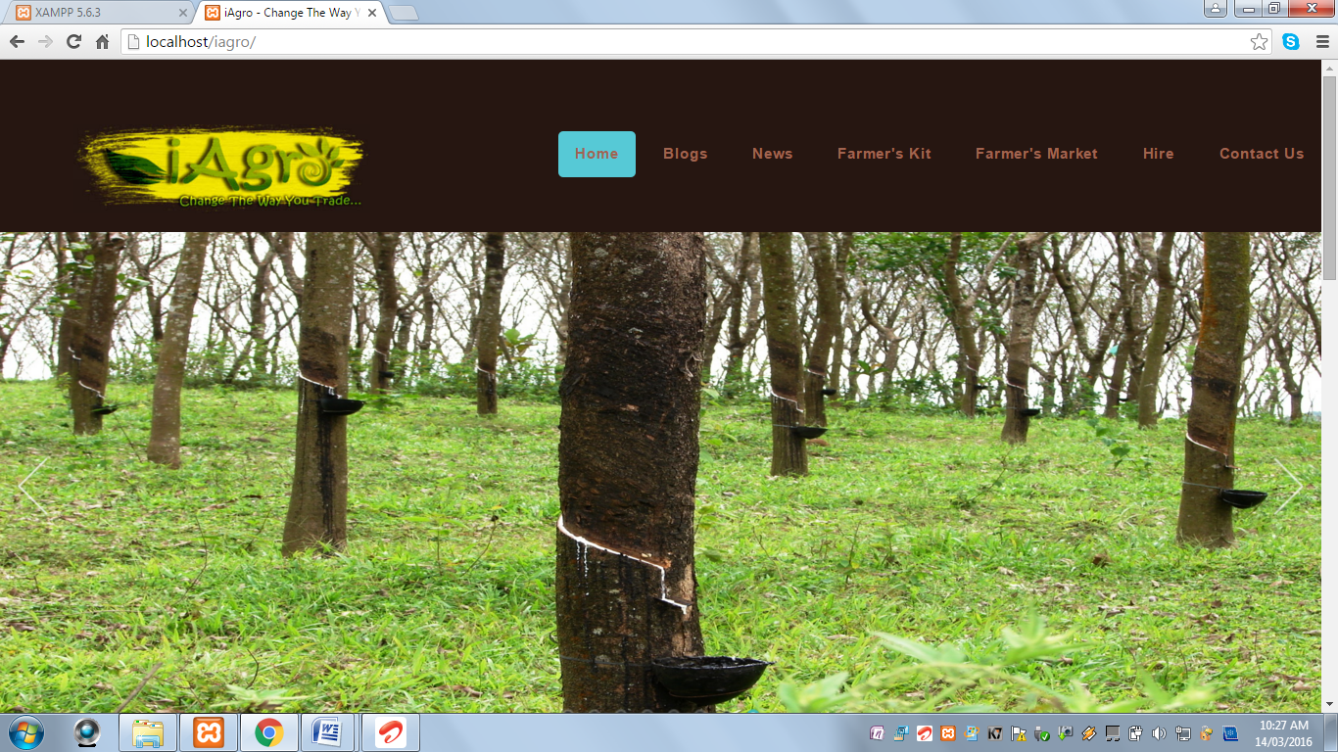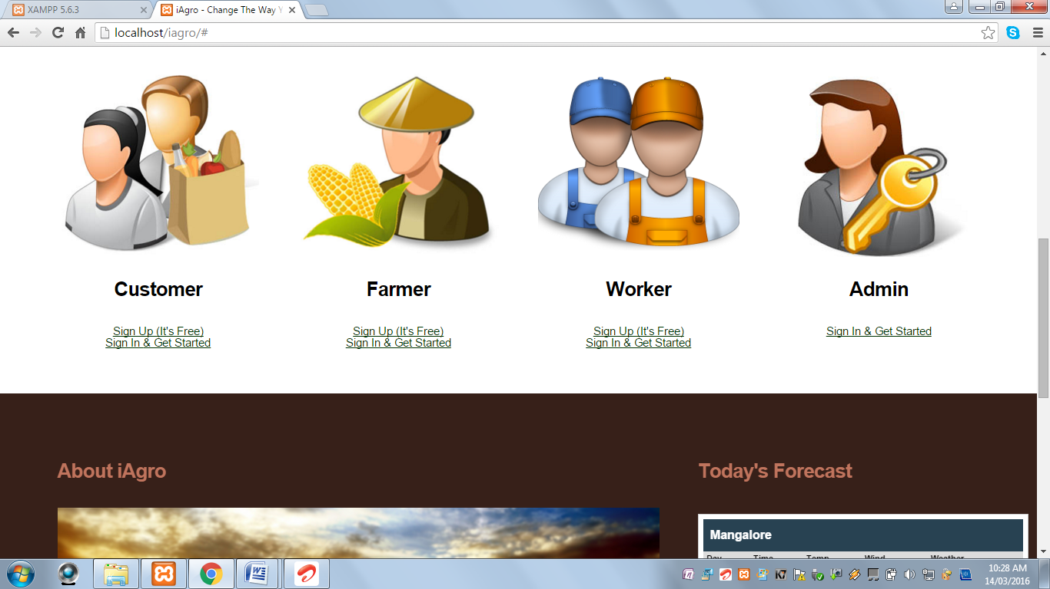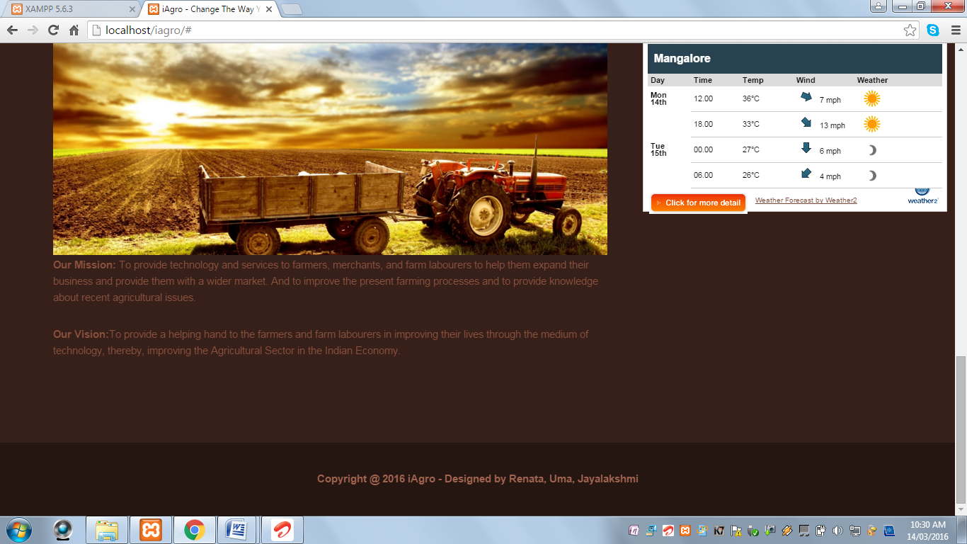

**Blogs Page**

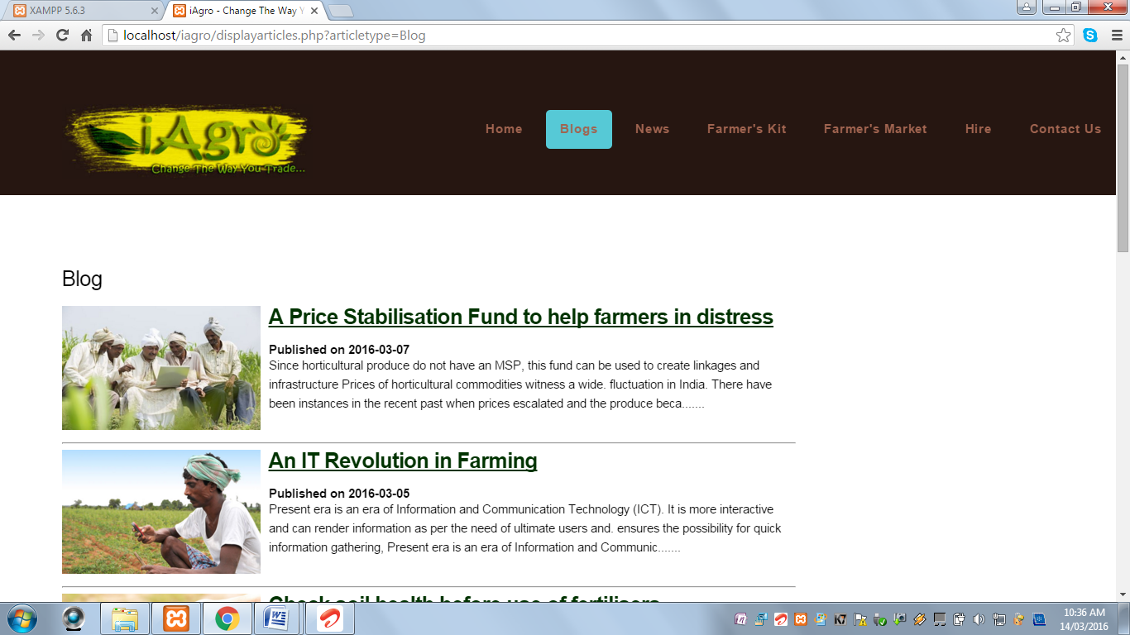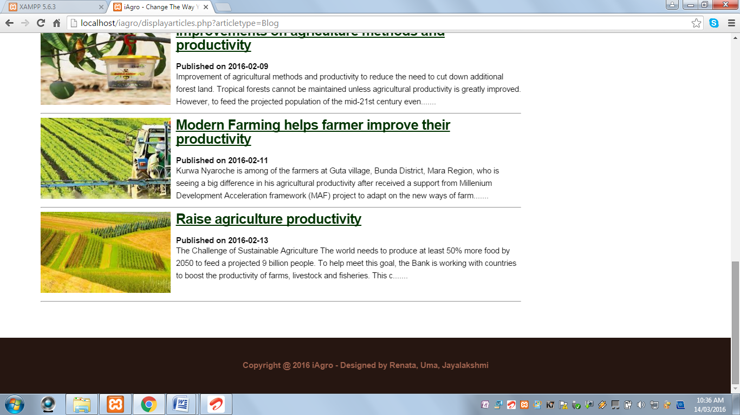

**News**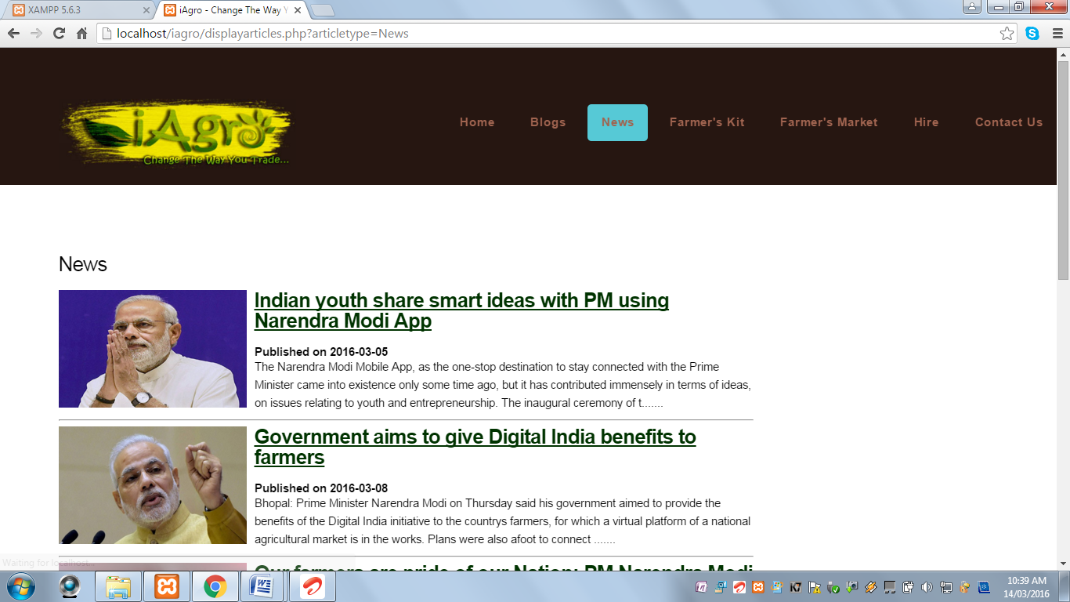

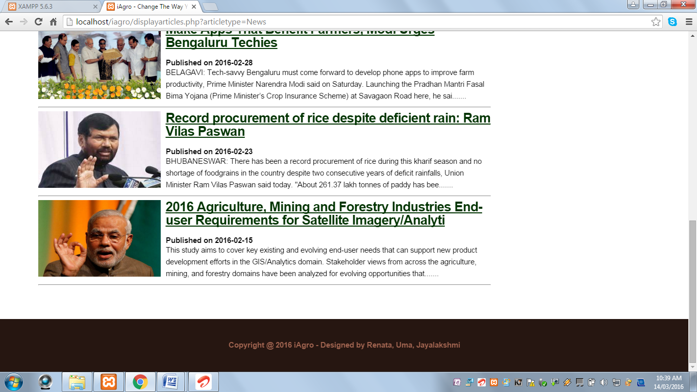

**Farmer’s Kit**

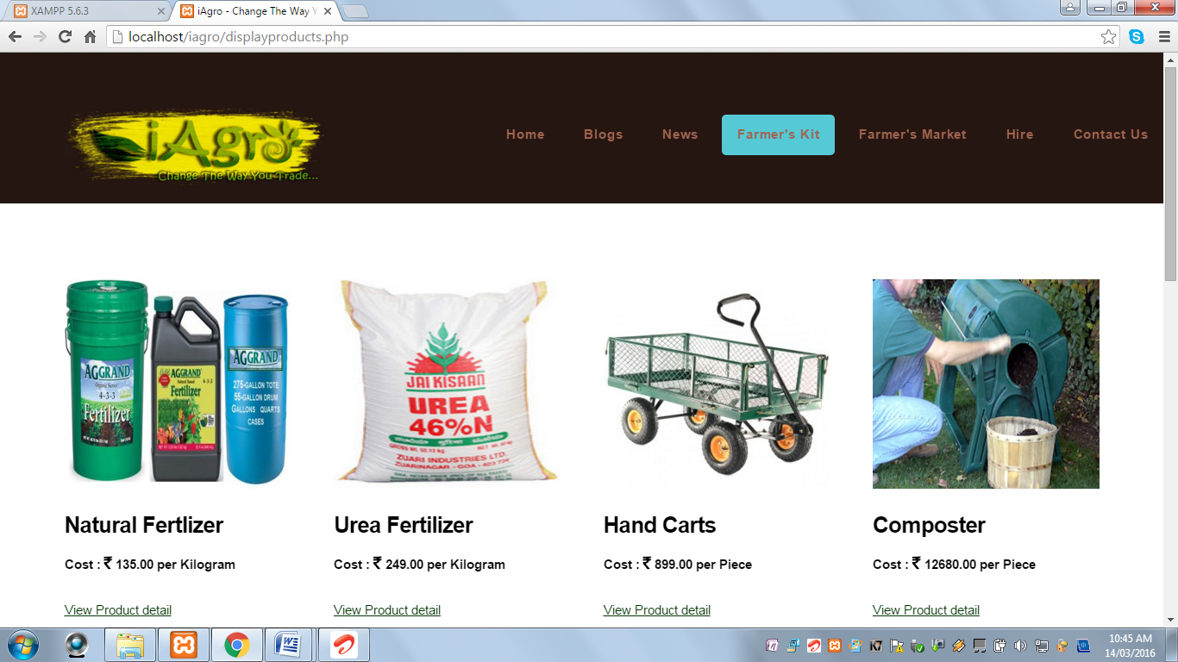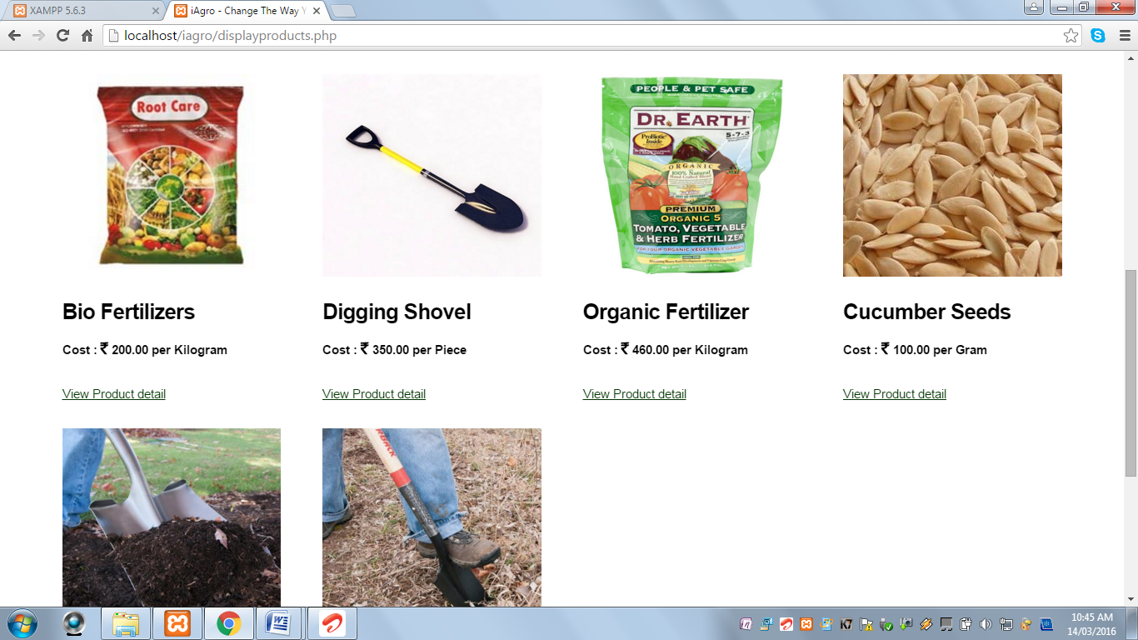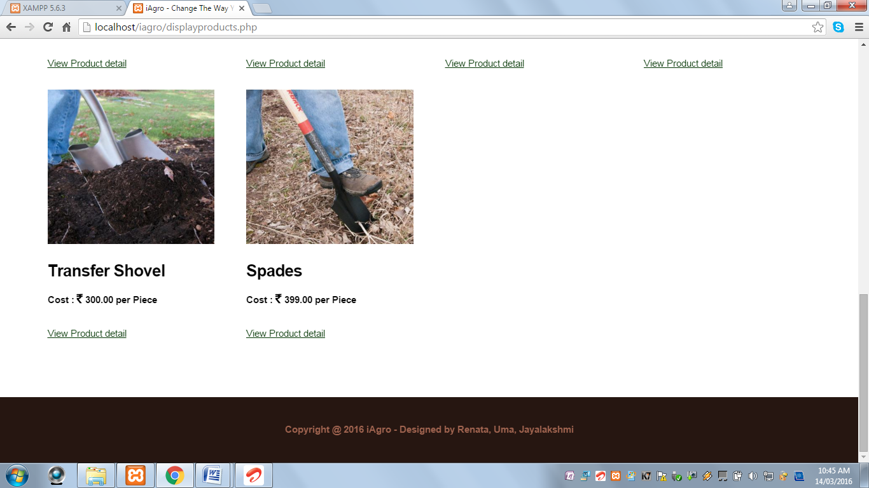

**Farmer’s Market**

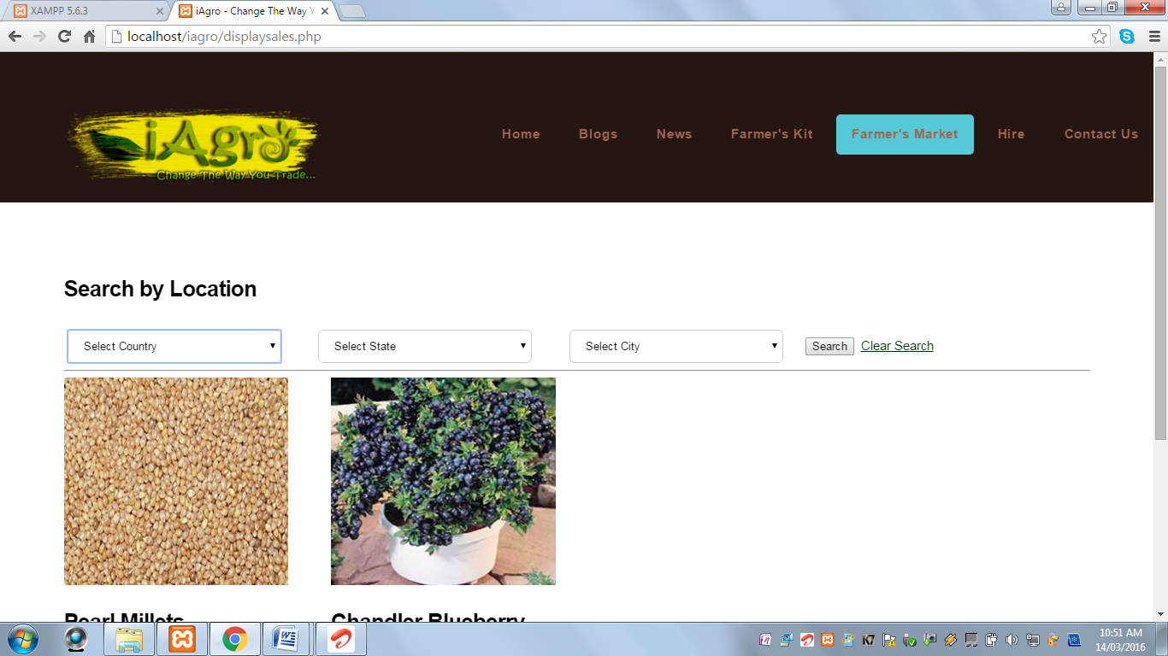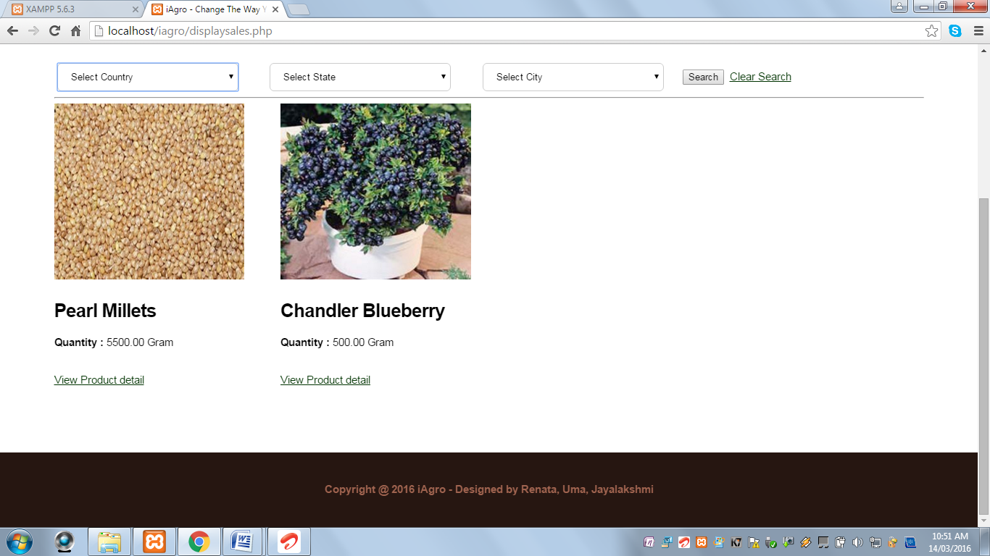

**Hire Page**

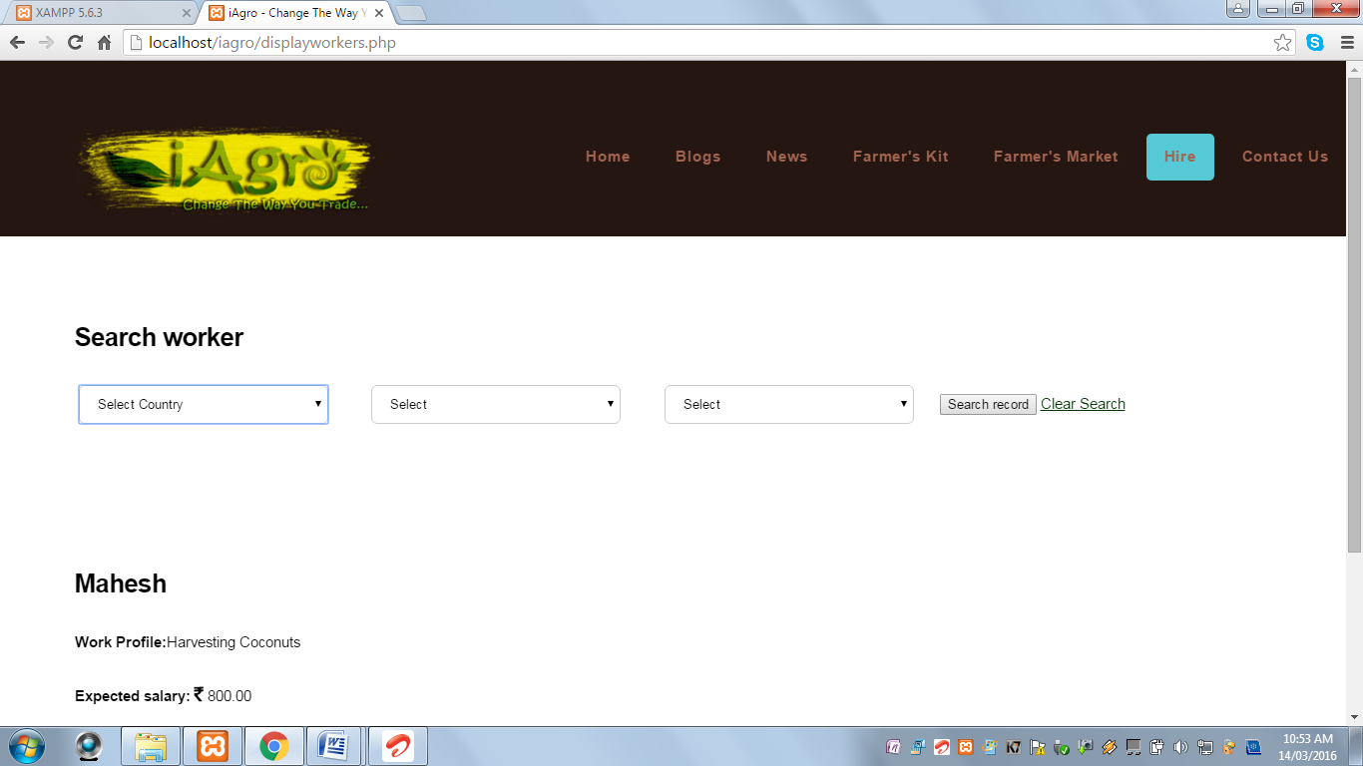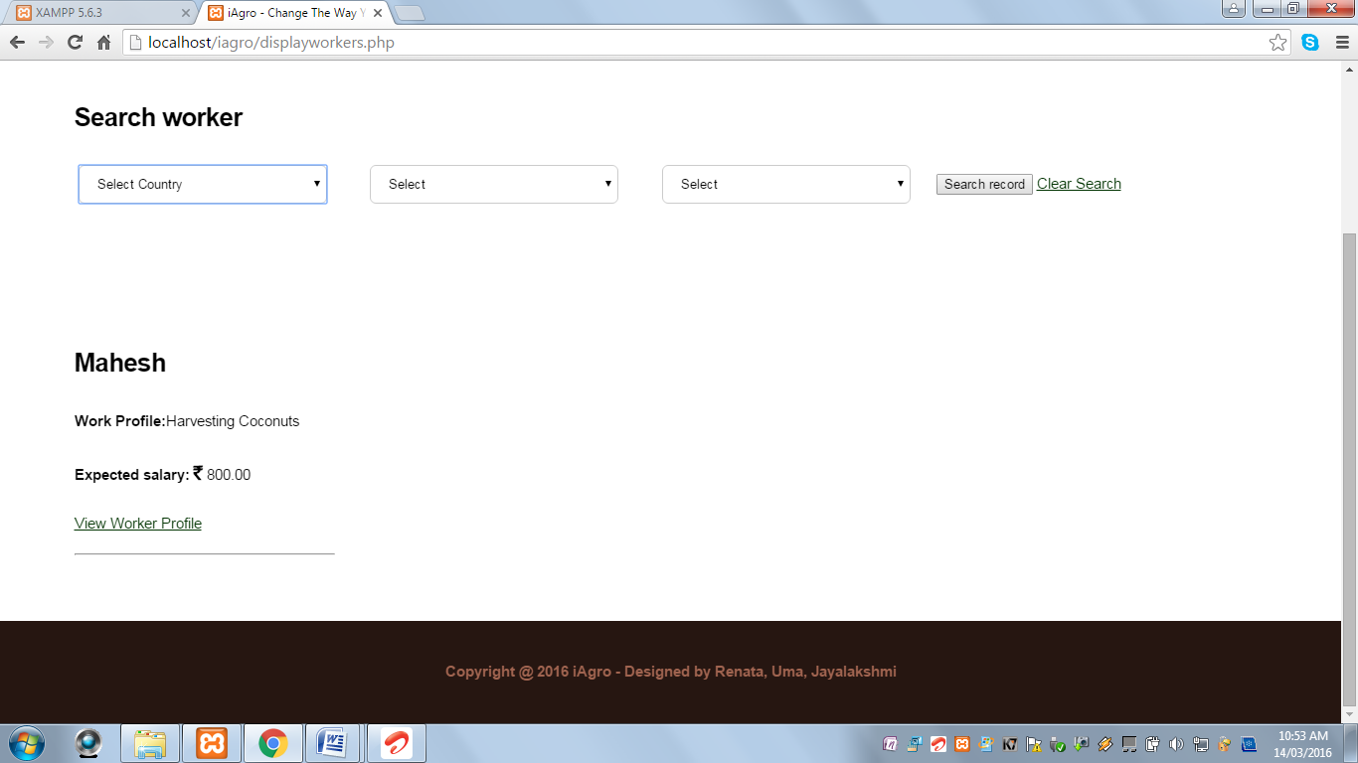

**Contact Us Page**

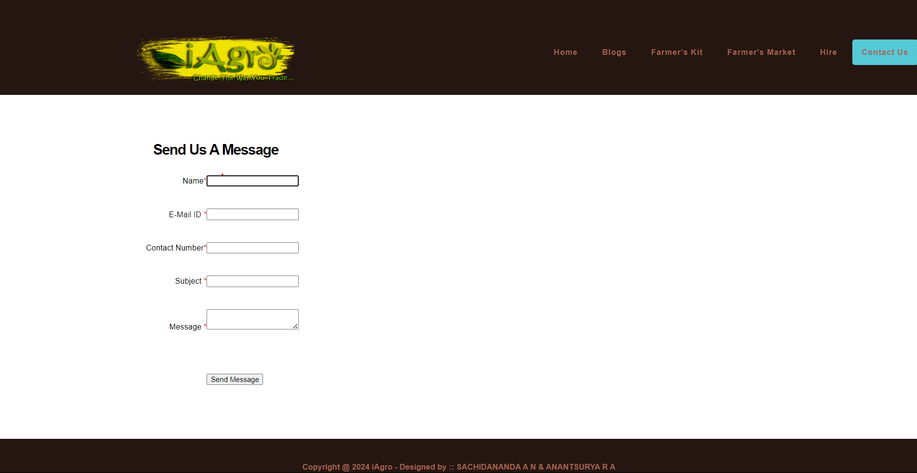

**Customer Registration Page:**

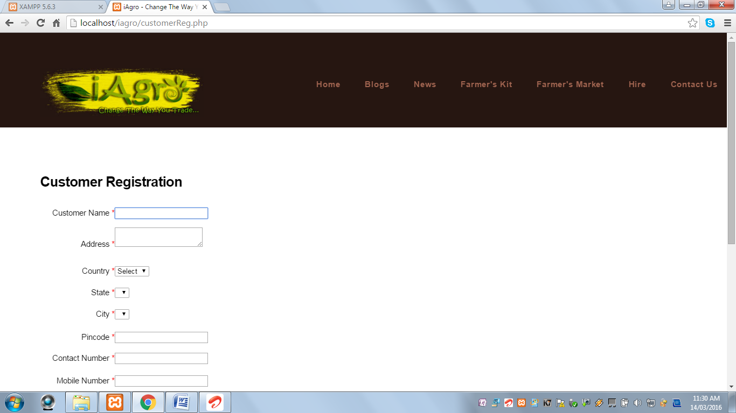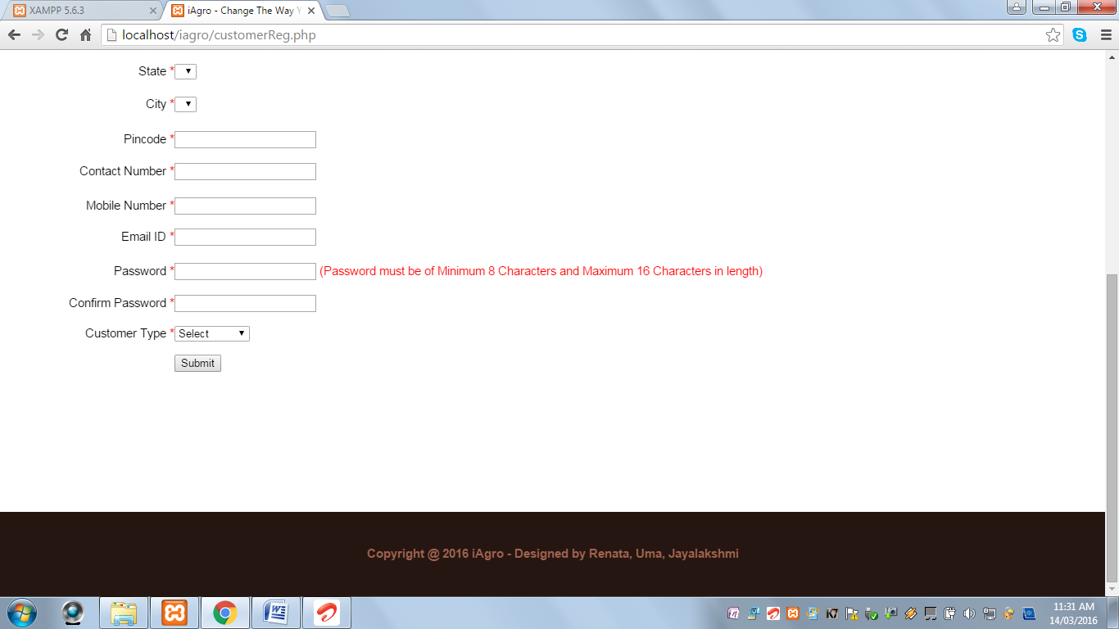

**Customer Login Page:**

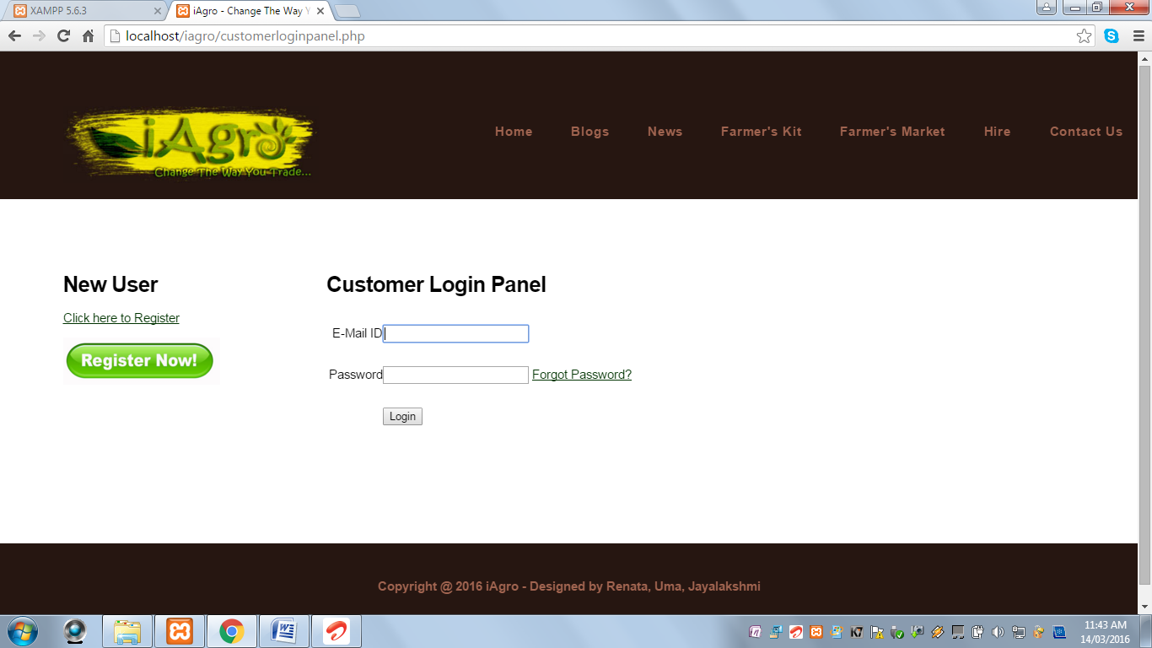

**View Your Profile:**

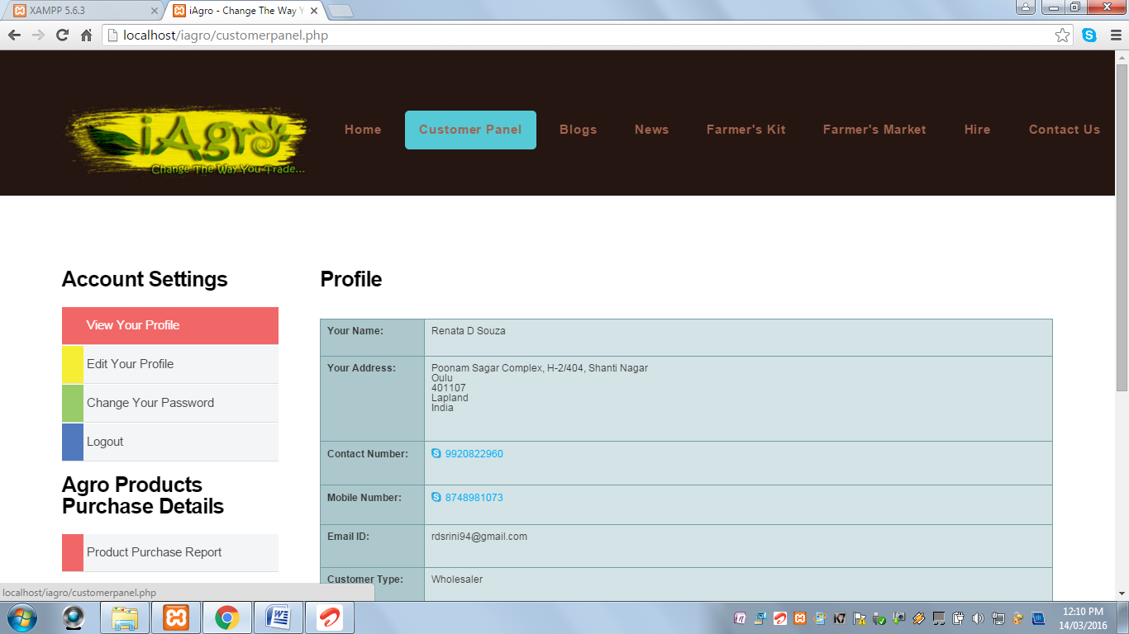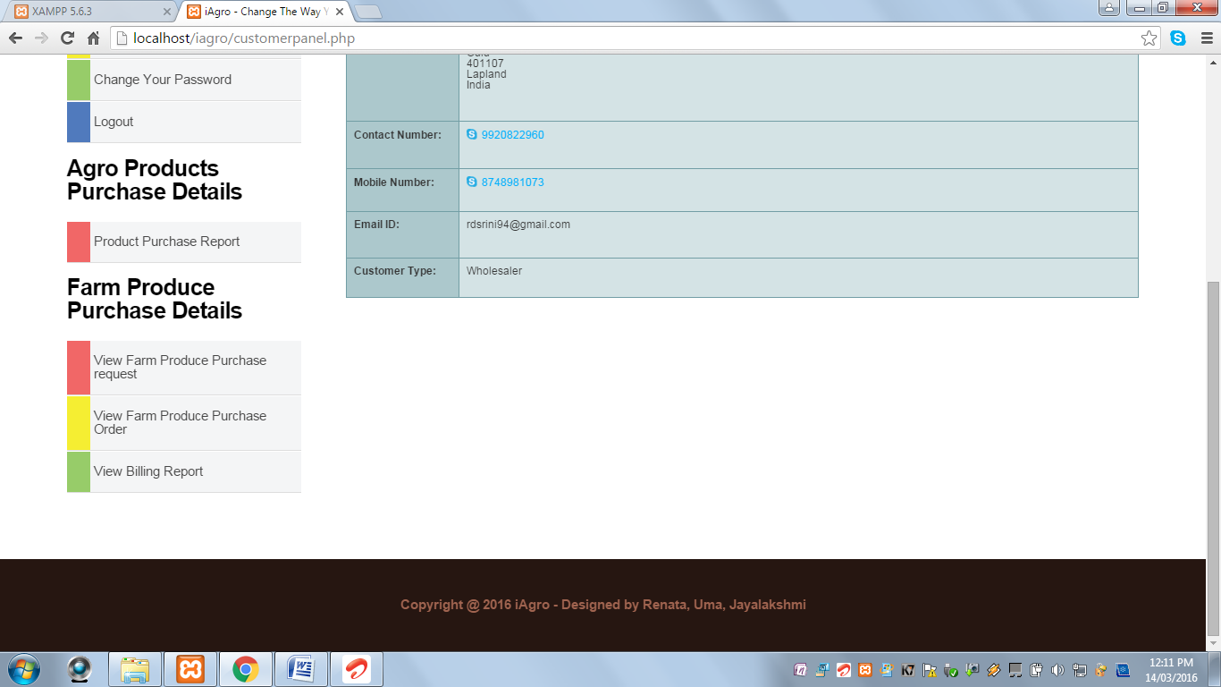

**Product Purchase Report:**

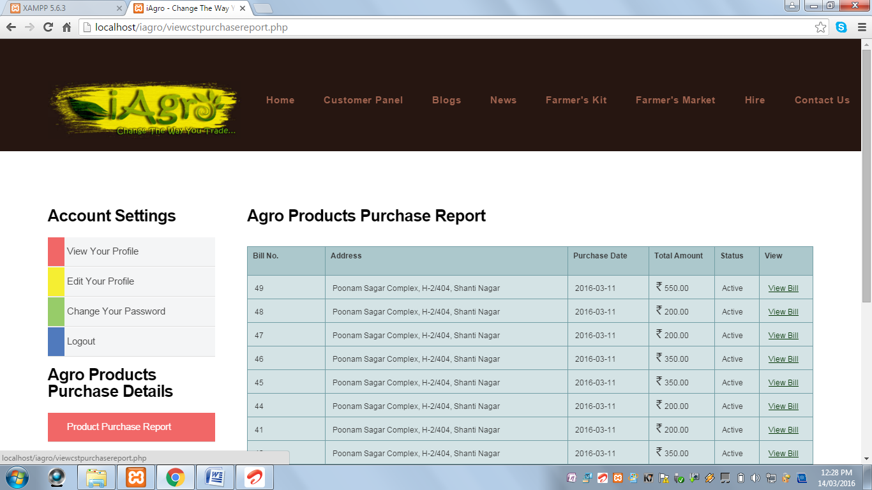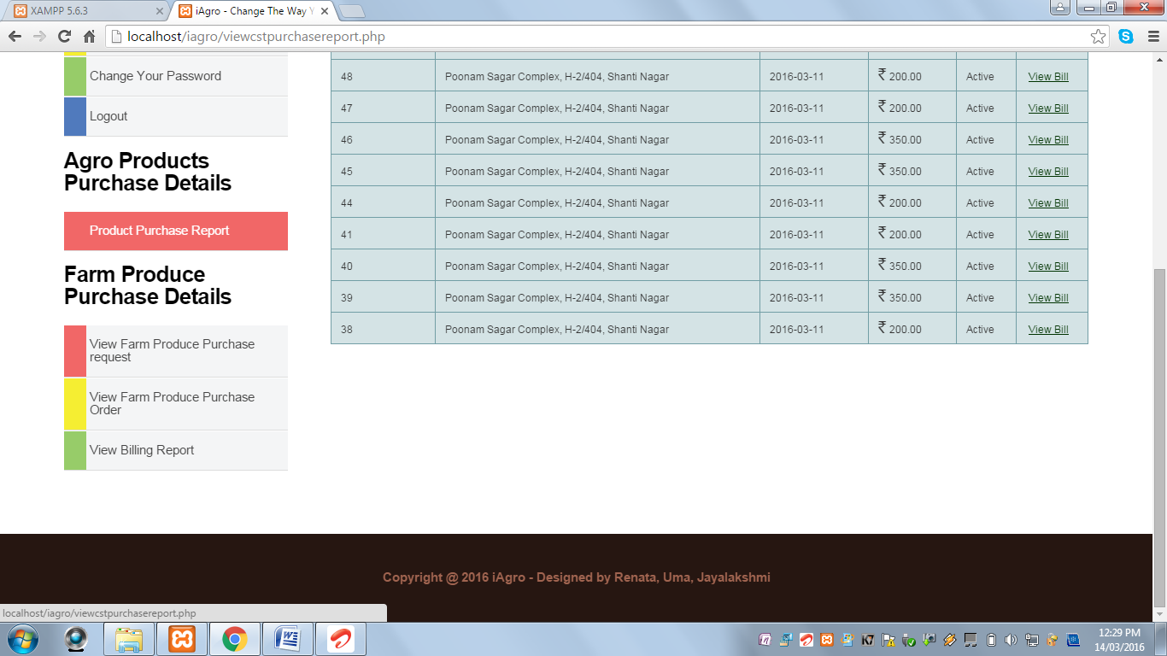

**Farmers Kit**

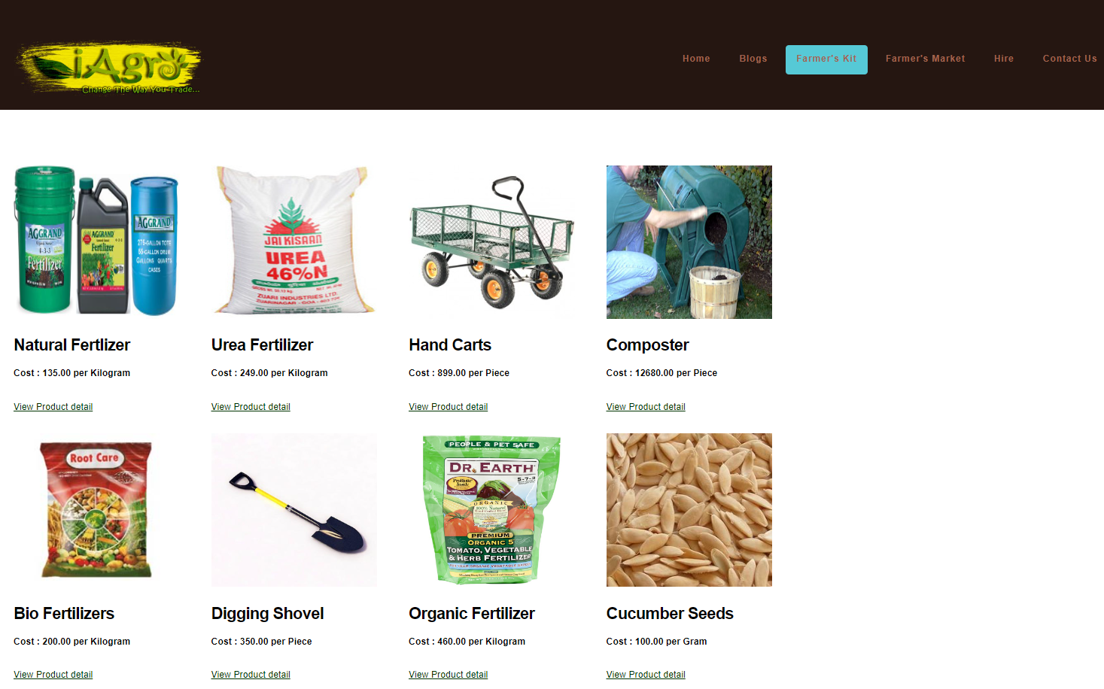

**Worker Profile**

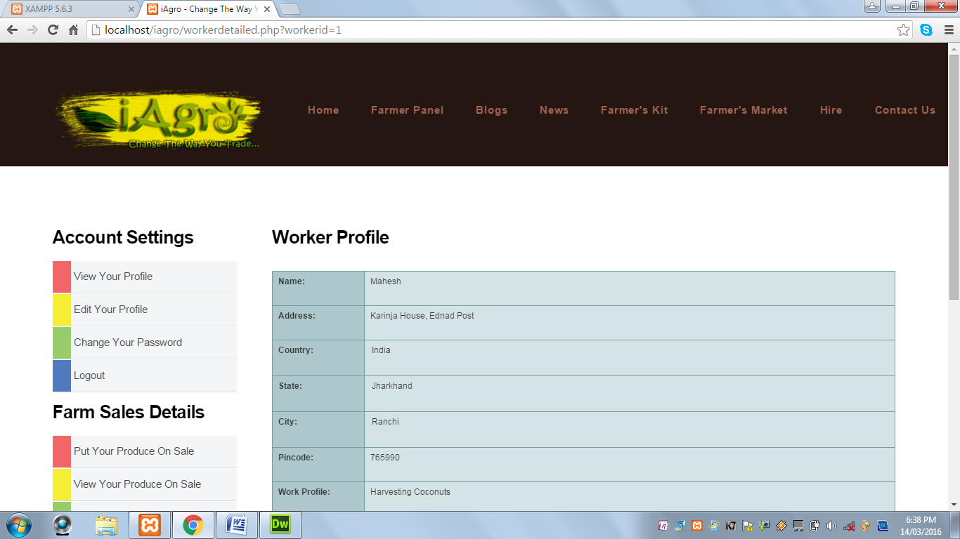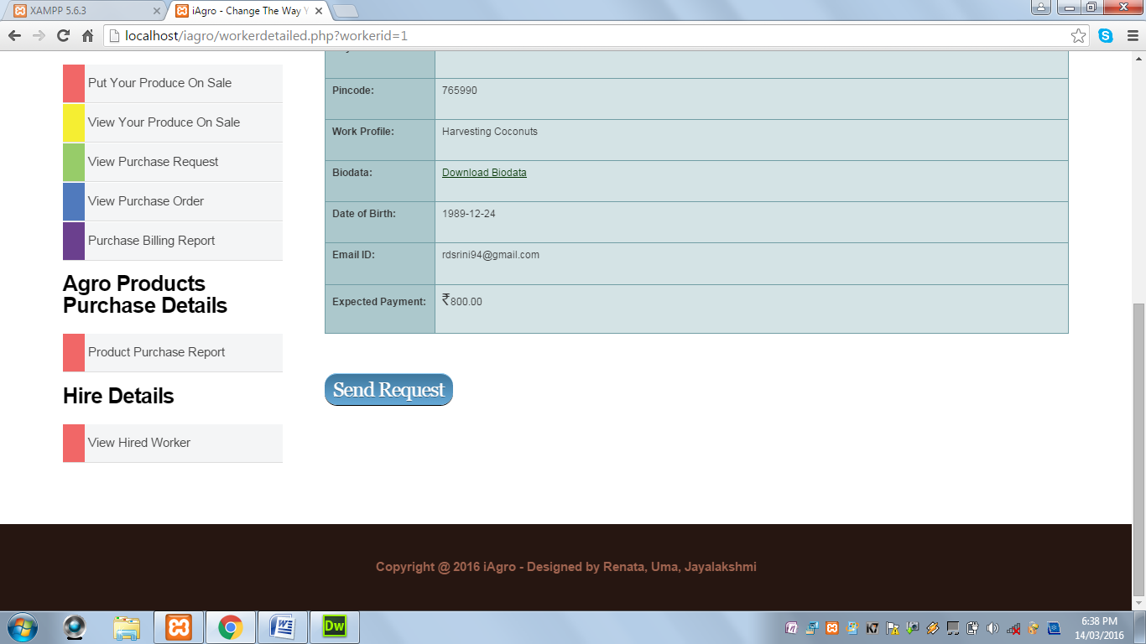

**Dashboard:**

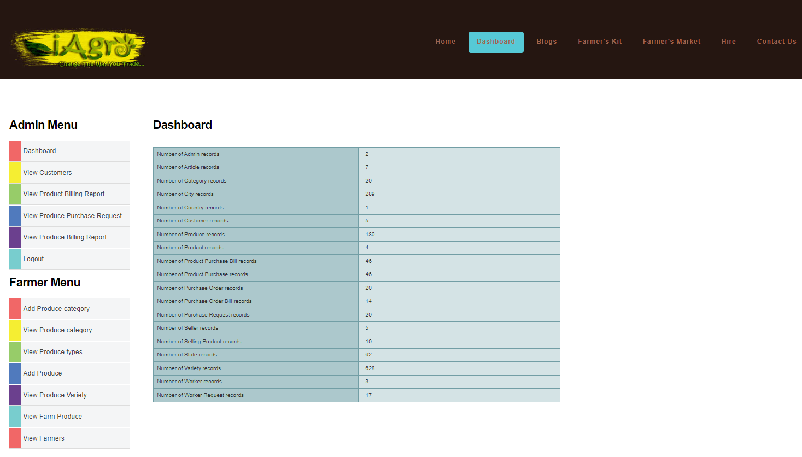

**2.Appendix II Coding**

**Index.php**

<?php include "header.php" ;?>

        <div id="featured">

            <div class="container">

                <div class="row">

                    <div class="3u">

                        <section>

                            <a href="#" class="image full">

                                                        <img src="images/customericon.jpg" alt="" width="150" height="200"></a>

                                                         <center>

                            <header>

                            <h2>Customer</h2>

                            </header>

                             <h4>

                            <a href="customerReg.php">Sign Up (It's Free)</a><br>

                             <a href="customerloginpanel.php">Sign In  & Get Started</a><br>

                            </h4>

                            </center>

                        </section>

                    </div>

                    <div class="3u">

                        <section>

                            <a href="#" class="image full"><img src="images/farmer icon.jpg" alt="" width="150" height="200"></a>

                            <center>

                            <header>

                                <h2>Farmer</h2>

                            </header>

                            <h4>

                            <a href="seller.php">Sign Up (It's Free)</a><br>

                             <a href="sellerloginpanel.php">Sign In & Get Started</a><br>

                            </h4>

                            </center>

                        </section>

                    </div>

                    <div class="3u">

                        <section>

                            <a href="#" class="image full"><img src="images/workers.png" alt="" width="150" height="200"></a>

                            <center>

                             <header>

                                <h2>Worker</h2>

                            </header>

                            <h4>

                            <a href="worker.php">Sign Up (It's Free)</a><br>

                             <a href="workerloginpanel.php">Sign In & Get Started</a><br>

                            </h4>

                            </center>

                        </section>

                    </div>

                    <div class="3u">

                        <section>

                            <a href="#" class="image full"><img src="images/women.png" alt="" width="150" height="200"></a>

                            <center>

                            <header>

                                <h2>Admin</h2>

                            </header>

                            <h4>

                             <a href="adminloginpanel.php">Sign In & Get Started</a><br>

<br>

                            </h4>

                            </center>

                        </section>

                    </div>

                </div>

            </div>

        </div>

        <div id="marketing">

            <div class="container">

                <div class="row">

                <div class="12u">

                        <section>

                            <header>

                                <h2>About iAgro</h2>

                            </header>

                            <img src="images/about.jpg" height="25%" width="75%">

                            <p> <strong>Our Mission: </strong>To provide technology and services to farmers, merchants, and farm labourers to help them expand their business and provide them with a wider market. And to improve the present farming processes and to provide knowledge about recent agricultural issues.

                            </p>

                            <p>

                           <strong>Our Vision:</strong>To provide a helping hand to the farmers and farm labourers in improving their lives through the medium of technology, thereby, improving the Agricultural Sector in the Indian Economy.

                            </p>

                        </section>

                   </div>

                </div>

            </div>

        </div>

        <?php include "footer.php" ;?>

**Admin.php**

<?php include "header.php";

include "dbconnection.php" ;

if($_SESSION['randnumber']  == $_POST['randnumber'])

{

if(isset($_POST['submit']))

{

    if(isset($_GET['editid']))

    {

        $sql ="UPDATE admin SET  `admin_name`='$_POST[adminname]', `login_id`='$_POST[loginid]', `password`='$_POST[password]', `status`='$_POST[status]' where admin_id='$_GET[editid]'";

        if(!mysqli_query($con,$sql))

        {

            echo "Error in mysqli query";

        }

        else

        {

            echo "<script>alert('Admin record updated successfully...');</script>";

        }

    }

    else

    {

$sql="INSERT INTO `admin`(`admin_id`, `admin_name`, `login_id`,`password`,`status`) VALUES ('','$_POST[adminname]','$_POST[loginid]','$_POST[password]','$_POST[status]')";

if(!mysqli_query($con,$sql))

    {

        echo "Error in mysqli query". mysqli_error($con);

    }

    else

    {

        echo "<script>alert(' Admin record inserted successfully...');</script>";

    }

}

}

}

$randnumber = rand();

$_SESSION['randnumber'] = $randnumber;

if(isset($_GET['editid']))

{

    $sql = "SELECT * FROM admin WHERE admin_id='$_GET[editid]'";

    $qsql = mysqli_query($con,$sql);

    $rsedit = mysqli_fetch_array($qsql);

}

?>

        <div id="featured">

            <div class="container">

                <div class="row">

<?php include "leftsidebaradmin.php" ;

?>

                    <div class="9u">

                        <section>

                            <header>

                                <h2>Add An Admin</h2>

                            </header>

                            <form method=POST action="" name="frmadminreg" onSubmit="return validateadminreg()">

                             <input type="hidden" name="randnumber" value="<?php echo $randnumber; ?>" >

                            <table width="1108" height="207" border="2">

                              <tbody>

                                <tr>

                                  <th width="132" height="27" scope="row" align="right">Admin Name  <font color="#FF0000">*</font></th>

                                  <td width="958"><input type="text" name="adminname" id="adminname" value="<?php echo $rsedit['admin_name']; ?>" autofocus></td>

                                </tr>

                                <tr>

                                  <th height="35" scope="row" align="right">Login ID  <font color="#FF0000">*</font></th>

                                  <td><input type="text" name="loginid" id="loginid" value="<?php echo $rsedit['login_id']; ?>"></td>

                                </tr>

                                <tr>

                                  <th height="33" scope="row" align="right">Password  <font color="#FF0000">*</font> </th>

                                  <td><input type="password" name="password" id="password" value="<?php echo $rsedit['password']; ?>">

                                    <font color="#FF0000"> (Password must be of Minimum 8 Characters and Maximum 16 Characters in length)</font>         </td>

                                </tr>

                                <tr>

                                  <th height="29" scope="row" align="right">Confirm Password  <font color="#FF0000">*</font></th>

                                  <td><input type="password" name="cpassword" id="cpassword" value="<?php echo $rsedit['password']; ?>"></td>

                                </tr>

                                <tr>

                                  <th height="33" scope="row" align="right">Status  </th>

                                  <td><select name="status" id="status">

                                    <?php

                                    $arr = array("Active","Inactive");

                                    foreach($arr as $val)

                                    {

                                        if($val == $rsedit['status'])

                                        {

                                        echo "<option value='$val' selected>$val</option>";

                                        }

                                        else

                                        {

                                        echo "<option value='$val'>$val</option>";

                                        }

                                    }

                                    ?>

                                  </select></td>

                                </tr>

                                <tr>

                                  <th colspan="2" scope="row" align="center"><input type="submit" name="submit" id="submit" value="Submit"></th>

                                </tr>

                              </tbody>

                          </table></form>

                            <p>&nbsp;</p>

                        </section>

                    </div>

                </div>

            </div>

        </div>

    <?php include "footer.php" ;?>

    <script type="application/javascript">

    function validateadminreg()

    {

var alphaExp = /^[a-zA-Z]+$/; //Variable to validate only alphabets

var alphaspaceExp = /^[a-zA-Z\s]+$/; //Variable to validate only alphabets and space

var numericExpression = /^[0-9]+$/; //Variable to validate only numbers

var emailExp = /^[\w\-\.\+]+\@[a-zA-Z0-9\.\-]+\.[a-zA-z0-9]{2,4}$/; //Variable to validate Email ID

        if(document.frmadminreg.adminname.value == "")

    {

        alert("Admin name should not be empty..");

        document.frmadminreg.adminname.focus();

        return false;

    }

    else if(!document.frmadminreg.adminname.value.match(alphaspaceExp))

    {

        alert("Please enter only letters for Admin name..");

        document.frmadminreg.adminname.focus();

        return false;

    }

    else if(document.frmadminreg.loginid.value == "")

    {

        alert("Login ID should not be empty..");

        document.frmadminreg.loginid.focus();

        return false;

    }

    else if(!document.frmadminreg.loginid.value.match(emailExp))

    {

        alert("Kindly enter Valid Login ID.");

        document.frmadminreg.loginid.focus();

        return false;

    }

    else if(document.frmadminreg.password.value == "")

    {

        alert("Password should not be empty..");

        document.frmadminreg.password.focus();

        return false;

    }

    else if(document.frmadminreg.password.value.length < 8)

    {

        alert("Password length should be more than 8 characters...");

        document.frmadminreg.password.focus();

        return false;

    }

    else if(document.frmadminreg.password.value.length > 16)

    {

        alert("Password length should be less than 16 characters...");

        document.frmadminreg.password.focus();

        return false;

    }

    else if(document.frmadminreg.cpassword.value == "")

    {

        alert("Confirm password should not be empty..");

        document.frmadminreg.cpassword.focus();

        return false;

    }

    else if(document.frmadminreg.password.value != document.frmadminreg.cpassword.value)

    {

        alert("Password and confirm password not matching...");

        document.frmadminreg.password.focus();

        return false;

    }

    else

    {

    return true;

    }

    }

    </script>

**Produce.php**

<?php

include "header.php" ;

include "dbconnection.php" ;

if($_SESSION['randnumber']  == $_POST['randnumber'])

{

if(isset($_POST['submit']))

{

    $imgname1 = rand() . $_FILES['img']['name'];

    move_uploaded_file($_FILES['img']['tmp_name'],"imgproduce/" . $imgname1);

    if(isset($_GET['editid']))

    {

        $sql ="UPDATE produce SET  `category_id`='$_POST[category]', `produce`='$_POST[produce]', `description`='$_POST[description]', `img`='$imgname1', `status`='$_POST[status]'  WHERE produce_id='$_GET[editid]'";

        if(!mysqli_query($con,$sql))

        {

            echo "Error in mysqli query".mysqli_error($con);

        }

        else

        {

            echo "<script>alert('Produce record updated successfully...');</script>";

        }

    }

    else

    {

    $sql="INSERT INTO `produce`(`produce_id`, `category_id`, `produce`, `description`, `img`, `status`) VALUES ('','$_POST[category]','$_POST[produce]','$_POST[description]','$imgname1','$_POST[status]')";

    if(!mysqli_query($con,$sql))

        {

            echo "Error in mysqli query".mysqli_error($con);

        }

        else

        {

            echo "<script>alert('Produce record inserted successfully...');</script>";

        }

    }

}

}

$randnumber = rand();

$_SESSION['randnumber'] = $randnumber;

if(isset($_GET['editid']))

{

    $sql = "SELECT * FROM produce WHERE produce_id='$_GET[editid]'";

    $qsql = mysqli_query($con,$sql);

    $rsedit = mysqli_fetch_array($qsql);

}

?>

        <div id="featured">

            <div class="container">

                <div class="row">

<?php include "leftsidebaradmin.php" ;

?>

                    <div class="9u">

                        <section>

                            <header>

                                <h2>Add A Produce</h2>

                            </header>

                            <form method="post" action="" enctype="multipart/form-data" name="frmproduce" onSubmit="return validateproduce()">

                            <input type="hidden" name="randnumber" value="<?php echo $randnumber; ?>" >

                            <table width="253" height="450" border="2">

                              <tbody>

                                <tr>

                                  <td height="36" align="right">Category  <font color="#FF0000">*</font></td>

                                  <td><select name="category" id="category" autofocus>

                                   <option value="">Select</option>

                                  <?php

                                  $sql2 = "SELECT * FROM category where status='Active' AND category_type='Produce'";

                                    $qsql2 =mysqli_query($con,$sql2);

                                  while($rssql2 = mysqli_fetch_array($qsql2))

                                  {

                                      if($rssql2['category_id'] == $rsedit['category_id'] )

                                      {

                                      echo "<option value='$rssql2[category_id]' selected>$rssql2[category]</option>";

                                      }

                                      else

                                      {

                                      echo "<option value='$rssql2[category_id]'>$rssql2[category]</option>";

                                      }

                                  }

                                  ?>

                                  </select></td>

                                </tr>

                                <tr>

                                  <td height="45" align="right">Produce  <font color="#FF0000">*</font></td>

                                  <td><input type="text" name="produce" id="produce" value="<?php echo $rsedit['produce']; ?>"></td>

                                </tr>

                                <tr>

                                  <td valign="top" align="right">Description</td>

                                  <td><textarea name="description" cols="75" rows="15" id="description"><?php echo $rsedit['description']; ?></textarea></td>

                                </tr>

                                <tr>

                                  <td height="39" align="right">Image  <font color="#FF0000">*</font></td>

                                  <td><input type="file" name="img" id="img"></td>

                                </tr>

                                <tr>

                                  <td height="37" align="right">Status</td>

                                  <td><select name="status" id="status">

                                   <option value="">Select</option>

                                  <?php

                                  $arr= array("Active","Inactive");

                                  foreach($arr as $val)

                                  {

                                      if($rsedit['status'] == $val)

                                      {

                                      echo "<option value='$val' selected >$val</option>";

                                      }

                                      else

                                      {

                                      echo "<option value='$val'>$val</option>";

                                      }

                                  }

                                  ?>

                                  </select></td>

                                </tr>

                                <tr>

                                  <td>&nbsp;</td>

                                  <td><input type="submit" name="submit" id="submit" value="Submit"></td>

                                </tr>

                              </tbody>

                          </table>

                          </form>

                            <p>&nbsp;</p>

                        </section>

                    </div>

                </div>

            </div>

        </div>

    <script type="application/javascript">

    function validateproduce()

    {

         if(document.frmproduce.category.value == "")

            {

                alert("Kindly select the category..");

                document.frmproduce.category.focus();

                return false;

            }

            else if(document.frmproduce.produce.value == "")

            {

                alert("Produce should not be blank..");

                document.frmproduce.produce.focus();

                return false;

            }

            else if(!document.frmproduce.produce.value.match(alphaspaceExp))

            {

                alert("Please enter only letters for produce..");

                document.frmproduce.produce.focus();

                return false;

            }

            else if(document.frmproduce.img.value == "")

            {

                alert("Select an image..");

                document.frmproduce.img.focus();

                return false;

            }

            else

            {

                return true;

            }

    }

    </script>

**Product.php**

<?php

if(!isset($_SESSION)) { session_start(); }

include "header.php" ;

include "dbconnection.php" ;

if($_SESSION['randnumber']  == $_POST['randnumber'])

{

if(isset($_POST['submit']))

{

    $dt = date("Y-m-d");

    $imgname1 = rand() . $_FILES['img1']['name'];

    move_uploaded_file($_FILES['img1']['tmp_name'],"imgproduct/" . $imgname1);

    //$imgname2 = rand() . $_FILES[img2][name];

    //move_uploaded_file($_FILES[img2][tmp_name],"imgproduct/" . $imgname2);

    //$imgname3 = rand() . $_FILES[img3][name];

    //move_uploaded_file($_FILES[img3][tmp_name],"imgproduct/" . $imgname3);

    //$imgname4 = rand() . $_FILES[img4][name];

    //move_uploaded_file($_FILES[img4][tmp_name],"imgproduct/" . $imgname4);

    //$imgname5 = rand() . $_FILES[img5][name];

    move_uploaded_file($_FILES['img5']['tmp_name'],"imgproduct/" . $imgname5);

        if($_POST['quantity'] == 0)

        {

            $status = "Inactive";

        }

        else

        {

            $status = $_POST['status'];

        }

    if(isset($_GET['editid']))

    {

        $qty = $_POST['quantity'];

        $sql ="UPDATE product SET  seller_id='$_SESSION[sellerid]',

                                   category_id='$_POST[category]',

                                   produce_id='$_POST[produce]',

                                   variety_id='$_POST[variety]',

                                   title='$_POST[title]', ";

        if($_FILES['img1']['name'] != "")

        {

        $sql = $sql . " img_1='$imgname1',  ";

        }

        /*if($_FILES[img2][name] != "")

        {

        $sql = $sql . " img_2='$imgname2',  ";

        }

        if($_FILES[img3][name] != "")

        {

        $sql = $sql . " img_3='$imgname3',  ";

        }

        if($_FILES[img4][name] != "")

        {

        $sql = $sql . " img_4='$imgname4',  ";

        }

        if($_FILES[img5][name] != "")

        {

        $sql = $sql . " img_5='$imgname5',  ";

        }*/

        $sql = $sql . " quantity='$_POST[quantity]',

                        quantity_type='$_POST[quantitytype]',

                        description='$_POST[description]',

                        uploaded_date='$_POST[uploaddate]',

                        status='' WHERE product_id='$_GET[editid]'";

        if(!mysqli_query($con,$sql))

        {

            echo "Error in mysqli query";

        }

        else

        {

            echo "<script>alert('Product record updated successfully...');</script>";

        }

    }

    else

    {

$sql="INSERT INTO product(product_id, seller_id, category_id, produce_id, variety_id, title, img_1)";

/*if($_FILES[img2][name] != "")

{

$sql = $sql . " , img_2";

}

if($_FILES[img2][name] != "")

{

$sql = $sql . " , img_3";

}

if($_FILES[img2][name] != "")

{

$sql = $sql . " , img_4";

}

if($_FILES[img2][name] != "")

{

$sql = $sql . " , img_5";

}*/

$sql = $sql . " , quantity, quantity_type, description, uploaded_date, status) VALUES ('','$_SESSION[sellerid]','$_POST[category]','$_POST[produce]','$_POST[variety]','$_POST[title]','$imgname1'";

/*if($_FILES[img2][name] != "")

{

$sql = $sql . " ,'$imgname2'";

}

if($_FILES[img2][name] != "")

{

$sql = $sql . " ,'$imgname3'";

}

if($_FILES[img2][name] != "")

{

$sql = $sql . " ,'$imgname4'";

}

if($_FILES[img2][name] != "")

{

$sql = $sql . " ,'$imgname5'";

}*/

$sql = $sql . " ,'$_POST[quantity]','$_POST[quantitytype]','$_POST[description]','$dt','$status')";

if(!mysqli_query($con,$sql))

    {

        echo "Error in mysqli query";

    }

    else

    {

        if($_POST['status'] == "Active")

        {

        echo "<script>alert('Your Produce Has Been Put On Sale...');</script>";

        }

        else

        {

        echo "<script>alert('Your Produce has not been put on sale..');</script>";

        }

    }

}

}

}

$randnumber = rand();

$_SESSION['randnumber'] = $randnumber;

if(isset($_GET['editid']))

{

    $sql = "SELECT * FROM product WHERE product_id='$_GET[editid]'";

    $qsql = mysqli_query($con,$sql);

    $rsedit = mysqli_fetch_array($qsql);

}

?>

        <div id="featured">

            <div class="container">

                <div class="row">

<?php include "leftsidebarseller.php" ;

?>

                    <div class="9u">

                        <section>

                          <header>

                                <h2>Product</h2>

                            </header>

                            <form method="post" action="" enctype="multipart/form-data" name="frmproduct" onSubmit="return validateproduct()">

                             <input type="hidden" name="randnumber" value="<?php echo $randnumber; ?>" >

                          <table width="414" height="471" border="2" class="tftable" >

                            <tbody>

                              <tr>

                                <td width="107" align="right">Category <font color="#FF0000">*</font></td>

                                <td width="289"><select name="category" id="category" onchange="showUser(this.value)" autofocus>

                                 <option value="">Select</option>

                                  <?php

                                  $sql2 = "SELECT * FROM category where status='Active' AND category_type='Produce'";

                                    $qsql2 =mysqli_query($con,$sql2);

                                  while($rssql2 = mysqli_fetch_array($qsql2))

                                  {

                                      if($rssql2['category_id'] == $rsedit['category_id'] )

                                      {

                                      echo "<option value='$rssql2[category_id]' selected>$rssql2[category]</option>";

                                      }

                                      else

                                      {

                                      echo "<option value='$rssql2[category_id]'>$rssql2[category]</option>";

                                      }

                                  }

                                  ?>

                                </select></td>

                              </tr>

                              <tr>

                                <td align="right">Produce <font color="#FF0000">*</font></td>

                                <td>

                                <div id="txtHint">

                                <select name="produce" id="produce" onchange="showUser1(this.value)">

                                 <option value="">Select</option>

                                  <?php

                                  $sql3 = "SELECT * FROM produce where status='Active'";

                                    $qsql3=mysqli_query($con,$sql3);

                                  while($rssql3 = mysqli_fetch_array($qsql3))

                                  {

                                      if($rssql3['produce_id'] == $rsedit['produce_id'] )

                                      {

                                      echo "<option value='$rssql3[produce_id]' selected>$rssql3[produce]</option>";

                                      }

                                      else

                                      {

                                      echo "<option value='$rssql3[produce_id]'>$rssql3[produce]</option>";

                                      }

                                  }

                                  ?>

                                </select>

                                </div>

                                </td>

                              </tr>

                              <tr>

                                <td align="right">Variety <font color="#FF0000">*</font></td>

                                <td><div id="txtHint1"><select name="variety" id="variety" >

                                 <option value="">Select</option>

                                  <?php

                                  $sql4 = "SELECT * FROM variety where status='Active'";

                                    $qsql4=mysqli_query($con,$sql4);

                                  while($rssql4 = mysqli_fetch_array($qsql4))

                                  {

                                      if($rssql4['variety_id'] == $rsedit['variety_id'] )

                                      {

                                      echo "<option value='$rssql4[variety_id]' selected>$rssql4[variety]</option>";

                                      }

                                      else

                                      {

                                      echo "<option value='$rssql4[variety_id]'>$rssql4[variety]</option>";

                                      }

                                  }

                                  ?>

                                </select></div></td>

                              </tr>

                              <tr>

                                <td align="right">Title  <font color="#FF0000">*</font> </td>

                                <td><input type="text" name="title" id="title" value="<?php echo $rsedit['title']; ?>"></td>

                              </tr>

                              <tr>

                                <td align="right">Image 1  <font color="#FF0000">*</font> </td>

                                <td><input type="file" name="img1" id="img1">

                                    <input type="hidden" name="img11" id="img11" value="<?php echo $rsedit['img_1']; ?>">

                                </td>

                              </tr>

                              <!--<tr>

                                <td align="right">Image 2</td>

                                <td><input type="file" name="img2" id="img2"></td>

                              </tr>

                              <tr>

                                <td align="right">Image 3</td>

                                <td><input type="file" name="img3" id="img3"></td>

                              </tr>

                              <tr>

                                <td align="right">Image 4</td>

                                <td><input type="file" name="img4" id="img4"></td>

                              </tr>

                              <tr>

                                <td align="right">Image 5</td>

                                <td><input type="file" name="img5" id="img5"></td>

                              </tr>-->

                              <tr>

                                <td align="right">Quantity  <font color="#FF0000">*</font></td>

                                <td><input type="number" name="quantity" id="quantity" value="<?php echo $rsedit['quantity']; ?>"></td>

                              </tr>

                              <tr>

                                <td align="right">Quantity Type  <font color="#FF0000">*</font></td>

                                <td><select name="quantitytype" id="quantitytype">

                                 <option value="">Select</option>

                                  <?php

                                  $arr= array("Kilogram","Gram","Quintal");

                                  foreach($arr as $val)

                                  {

                                      if($rsedit['quantity_type'] == $val)

                                      {

                                      echo "<option value='$val' selected >$val</option>";

                                      }

                                      else

                                      {

                                      echo "<option value='$val'>$val</option>";

                                      }

                                  }

                                  ?>

                                </select></td>

                              </tr>

                              <tr>

                                <td align="right">Description</td>

                                <td><textarea name="description" id="description"><?php echo $rsedit['description']; ?></textarea></td>

                              </tr>

                              <tr>

                                <td align="right">Status</td>

                                <td><select name="status" id="status" onChange="loadstatus(this.value)">

                                 <?php

                                  $arr= array("Active","Inactive");

                                  $i=1;

                                  foreach($arr as $val)

                                  {

                                      if($rsedit['status'] == $val)

                                      {

                                      echo "<option value='$val' selected >$val</option>";

                                      }

                                      else

                                      {

                                      echo "<option value='$val'>$val</option>";

                                      }

                                  }

                                  ?>

                                </select>

                                <span id="ajaxstatus">Your produce will be put on sale..</span>

                                </td>

                              </tr>

                              <tr>

                                <td>&nbsp;</td>

                                <td><input type="submit" name="submit" id="submit" value="Submit"></td>

                              </tr>

                            </tbody>

                          </table>

                          </form>

                          <p>&nbsp;</p>

                        </section>

                    </div>

                </div>

            </div>

        </div>

<script>

function showUser(str) {

    if (str == "") {

        document.getElementById("txtHint").innerHTML = "";

        return;

    } else {

        if (window.XMLHttpRequest) {

            // code for IE7+, Firefox, Chrome, Opera, Safari

            xmlhttp = new XMLHttpRequest();

        } else {

            // code for IE6, IE5

            xmlhttp = new ActiveXObject("Microsoft.XMLHTTP");

        }

        xmlhttp.onreadystatechange = function() {

            if (xmlhttp.readyState == 4 && xmlhttp.status == 200) {

                document.getElementById("txtHint").innerHTML = xmlhttp.responseText;

            }

        };

        xmlhttp.open("GET","ajaxproduce.php?q="+str,true);

        xmlhttp.send();

    }

}

function showUser1(str) {

    if (str == "") {

        document.getElementById("txtHint1").innerHTML = "";

        return;

    } else {

        if (window.XMLHttpRequest) {

            // code for IE7+, Firefox, Chrome, Opera, Safari

            xmlhttp = new XMLHttpRequest();

        } else {

            // code for IE6, IE5

            xmlhttp = new ActiveXObject("Microsoft.XMLHTTP");

        }

        xmlhttp.onreadystatechange = function() {

            if (xmlhttp.readyState == 4 && xmlhttp.status == 200) {

                document.getElementById("txtHint1").innerHTML = xmlhttp.responseText;

            }

        };

        xmlhttp.open("GET","ajaxvariety.php?q="+str,true);

        xmlhttp.send();

    }

}

</script>

<script type="application/javascript">

function validateproduct()

{

    var numericExpression = /^[0-9]+$/; //Variable to validate only numbers

     if(document.frmproduct.category.value == "")

    {

        alert("Kindly select the category..");

        document.frmproduct.category.focus();

        return false;

    }

    else if(document.frmproduct.produce.value == "")

    {

        alert("Kindly select the produce..");

        document.frmproduct.produce.focus();

        return false;

    }

     else if(document.frmproduct.variety.value == "")

    {

        alert("Kindly select the variety..");

        document.frmproduct.variety.focus();

        return false;

    }

    else if(document.frmproduct.title.value == "")

    {

        alert("Title should not be empty..");

        document.frmproduct.title.focus();

        return false;

    }

    else if(document.frmproduct.img1.value == "")

    {

        if(document.frmproduct.img1.value == "")

        {

        alert("Select at least one image..");

        document.frmproduct.img1.focus();

        return false;

        }

    }

    else if(document.frmproduct.quantity.value == "")

    {

        alert("Quantity should not be empty..");

        document.frmproduct.quantity.focus();

        return false;

    }

    else if(document.frmproduct.quantity.value < 1)

    {

        alert("Quantity should not be less than 1..");

        document.frmproduct.quantity.focus();

        return false;

    }

    else if(document.frmproduct.quantitytype.value == "")

    {

        alert("Select a quantity type..");

        document.frmproduct.quantitytype.focus();

        return false;

    }

    else

    {

        return true;

    }

}

function loadstatus(prodstatus)

{

    if(prodstatus == "Active")

    {

    document.getElementById("ajaxstatus").innerHTML = "Your produce will be put on sale..";

    }

    else

    {

    document.getElementById("ajaxstatus").innerHTML = "Your produce will not be put on sale because the status is inactive. Put it on Active to display the products";

    }

}

</script>

**Productpurchasebill.php**

<?php

include "header.php" ;

include "dbconnection.php" ;

if($_SESSION['randnumber']  == $_POST['randnumber'])

{

if(isset($_POST['submit']))

{

    if(isset($_GET['editid']))

    {

        $sql ="UPDATE product_purchase_bill SET `country_id`='$_POST[country]', `state_id`='$_POST[state]', `city_id`='$_POST[city]', `customer_name`='$_POST[customername]', `customer_address`='$_POST[customeraddress]', `pincode`='$_POST[pincode]', `customer_contact_number`='$_POST[contactnumber]', `purchase_date`='', `status`='$_POST[status]' WHERE product_purchase_bill_id='$_GET[editid]'";

        if(!mysqli_query($con,$sql))

        {

            echo "Error in mysqli query";

        }

        else

        {

            echo "<script>alert('Product Purchase Bill record updated successfully...');</script>";

        }

    }

    else

    {

$sql="INSERT INTO `product_purchase_bill`(`product_purchase_bill_id`, `country_id`, `state_id`, `city_id`, `customer_name`, `customer_address`, `pincode`, `customer_contact_number`, `purchase_date`, `status`) VALUES ('','$_POST[country]','$_POST[state]','$_POST[city]','$_POST[customername]','$_POST[customeraddress]','$_POST[pincode]','$_POST[contactnumber]','','$_POST[status]')";

if(!mysqli_query($con,$sql))

    {

        echo "Error in mysqli query";

    }

    else

    {

        echo "<script>alert('Product Purchase Bill record inserted successfully...');</script>";

    }

}

}

}

$randnumber = rand();

$_SESSION['randnumber'] = $randnumber;

if(isset($_GET['editid']))

{

    $sql = "SELECT * FROM product_purchase_bill WHERE product_purchase_bill_id='$_GET[editid]'";

    $qsql = mysqli_query($con,$sql);

    $rsedit = mysqli_fetch_array($qsql);

}

?>

        <div id="featured">

            <div class="container">

                <div class="row">

<?php include "leftsidebar.php" ;

?>

                    <div class="9u">

                        <section>

                          <header>

                                <h2>Product Purchase Bill</h2>

                            </header>

                            <form method="post" action="" name="frmprodpurchasebill" onSubmit="return validateprodpurchasebill()">

                            <input type="hidden" name="randnumber" value="<?php echo $randnumber; ?>" >

                          <table width="326" height="232" border="2">

                            <tbody>

                              <tr>

                                <td width="140" align="right">Customer Name  <font color="#FF0000">*</font></td>

                                <td width="168"><input type="text" name="customername" id="customername" value="<?php echo $rsedit['customer_name']; ?>" autofocus ></td>

                              </tr>

                              <tr>

                                <td align="right">Customer Address <font color="#FF0000">*</font></td>

                                <td><textarea name="customeraddress" id="customeraddress"><?php echo $rsedit['customer_address']; ?> </textarea></td>

                              </tr>

                              <tr>

                                <td align="right">Country <font color="#FF0000">*</font></td>

                                <td><select name="country" id="country">

                                <option value="">Select</option>

                                  <?php

                                  $sql4 = "SELECT * FROM country where status='Active'";

                                    $qsql4 =mysqli_query($con,$sql4);

                                  while($rssql4= mysqli_fetch_array($qsql4))

                                  {

                                      if($rssql4['country_id'] == $rsedit['country_id'] )

                                      {

                                      echo "<option value='$rssql4[country_id]' selected>$rssql4[country]</option>";

                                      }

                                      else

                                      {

                                      echo "<option value='$rssql4[country_id]'>$rssql4[country]</option>";

                                      }

                                  }

                                  ?>

                                </select></td>

                              </tr>

                              <tr>

                                <td align="right">State <font color="#FF0000">*</font></td>

                                <td><select name="state" id="state">

                                <option value="">Select</option>

                                  <?php

                                  $sql3 = "SELECT * FROM state where status='Active'";

                                    $qsql3 =mysqli_query($con,$sql3);

                                  while($rssql3= mysqli_fetch_array($qsql3))

                                  {

                                      if($rssql3['state_id'] == $rsedit['state_id'] )

                                      {

                                      echo "<option value='$rssql3[state_id]' selected>$rssql3[state]</option>";

                                      }

                                      else

                                      {

                                      echo "<option value='$rssql3[state_id]'>$rssql3[state]</option>";

                                      }

                                  }

                                  ?>

                                </select></td>

                              </tr>

                              <tr>

                                <td align="right">City <font color="#FF0000">*</font></td>

                                <td><select name="city" id="city">

                                 <option value="">Select</option>

                                  <?php

                                  $sql2 = "SELECT * FROM city where status='Active'";

                                    $qsql2 =mysqli_query($con,$sql2);

                                  while($rssql2 = mysqli_fetch_array($qsql2))

                                  {

                                      if($rssql2['city_id'] == $rsedit['city_id'] )

                                      {

                                      echo "<option value='$rssql2[city_id]' selected>$rssql2[city]</option>";

                                      }

                                      else

                                      {

                                      echo "<option value='$rssql2[city_id]'>$rssql2[city]</option>";

                                      }

                                  }

                                  ?>

                                </select></td>

                              </tr>

                              <tr>

                                <td align="right">Pincode <font color="#FF0000">*</font></td>

                                <td><input type="number" name="pincode" id="pincode"  value="<?php echo $rsedit['pincode']; ?>" ></td>

                              </tr>

                              <tr>

                                <td align="right">Contact Number <font color="#FF0000">*</font></td>

                                <td><input type="number" name="contactnumber" id="contactnumber" value="<?php echo $rsedit['customer_contact_number']; ?>"  ></td>

                              </tr>

                              <tr>

                                <td>&nbsp;</td>

                                <td><input type="submit" name="submit" id="submit" value="Submit"></td>

                              </tr>

                            </tbody>

                          </table>

                          </form>

                          <p>&nbsp;</p>

                        </section>

                    </div>

                </div>

            </div>

        </div>

    <?php include "footer.php" ;?>

    <script type="application/javascript">

    function validateprodpurchasebill()

    {

        var alphaspaceExp = /^[a-zA-Z\s]+$/; //Variable to validate only alphabets and space

        var numericExpression = /^[0-9]+$/; //Variable to validate only numbers

        if(document.frmprodpurchasebill.customername.value == "")

        {

            alert("Customer name should not be empty..");

            document.frmprodpurchasebill.customername.focus();

            return false;

        }

        else if(!document.frmprodpurchasebill.customername.value.match(alphaspaceExp))

        {

            alert("Please enter only letters Customer name..");

            document.frmprodpurchasebill.customername.focus();

            return false;

        }

        else if(document.frmprodpurchasebill.customeraddress.value == "")

        {

            alert("Customer address should not be empty..");

            document.frmprodpurchasebill.customeraddress.focus();

            return false;

        }

        else if(document.frmprodpurchasebill.country.value == "")

        {

            alert("Kindly select the country..");

            document.frmprodpurchasebill.country.focus();

            return false;

        }

        else if(document.frmprodpurchasebill.state.value == "")

        {

            alert("Kindly select the state..");

            document.frmprodpurchasebill.state.focus();

            return false;

        }

        else if(document.frmprodpurchasebill.city.value == "")

        {

            alert("Kindly select the city..");

            document.frmprodpurchasebill.city.focus();

            return false;

        }

        else if(document.frmprodpurchasebill.pincode.value == "")

        {

            alert("Kindly enter PIN Code..");

            document.frmprodpurchasebill.pincode.focus();

            return false;

        }

        else if(document.frmprodpurchasebill.contactnumber.value == "")

        {

            alert("Kindly enter Contact number..");

            document.frmprodpurchasebill.contactnumber.focus();

            return false;

        }

        else

        {

            return true;

        }

    }

    </script>

**Seller.php**

<?php

include "header.php" ;

include "dbconnection.php" ;

if($_SESSION['randnumber']  == $_POST['randnumber'])

{

if(isset($_POST['submit']))

{

    if(isset($_GET['editid']))

    {

        $sql ="UPDATE seller SET seller_name='$_POST[sellername]',

                                  seller_address='$_POST[selleraddress]',

                                  state_id='$_POST[state]',

                                  country_id='$_POST[country]',

                                  city_id='$_POST[city]',

                                  pincode='$_POST[pincode]',

                                  contact_number='$_POST[contactnumber]',

                                  mobile_no='$_POST[mbnumber]',

                                  email_id='$_POST[emailid]',

                                  password='$_POST[password]',

                                  status='$_POST[status]' WHERE seller_id='$_GET[editid]'";

        if(!mysqli_query($con,$sql))

        {

            echo "Error in mysqli query";

        }

        else

        {

            echo "<script>alert('Seller record updated successfully...');</script>";

        }

    }

    else

    {

$sql="INSERT INTO seller(seller_name, seller_address, state_id, country_id, city_id, pincode, contact_number, mobile_no, email_id, password, bank_name, bank_branch, bank_IFSC, bank_acno, status) VALUES ('$_POST[sellername]','$_POST[selleraddress]','$_POST[state]','$_POST[country]','$_POST[city]','$_POST[pincode]','$_POST[contactnumber]','$_POST[mbnumber]','$_POST[emailid]','$_POST[password]','$_POST[bankname]','$_POST[branch]','$_POST[ifsccode]','$_POST[bankacnumber]','Active')";

    if(!mysqli_query($con,$sql))

        {

            echo "Error in mysqli query".mysqli_error($con);

        }

        else

        {

            echo "<script>alert('You have registered successfuly.....');</script>";

            echo "<script>window.location.assign('sellerloginpanel.php')</script>";

        }

    }

}

}

$randnumber = rand();

$_SESSION['randnumber'] = $randnumber;

if(isset($_GET['editid']))

{

    $sql = "SELECT * FROM seller WHERE seller_id='$_GET[editid]'";

    $qsql = mysqli_query($con,$sql);

    $rsedit = mysqli_fetch_array($qsql);

}

?>

        <div id="featured">

            <div class="container">

                <div class="row">

<!-- <?php include "leftsidebar.php" ;

?> -->

                    <div class="9u">

                        <section>

                          <header>

                                <h2>Farmer Registration</h2>

                            </header>

                            <form method="post" action=""  name="frmsellreg" onSubmit="return validatesellreg()">

                            <input type="hidden" name="randnumber" value="<?php echo $randnumber; ?>" >

                          <table width="1140" height="636" border="2">

                            <tbody>

                              <tr>

                                <td width="155" align="right">Seller Name  <font color="#FF0000">*</font></td>

                                <td width="967"><input type="text" name="sellername" id="sellername" value="<?php echo $rsedit['seller_name']; ?>" autofocus></td>

                              </tr>

                              <tr>

                                <td align="right">Seller Address <font color="#FF0000">*</font></td>

                                <td><textarea name="selleraddress" id="selleraddress"><?php echo $rsedit['seller_address']; ?></textarea></td>

                              </tr>

                              <tr>

                                <td align="right">Country  <font color="#FF0000">*</font> </td>

                                <td><select name="country" id="country"  onChange="loadstate(this.value)">

                                <option value="">Select</option>

                                  <?php

                                  $sql1 = "SELECT * FROM country where status='Active'";

                                    $qsql1 =mysqli_query($con,$sql1);

                                  while($rssql1 = mysqli_fetch_array($qsql1))

                                  {

                                      if($rssql1['country_id'] == $rsedit['country_id'] )

                                      {

                                      echo "<option value='$rssql1[country_id]' selected>$rssql1[country]</option>";

                                      }

                                      else

                                      {

                                      echo "<option value='$rssql1[country_id]'>$rssql1[country]</option>";

                                      }

                                  }

                                  ?>

                                </select></td>

                              </tr>

                              <tr>

                                <td align="right">State  <font color="#FF0000">*</font></td>

                                <td><span id='loadstate'><select></select></span></td>

                              </tr>

                              <tr>

                                <td align="right">City  <font color="#FF0000">*</font></td>

                                <td><span id='loadcity'><select></select></span></td>

                              </tr>

                              <tr>

                                <td align="right">Pincode  <font color="#FF0000">*</font></td>

                                <td><input type="number" name="pincode" id="pincode" value="<?php echo $rsedit['pincode']; ?>"></td>

                              </tr>

                              <tr>

                                <td align="right">Contact Number  <font color="#FF0000">*</font></td>

                                <td><input type="number" name="contactnumber" id="contactnumber" value="<?php echo $rsedit['contact_number']; ?>"></td>

                              </tr>

                              <tr>

                                <td align="right">Mobile Number <font color="#FF0000">*</font></td>

                                <td><input type="number" name="mbnumber" id="mbnumber" value="<?php echo $rsedit['mobile_no']; ?>"></td>

                              </tr>

                              <tr>

                                <td align="right">Email ID  <font color="#FF0000">*</font></td>

                                <td><input type="text" name="emailid" id="emailid" value="<?php echo $rsedit['email_id']; ?>"></td>

                              </tr>

                              <tr>

                                <td align="right">Password  <font color="#FF0000">*</font></td>

                                <td><input type="password" name="password" id="password" value="<?php echo $rsedit['password']; ?>"> <font color="#FF0000"> (Password must be of Minimum 8 Characters and Maximum 16 Characters in length) </font></td>

                              </tr>

                              <tr>

                                <td height="26" align="right">Confirm Password  <font color="#FF0000">*</font> </td>

                                <td><input type="password" name="cpassword" id="cpassword" value="<?php echo $rsedit['password']; ?>"></td>

                              </tr>

                              <!--

                              <tr>

                                <td align="right">Bank Name  <font color="#FF0000">*</font></td>

                                <td><input type="text" name="bankname" id="bankname" value="<?php echo $rsedit['bank_name']; ?>"></td>

                              </tr>

                              <tr>

                                <td align="right">Branch  <font color="#FF0000">*</font></td>

                                <td><input type="text" name="branch" id="branch" value="<?php echo $rsedit['bank_branch']; ?>"></td>

                              </tr>

                              <tr>

                                <td align="right">IFSC Code <font color="#FF0000">*</font></td>

                                <td><input type="text" name="ifsccode" id="ifsccode" value="<?php echo $rsedit['bank_IFSC']; ?>"></td>

                              </tr>

                              <tr>

                                <td align="right">Bank Account Number <font color="#FF0000">*</font></td>

                                <td><input type="text" name="bankacnumber" id="bankacnumber" value="<?php echo $rsedit['bank_acno']; ?>"></td>

                              </tr>

                              -->

                              <tr>

                                <td>&nbsp;</td>

                                <td><input type="submit" name="submit" id="submit" value="Submit"></td>

                              </tr>

                            </tbody>

                          </table>

                          </form>

                          <p>&nbsp;</p>

                        </section>

                    </div>

                </div>

            </div>

        </div>

    <script type="application/javascript">

      function validatesellreg()

      {

               var alphaExp = /^[a-zA-Z]+$/; //Variable to validate only alphabets

                var alphaspaceExp = /^[a-zA-Z\s]+$/; //Variable to validate only alphabets and space

                var numericExpression = /^[0-9]+$/; //Variable to validate only numbers

                var emailExp = /^[\w\-\.\+]+\@[a-zA-Z0-9\.\-]+\.[a-zA-z0-9]{2,4}$/; //Variable to validate Email ID

          if(document.frmsellreg.sellername.value == "")

          {

            alert("Seller name should not be empty..");

            document.frmsellreg.sellername.focus();

            return false;

          }

          else if(!document.frmsellreg.sellername.value.match(alphaspaceExp))

        {

            alert("Please enter only letters for Seller  name..");

            document.frmsellreg.sellername.focus();

            return false;

        }

              else if(document.frmsellreg.selleraddress.value == "")

          {

            alert("Seller address should not be empty..");

            document.frmsellreg.selleraddress.focus();

            return false;

          }

          else if(document.frmsellreg.country.value == "")

          {

            alert("Kindly select the country..");

            document.frmsellreg.country.focus();

            return false;

          }

            else if(document.frmsellreg.state.value == "")

          {

            alert("Kindly select the state...");

            document.frmsellreg.state.focus();

            return false;

          }

            else if(document.frmsellreg.city.value == "")

          {

            alert("Kindly select the city..");

            document.frmsellreg.city.focus();

            return false;

          }

           else if(document.frmsellreg.pincode.value == "")

          {

            alert("Kindly enter the pincode..");

            document.frmsellreg.pincode.focus();

            return false;

          }

          else if(document.frmsellreg.contactnumber.value == "")

          {

            alert("Kindly enter the contact number..");

            document.frmsellreg.contactnumber.focus();

            return false;

          }

           else if(document.frmsellreg.mbnumber.value == "")

          {

            alert("Kindly enter the mobile number..");

            document.frmsellreg.mbnumber.focus();

            return false;

          }

           else if(document.frmsellreg.emailid.value == "")

          {

            alert("Kindly enter the E-Mail ID..");

            document.frmsellreg.emailid.focus();

            return false;

          }

            else if(!document.frmsellreg.emailid.value.match(emailExp))

    {

        alert("Kindly enter Valid Email ID.");

        document.frmsellreg.emailid.focus();

        return false;

    }

           else if(document.frmsellreg.password.value == "")

          {

            alert("Kindly enter the password..");

            document.frmsellreg.password.focus();

            return false;

          }

            else if(document.frmsellreg.password.value.length < 8)

    {

        alert("Password length should be more than 8 characters...");

        document.frmsellreg.password.focus();

        return false;

    }

    else if(document.frmsellreg.password.value.length > 16)

    {

        alert("Password length should be less than 16 characters...");

        document.frmsellreg.password.focus();

        return false;

    }

    else if(document.frmsellreg.cpassword.value == "")

    {

        alert("Confirm password should not be empty..");

        document.frmsellreg.cpassword.focus();

        return false;

    }

          else if(document.frmsellreg.password.value != document.frmsellreg.cpassword.value)

          {

            alert("Password and confirm password not matching...");

            document.frmsellreg.cpassword.focus();

            return false;

          }

           //else if(document.frmsellreg.bankname.value == "")

          //{

            //alert("Kindly enter the name of the bank...");

            //document.frmsellreg.bankname.focus();

            //return false;

        //  }

          //  else if(!document.frmsellreg.bankname.value.match(alphaspaceExp))

        //{

            //alert("Please enter only letters..");

            //document.frmsellreg.bankname.focus();

            //return false;

        //}

            //else if(document.frmsellreg.branch.value == "")

          //{

            //alert("Kindly enter the branch of the bank...");

            //document.frmsellreg.branch.focus();

            //return false;

         // }

          //  else if(!document.frmsellreg.branch.value.match(alphaspaceExp))

        //{

            //alert("Please enter only letters ..");

            //document.frmsellreg.branch.focus();

            //return false;

        //}

          // else if(document.frmsellreg.ifsccode.value == "")

          //{

        //  alert("Kindly enter the IFSC Code of the bank...");

        //  document.frmsellreg.ifsccode.focus();

        //  return false;

        //  }

         //  else if(document.frmsellreg.ifsccode.value.length > 11)

         // {

            //alert("Kindly enter a valid 11 Characters IFSC Code...");

            //document.frmsellreg.ifsccode.focus();

            //return false;

          //}

         //  else if(document.frmsellreg.ifsccode.value.length < 11)

         // {

        //  alert("Kindly enter a valid 11 Characters IFSC Code...");

        //  document.frmsellreg.ifsccode.focus();

        //  return false;

         // }

         // else if(document.frmsellreg.bankacnumber.value == "")

        //  {

        //  alert("Kindly enter the A/c number of the bank...");

        //  document.frmsellreg.bankacnumber.focus();

            //return false;

        //  }

          else

          {

              return true;

          }

       }

function loadstate(id) {

    if (id == "") {

        document.getElementById("loadstate").innerHTML = "";

        return;

    } else {

        if (window.XMLHttpRequest) {

            // code for IE7+, Firefox, Chrome, Opera, Safari

            xmlhttp = new XMLHttpRequest();

        } else {

            // code for IE6, IE5

            xmlhttp = new ActiveXObject("Microsoft.XMLHTTP");

        }

        xmlhttp.onreadystatechange = function() {

            if (xmlhttp.readyState == 4 && xmlhttp.status == 200) {

                document.getElementById("loadstate").innerHTML = xmlhttp.responseText;

            }

        };

        xmlhttp.open("GET","ajaxstate.php?id="+id,true);

        xmlhttp.send();

    }

}

function loadcity(id) {

    if (id == "") {

        document.getElementById("loadcity").innerHTML = "";

        return;

    } else {

        if (window.XMLHttpRequest) {

            // code for IE7+, Firefox, Chrome, Opera, Safari

            xmlhttp = new XMLHttpRequest();

        } else {

            // code for IE6, IE5

            xmlhttp = new ActiveXObject("Microsoft.XMLHTTP");

        }

        xmlhttp.onreadystatechange = function() {

            if (xmlhttp.readyState == 4 && xmlhttp.status == 200) {

                document.getElementById("loadcity").innerHTML = xmlhttp.responseText;

            }

        };

        xmlhttp.open("GET","ajaxcity.php?id="+id,true);

        xmlhttp.send();

    }

}

      </script>

      <?php include "footer.php" ;?>

**Sellingproduce.php**

<?php

if(!isset($_SESSION)) { session_start(); }

include "header.php" ;

include "dbconnection.php" ;

if($_SESSION['randnumber']  == $_POST['randnumber'])

{

if(isset($_POST['submit']))

{

    $dt = date("Y-m-d");

    $imgname1 = rand() . $_FILES['img1']['name'];

    move_uploaded_file($_FILES['img1']['tmp_name'],"imgproduct/" . $imgname1);

    $imgname2 = rand() . $_FILES['img2']['name'];

    move_uploaded_file($_FILES['img2']['tmp_name'],"imgproduct/" . $imgname2);

    $imgname3 = rand() . $_FILES['img3']['name'];

    move_uploaded_file($_FILES['img3']['tmp_name'],"imgproduct/" . $imgname3);

    $imgname4 = rand() . $_FILES['img4']['name'];

    move_uploaded_file($_FILES['img4']['tmp_name'],"imgproduct/" . $imgname4);

    $imgname5 = rand() . $_FILES['img5']['name'];

    move_uploaded_file($_FILES['img5']['tmp_name'],"imgproduct/" . $imgname5);

    if(isset($_GET['editid']))

    {

        $sql ="UPDATE product SET  seller_id='$_SESSION[sellerid]', category_id='$_POST[category]', produce_id='$_POST[produce]', variety_id='$_POST[variety]', title='$_POST[title]', img_1='$imgname1', img_2='$imgname2', img_3='$imgname3', img_4='$imgname4', img_5='$imgname5', quantity='$_POST[quantity]', quantity_type='$_POST[quantitytype]', description='$_POST[description]', uploaded_date='$_POST[uploaddate]', status='$_POST[status]' WHERE product_id='$_GET[editid]'";

        if(!mysqli_query($con,$sql))

        {

            echo "Error in mysqli query";

        }

        else

        {

            echo "<script>alert('Product record updated successfully...');</script>";

        }

    }

    else

    {

$sql="INSERT INTO product(seller_id, category_id, produce_id, variety_id, title, img_1, img_2, img_3, img_4, img_5, quantity, quantity_type, description, uploaded_date, status) VALUES (";

if(isset($_SESSION['sellerid']))

{

    $sql = $sql ." '$_SESSION[sellerid]'";

}

else

{

    $sql = $sql . "'" .$_POST['sellerid'] . "'";

}

$sql = $sql . " ,'$_POST[category]','$_POST[produce]','$_POST[variety]','$_POST[title]','$imgname1','$imgname2','$imgname3','$imgname4','$imgname5','$_POST[quantity]','$_POST[quantitytype]','$_POST[description]','$dt','$_POST[status]')";

if(!mysqli_query($con,$sql))

    {

        echo "Error in mysqli query";

    }

    else

    {

        echo "<script>alert('Product record inserted successfully...');</script>";

    }

}

}

}

$randnumber = rand();

$_SESSION['randnumber'] = $randnumber;

if(isset($_GET['editid']))

{

    $sql = "SELECT * FROM product WHERE product_id='$_GET[editid]'";

    $qsql = mysqli_query($con,$sql);

    $rsedit = mysqli_fetch_array($qsql);

}

?>

        <div id="featured">

            <div class="container">

                <div class="row">

<?php include "leftsidebar.php" ;

?>

                    <div class="9u">

                        <section>

                          <header>

                                <h2>Add A Farm Produce</h2>

                            </header>

                            <form method="post" action="" enctype="multipart/form-data" name="frmsellingproduce" onSubmit="return validatesellingproduce()">

                        <input type="hidden" name="randnumber" value="<?php echo $randnumber; ?>" >

                          <table width="512" height="471" border="2">

                            <tbody>

                            <?php

                            if(isset($_SESSION['adminid'] ))

                            {

                            ?>

                                <tr>

                                  <td height="36" align="right">Seller Name  <font color="#FF0000">*</font> </td>

                                  <td>

                                    <select name="sellerid" id="sellerid" autofocus>

                                      <option value="">Select</option>

                                      <?php

                                  $sql2 = "SELECT * FROM seller where status='Active'";

                                    $qsql2 =mysqli_query($con,$sql2);

                                  while($rssql2 = mysqli_fetch_array($qsql2))

                                  {

                                      if($rssql2['seller_id'] == $rsedit['seller_id'] )

                                      {

                                      echo "<option value='$rssql2[seller_id]' selected>$rssql2[seller_name]</option>";

                                      }

                                      else

                                      {

                                      echo "<option value='$rssql2[seller_id]'>$rssql2[seller_name]</option>";

                                      }

                                  }

                                  ?>

                                  </select></td>

                                </tr>

                            <?php

                            }

                            ?>

                              <tr>

                                <td width="103" align="right">Category  <font color="#FF0000">*</font></td>

                                <td width="391"><select name="category" id="category" onchange="showUser(this.value)">

                                 <option value="">Select</option>

                                  <?php

                                  $sql2 = "SELECT * FROM category where status='Active' AND category_type='Produce' ";

                                    $qsql2 =mysqli_query($con,$sql2);

                                  while($rssql2 = mysqli_fetch_array($qsql2))

                                  {

                                      if($rssql2['category_id'] == $rsedit['category_id'] )

                                      {

                                      echo "<option value='$rssql2[category_id]' selected>$rssql2[category]</option>";

                                      }

                                      else

                                      {

                                      echo "<option value='$rssql2[category_id]'>$rssql2[category]</option>";

                                      }

                                  }

                                  ?>

                                </select></td>

                              </tr>

                              <tr>

                                <td align="right">Produce  <font color="#FF0000">*</font></td>

                                <td>

                                <div id="txtHint">

                                <select name="produce" id="produce" onchange="showUser1(this.value)">

                                 <option value="">Select</option>

                                  <?php

                                  $sql3 = "SELECT * FROM produce where status='Active'";

                                    $qsql3=mysqli_query($con,$sql3);

                                  while($rssql3 = mysqli_fetch_array($qsql3))

                                  {

                                      if($rssql3['produce_id'] == $rsedit['produce_id'] )

                                      {

                                      echo "<option value='$rssql3[produce_id]' selected>$rssql3[produce]</option>";

                                      }

                                      else

                                      {

                                      echo "<option value='$rssql3[produce_id]'>$rssql3[produce]</option>";

                                      }

                                  }

                                  ?>

                                </select>

                                </div>

                                </td>

                              </tr>

                              <tr>

                                <td align="right">Variety  <font color="#FF0000">*</font></td>

                                <td><div id="txtHint1"><select name="variety" id="variety" >

                                 <option value="">Select</option>

                                  <?php

                                  $sql4 = "SELECT * FROM variety where status='Active'";

                                    $qsql4=mysqli_query($con,$sql4);

                                  while($rssql4 = mysqli_fetch_array($qsql4))

                                  {

                                      if($rssql4['variety_id'] == $rsedit['variety_id'] )

                                      {

                                      echo "<option value='$rssql4[variety_id]' selected>$rssql4[variety]</option>";

                                      }

                                      else

                                      {

                                      echo "<option value='$rssql4[variety_id]'>$rssql4[variety]</option>";

                                      }

                                  }

                                  ?>

                                </select></div></td>

                              </tr>

                              <tr>

                                <td align="right">Title  <font color="#FF0000">*</font></td>

                                <td><input type="text" name="title" id="title" value="<?php echo $rsedit['title']; ?>"></td>

                              </tr>

                              <tr>

                                <td align="right">Image  1  <font color="#FF0000">*</font></td>

                                <td><input type="file" name="img1" id="img1"></td>

                              </tr>

                              <tr>

                                <td align="right">Image 2 </td>

                                <td><input type="file" name="img2" id="img2"></td>

                              </tr>

                              <tr>

                                <td align="right">Image 3</td>

                                <td><input type="file" name="img3" id="img3"></td>

                              </tr>

                              <tr>

                                <td align="right">Image 4</td>

                                <td><input type="file" name="img4" id="img4"></td>

                              </tr>

                              <tr>

                                <td align="right">Image 5</td>

                                <td><input type="file" name="img5" id="img5"></td>

                              </tr>

                              <tr>

                                <td align="right">Quantity  <font color="#FF0000">*</font></td>

                                <td><input type="number" name="quantity" id="quantity" value="<?php echo $rsedit['quantity']; ?>" /></td>

                              </tr>

                              <tr>

                                <td align="right">Quantity Type <font color="#FF0000">*</font></td>

                                <td><select name="quantitytype" id="quantitytype">

                                 <option value="">Select</option>

                                  <?php

                                  $arr= array("Kilogram","Gram","Quintal");

                                  foreach($arr as $val)

                                  {

                                      if($rsedit['quantity_type'] == $val)

                                      {

                                      echo "<option value='$val' selected >$val</option>";

                                      }

                                      else

                                      {

                                      echo "<option value='$val'>$val</option>";

                                      }

                                  }

                                  ?>

                                </select></td>

                              </tr>

                              <tr>

                                <td align="right">Description</td>

                                <td><textarea name="description" id="description"><?php echo $rsedit['description']; ?></textarea></td>

                              </tr>

                              <tr>

                                <td align="right">Status</td>

                                <td><select name="status" id="status">

                                <option value="">Select</option>

                                 <?php

                                  $arr= array("Active","Inactive");

                                  $i=1;

                                  foreach($arr as $val)

                                  {

                                      if($rsedit['status'] == $val)

                                      {

                                      echo "<option value='$val' selected >$val</option>";

                                      }

                                      else

                                      {

                                      echo "<option value='$val'>$val</option>";

                                      }

                                  }

                                  ?>

                                </select></td>

                              </tr>

                              <tr>

                                <td>&nbsp;</td>

                                <td><input type="submit" name="submit" id="submit" value="Submit"></td>

                              </tr>

                            </tbody>

                          </table>

                          </form>

                          <p>&nbsp;</p>

                        </section>

                    </div>

                </div>

            </div>

        </div>

<script>

function showUser(str) {

    if (str == "") {

        document.getElementById("txtHint").innerHTML = "";

        return;

    } else {

        if (window.XMLHttpRequest) {

            // code for IE7+, Firefox, Chrome, Opera, Safari

            xmlhttp = new XMLHttpRequest();

        } else {

            // code for IE6, IE5

            xmlhttp = new ActiveXObject("Microsoft.XMLHTTP");

        }

        xmlhttp.onreadystatechange = function() {

            if (xmlhttp.readyState == 4 && xmlhttp.status == 200) {

                document.getElementById("txtHint").innerHTML = xmlhttp.responseText;

            }

        };

        xmlhttp.open("GET","ajaxproduce.php?q="+str,true);

        xmlhttp.send();

    }

}

function showUser1(str) {

    if (str == "") {

        document.getElementById("txtHint1").innerHTML = "";

        return;

    } else {

        if (window.XMLHttpRequest) {

            // code for IE7+, Firefox, Chrome, Opera, Safari

            xmlhttp = new XMLHttpRequest();

        } else {

            // code for IE6, IE5

            xmlhttp = new ActiveXObject("Microsoft.XMLHTTP");

        }

        xmlhttp.onreadystatechange = function() {

            if (xmlhttp.readyState == 4 && xmlhttp.status == 200) {

                document.getElementById("txtHint1").innerHTML = xmlhttp.responseText;

            }

        };

        xmlhttp.open("GET","ajaxvariety.php?q="+str,true);

        xmlhttp.send();

    }

}

</script>

<script type="application/javascript">

function validatesellingproduce()

{

    var alphaExp = /^[a-zA-Z]+$/; //Variable to validate only alphabets

var alphaspaceExp = /^[a-zA-Z\s]+$/; //Variable to validate only alphabets and space

var numericExpression = /^[0-9]+$/; //Variable to validate only numbers

var emailExp = /^[\w\-\.\+]+\@[a-zA-Z0-9\.\-]+\.[a-zA-z0-9]{2,4}$/; //Variable to validate Email ID

    if(document.frmsellingproduce.sellerid.value == "")

    {

        alert("Kindly select a seller name..");

        document.frmsellingproduce.sellerid.focus();

        return false;

    }

    else if(document.frmsellingproduce.category.value == "")

    {

        alert("Kindly select a category..");

        document.frmsellingproduce.cateory.focus();

        return false;

    }

    else if(document.frmsellingproduce.produce.value == "")

    {

        alert("Kindly select a produce..");

        document.frmsellingproduce.produce.focus();

        return false;

    }

    else if(document.frmsellingproduce.variety.value == "")

    {

        alert("Kindly select a variety..");

        document.frmsellingproduce.variety.focus();

        return false;

    }

     else if(document.frmsellingproduce.title.value == "")

    {

        alert("Title should not be blank..");

        document.frmsellingproduce.title.focus();

        return false;

    }

    else if(document.frmsellingproduce.img1.value == "")

    {

        alert("Kindly upload at least one image..");

        document.frmsellingproduce.img1.focus();

        return false;

    }

    else if(document.frmsellingproduce.quantity.value == "")

    {

        alert("Quantity should not be blank..");

        document.frmsellingproduce.quantity.focus();

        return false;

    }

    else if(document.frmsellingproduce.quantitytype.value == "")

    {

        alert("Kindly select a quantity type..");

        document.frmsellingproduce.quantitytype.focus();

        return false;

    }

    else

    {

        return true;

    }

}

</script>

**Worker.php**

<?php include "header.php" ;

include "dbconnection.php" ;

if($_SESSION['randnumber']  == $_POST['randnumber'])

{

if(isset($_POST['submit']))

{

    $imgname1 = rand() . $_FILES['biodata']['name'];

    //move_uploaded_file($_FILES[biodata][tmp_name],"imgworker/" . $imgname1);

    if(isset($_GET['editid']))

    {

        $sql ="UPDATE worker SET name='$_POST[name]',

        address='$_POST[address]',

        state_id='$_POST[state]',

        city_id='$_POST[city]',

        country_id='$_POST[country]',

        pincode='$_POST[pincode]',

        contactno='$_POST[contct]',

        work_profile='$_POST[workprofile]',

         date_of_birth='$_POST[dob]',

         login_id='$_POST[loginid]',

         password='$_POST[password]',

         expected_salary='$_POST[expectedsalary]',

         status='Active'";

        if(!mysqli_query($con,$sql))

        {

            echo "Error in mysqli query";

        }

        else

        {

            echo "<script>alert('Worker record updated successfully...');</script>";

        }

    }

    else

    {

$sql="INSERT INTO worker(worker_id, name, address, state_id, city_id, country_id, pincode, contactno, work_profile,date_of_birth, login_id, password, expected_salary, status) VALUES ('','$_POST[name]','$_POST[address]','$_POST[state]','$_POST[city]','$_POST[country]','$_POST[pincode]','$_POST[contct]','$_POST[workprofile]','$imgname1','$_POST[dob]','$_POST[loginid]','$_POST[password]','$_POST[expectedsalary]','Active')";

if(!mysqli_query($con,$sql))

    {

        echo "Error in mysqli query";

    }

    else

    {

        echo "<script>alert('Worker record inserted successfully...');</script>";

        echo "<script>window.location='workerloginpanel.php';</script>";

    }

}

}

}

$randnumber = rand();

$_SESSION['randnumber'] = $randnumber;

if(isset($_GET['editid']))

{

    $sql = "SELECT * FROM worker WHERE worker_id='$_GET[editid]'";

    $qsql = mysqli_query($con,$sql);

    $rsedit = mysqli_fetch_array($qsql);

}

?>

        <div id="featured">

            <div class="container">

                <div class="row">

<!-- <?php include "leftsidebar.php" ;

?> -->

                    <div class="9u">

                        <section>

                          <header>

                                <h2>Worker Registration</h2>

                            </header>

                             <form method="post" action="" enctype="multipart/form-data"  name="frmworkreg" onSubmit="return validateworkreg()">

                           <input type="hidden" name="randnumber" value="<?php echo $randnumber; ?>" >

                          <table width="991" height="556" border="2">

                            <tbody>

                              <tr>

                                <td width="142" align="right">Name <font color="#FF0000">*</font></td>

                                <td width="831"><input type="text" name="name" id="name" value="<?php echo $rsedit['name']; ?>" autofocus></td>

                              </tr>

                              <tr>

                                <td align="right">Address <font color="#FF0000">*</font></td>

                                <td><textarea name="address" id="address"><?php echo $rsedit['address']; ?></textarea></td>

                              </tr>

                              <tr>

                                <td align="right">Country  <font color="#FF0000">*</font></td>

                                <td><select name="country" id="country" onChange="loadstate(this.value)">

                                <option value="">Select</option>

                                  <?php

                                  $sql1 = "SELECT * FROM country where status='Active'";

                                    $qsql1 =mysqli_query($con,$sql1);

                                  while($rssql1 = mysqli_fetch_array($qsql1))

                                  {

                                      if($rssql1['country_id'] == $rsedit['country_id'] )

                                      {

                                      echo "<option value='$rssql1[country_id]' selected>$rssql1[country]</option>";

                                      }

                                      else

                                      {

                                      echo "<option value='$rssql1[country_id]'>$rssql1[country]</option>";

                                      }

                                  }

                                  ?>

                                </select></td>

                              </tr>

                              <tr>

                                <td align="right">State  <font color="#FF0000">*</font></td>

                                <td><span id='loadstate'><select> </select></span></td>

                              </tr>

                              <tr>

                                <td align="right">City  <font color="#FF0000">*</font></td>

                                       <td><span id='loadcity'><select> </select></span></td>

                              </tr>

                              <tr>

                                <td align="right">Pincode  <font color="#FF0000">*</font></td>

                                <td><input type="number" name="pincode" id="pincode" value="<?php echo $rsedit['pincode']; ?>"></td>

                              </tr>

                              <tr>

                                <td align="right">Contact Number <font color="#FF0000">*</font></td>

                                <td><input type="number" name="contct" id="contct" value="<?php echo $rsedit['contactno']; ?>"></td>

                              </tr>

                              <tr>

                                <td align="right">Work Profile  <font color="#FF0000">*</font></td>

                                <td><textarea name="workprofile" id="workprofile"><?php echo $rsedit['work_profile']; ?></textarea></td>

                              </tr>

                              <!--

                              <tr>

                                <td align="right">Biodata  <font color="#FF0000">*</font></td>

                                <td><input type="file" name="biodata" id="biodata" value="<?php echo $rsedit['biodata']; ?>"></td>

                              </tr>-->

                              <tr>

                                <td align="right">Date of Birth  <font color="#FF0000">*</font></td>

                                <td><input type="date" name="dob" id="dob" value="<?php echo $rsedit['date_of_birth']; ?>"></td>

                              </tr>

                              <tr>

                                <td align="right">Email ID  <font color="#FF0000">*</font></td>

                                <td><input type="text" name="loginid" id="loginid" value="<?php echo $rsedit['login_id']; ?>"></td>

                              </tr>

                              <tr>

                                <td align="right">Password  <font color="#FF0000">*</font></td>

                                <td><input type="password" name="password" id="password" value="<?php echo $rsedit['password']; ?>"> <font color="#FF0000"> (Password must be of Minimum 8 Characters and Maximum 16 Characters in length) </font></td>

                              </tr>

                              <tr>

                                <td align="right">Confirm Password  <font color="#FF0000">*</font></td>

                                <td><input type="password" name="cpassword" id="cpassword" value="<?php echo $rsedit['password']; ?>"></td>

                              </tr>

                              <tr>

                                <td align="right">Expected Payment <font color="#FF0000">*</font></td>

                                <td><input type="number" name="expectedsalary" id="expectedsalary" value="<?php echo $rsedit['expected_salary']; ?>"></td>

                              </tr>

                              <tr>

                                <td>&nbsp;</td>

                                <td><input type="submit" name="submit" id="submit" value="Submit"></td>

                              </tr>

                            </tbody>

                          </table>

                          </form>

                        </section>

                    </div>

                </div>

            </div>

        </div>

    <script type="application/javascript">

    function validateworkreg()

    {

        var alphaExp = /^[a-zA-Z]+$/; //Variable to validate only alphabets

var alphaspaceExp = /^[a-zA-Z\s]+$/; //Variable to validate only alphabets and space

var numericExpression = /^[0-9]+$/; //Variable to validate only numbers

var emailExp = /^[\w\-\.\+]+\@[a-zA-Z0-9\.\-]+\.[a-zA-z0-9]{2,4}$/; //Variable to validate Email ID

        if(document.frmworkreg.name.value == "")

    {

        alert("Worker name should not be empty..");

        document.frmworkreg.name.focus();

        return false;

    }

    else if(!document.frmworkreg.name.value.match(alphaspaceExp))

    {

        alert("Please enter only letters for your name..");

        document.frmworkreg.name.focus();

        return false;

    }

    else if(document.frmworkreg.address.value == "")

    {

        alert("Address should not be empty..");

        document.frmworkreg.address.focus();

        return false;

    }

    else if(document.frmworkreg.country.value == "")

    {

        alert("Kindly select a country..");

        document.frmworkreg.country.focus();

        return false;

    }

    else if(document.frmworkreg.state.value == "")

    {

        alert("Kindly select a state..");

        document.frmworkreg.state.focus();

        return false;

    }

    else if(document.frmworkreg.city.value == "")

    {

        alert("Kindly select a city..");

        document.frmworkreg.city.focus();

        return false;

    }

    else if(document.frmworkreg.pincode.value == "")

    {

        alert("Kindly enter the PIN Code..");

        document.frmworkreg.pincode.focus();

        return false;

    }

    else if(document.frmworkreg.contct.value == "")

    {

        alert("Kindly enter the Contact Number..");

        document.frmworkreg.contct.focus();

        return false;

    }

    else if(document.frmworkreg.workprofile.value == "")

    {

        alert("Work Profile should not be blank..");

        document.frmworkreg.workprofile.focus();

        return false;

    }

    //else if(document.frmworkreg.biodata.value == "")

    //{

    //  alert("Kindly enter the biodata..");

    //  document.frmworkreg.biodata.focus();

    //  return false;

    //}

    else if(document.frmworkreg.dob.value == "")

    {

        alert("Date of Birth should not be blank..");

        document.frmworkreg.dob.focus();

        return false;

    }

    else if(document.frmworkreg.loginid.value == "")

    {

        alert("E-Mail ID should not be blank..");

        document.frmworkreg.loginid.focus();

        return false;

    }

    else if(!document.frmworkreg.loginid.value.match(emailExp))

    {

        alert("Kindly enter Valid Email ID..");

        document.frmworkreg.loginid.focus();

        return false;

    }

    else if(document.frmworkreg.password.value == "")

    {

        alert("Password should not be blank..");

        document.frmworkreg.password.focus();

        return false;

    }

    else if(document.frmworkreg.password.value.length < 8)

    {

        alert("Password length should be more than 8 characters...");

        document.frmworkreg.password.focus();

        return false;

    }

    else if(document.frmworkreg.password.value.length > 16)

    {

        alert("Password length should be less than 16 characters...");

        document.frmworkreg.password.focus();

        return false;

    }

    else if(document.frmworkreg.cpassword.value == "")

    {

        alert("Confirm password should not be blank..");

        document.frmworkreg.password.focus();

        return false;

    }

    else if(document.frmworkreg.password.value != document.frmworkreg.cpassword.value)

    {

        alert("Password and confirm password not matching...");

        document.frmworkreg.cpassword.focus();

        return false;

    }

        else if(document.frmworkreg.expectedsalary.value == "")

    {

        alert("Kindly enter the expected salary..");

        document.frmworkreg.cpassword.focus();

        return false;

    }

    else

    {

        return true;

    }

    }

function loadstate(id) {

    if (id == "") {

        document.getElementById("loadstate").innerHTML = "";

        return;

    } else {

        if (window.XMLHttpRequest) {

            // code for IE7+, Firefox, Chrome, Opera, Safari

            xmlhttp = new XMLHttpRequest();

        } else {

            // code for IE6, IE5

            xmlhttp = new ActiveXObject("Microsoft.XMLHTTP");

        }

        xmlhttp.onreadystatechange = function() {

            if (xmlhttp.readyState == 4 && xmlhttp.status == 200) {

                document.getElementById("loadstate").innerHTML = xmlhttp.responseText;

            }

        };

        xmlhttp.open("GET","ajaxstate.php?id="+id,true);

        xmlhttp.send();

    }

}

function loadcity(id) {

    if (id == "") {

        document.getElementById("loadcity").innerHTML = "";

        return;

    } else {

        if (window.XMLHttpRequest) {

            // code for IE7+, Firefox, Chrome, Opera, Safari

            xmlhttp = new XMLHttpRequest();

        } else {

            // code for IE6, IE5

            xmlhttp = new ActiveXObject("Microsoft.XMLHTTP");

        }

        xmlhttp.onreadystatechange = function() {

            if (xmlhttp.readyState == 4 && xmlhttp.status == 200) {

                document.getElementById("loadcity").innerHTML = xmlhttp.responseText;

            }

        };

        xmlhttp.open("GET","ajaxcity.php?id="+id,true);

        xmlhttp.send();

    }

}

    </script>

    <?php include "footer.php" ;?>

**Sellingproduct.php**

<?php

if(!isset($_SESSION)) { session_start(); }

include "header.php" ;

include "dbconnection.php" ;

if($_SESSION['randnumber']  == $_POST['randnumber'])

{

if(isset($_POST['submit']))

{

    $imgname1 = rand() . $_FILES['img1']['name'];

    move_uploaded_file($_FILES['img1']['tmp_name'],"imgsellingproduct/" . $imgname1);

    $imgname2 = rand() . $_FILES['img2']['name'];

    move_uploaded_file($_FILES['img2']['tmp_name'],"imgsellingproduct/" . $imgname2);

    $imgname3 = rand() . $_FILES['img3']['name'];

    move_uploaded_file($_FILES['img3']['tmp_name'],"imgsellingproduct/" . $imgname3);

    $imgname4 = rand() . $_FILES['img4']['name'];

    move_uploaded_file($_FILES['img4']['tmp_name'],"imgsellingproduct/" . $imgname4);

    $imgname5 = rand() . $_FILES['img5']['name'];

    move_uploaded_file($_FILES['img5']['tmp_name'],"imgsellingproduct/" . $imgname5);

    if(isset($_GET['editid']))

    {

        $sql ="UPDATE selling_product SET  `category_id`='$_POST[category]', `product_name`='$_POST[productname]', `product_description`='$_POST[productdescription]', `product_img1`='$imgname1', `product_img2`='$imgname2', `product_img3`='$imgname3', `product_img4`='$imgname4', `product_img5`='$imgname5', `cost`='$_POST[cost]',`quantity_type`='$_POST[quantitytype]', `status`='Active' WHERE selling_prod_id='$_GET[editid]'";

        if(!mysqli_query($con,$sql))

        {

            echo "Error in mysqli query";

        }

        else

        {

            echo "<script>alert('Selling Product record updated successfully...');</script>";

        }

    }

    else

    {

    $sql="INSERT INTO `selling_product`(`category_id`, `product_name`, `product_description`,  `product_img1`,";

    if($_FILES['img2']['name'] != "")

    {

    $sql = $sql . "  `product_img2`, ";

    }

    if($_FILES['img3']['name'] != "")

    {

    $sql = $sql . " `product_img3`, ";

    }

    if($_FILES['img4']['name'] != "")

    {

    $sql = $sql . " `product_img4`, ";

    }

    if($_FILES['img5']['name'] != "")

    {

    $sql = $sql . " `product_img5`,";

    }

    $sql = $sql . "  `cost`,`quantity_type`, `status`) VALUES ('$_POST[category]','$_POST[productname]','$_POST[productdescription]','$imgname1',";

    if($_FILES['img2']['name'] != "")

    {

    $sql = $sql . " '$imgname2',";

    }

    if($_FILES['img3']['name'] != "")

    {

    $sql = $sql . " '$imgname3',";

    }

    if($_FILES['img4']['name'] != "")

    {

    $sql = $sql . " '$imgname4',";

    }

    if($_FILES['img5']['name'] != "")

    {

    $sql = $sql . " '$imgname5',";

    }

    $sql = $sql . "'$_POST[cost]','$_POST[quantitytype]','Active')";

    if(!mysqli_query($con,$sql))

    {

        echo "Error in mysqli query".mysqli_error($con);

    }

    else

    {

        echo "<script>alert('Selling Product record inserted successfully...');</script>";

    }

}

}

}

$randnumber = rand();

$_SESSION['randnumber'] = $randnumber;

if(isset($_GET['editid']))

{

    $sql = "SELECT * FROM selling_product WHERE selling_prod_id='$_GET[editid]'";

    $qsql = mysqli_query($con,$sql);

    $rsedit = mysqli_fetch_array($qsql);

}

?>

<div id="featured">

            <div class="container">

                <div class="row">

<?php include "leftsidebar.php" ;

?>

                    <div class="9u">

                        <section>

                          <header>

                                <h2>Add A Agro Product</h2>

                            </header>

                            <form method="post" action="" enctype="multipart/form-data" name="frmsellingproduct" onSubmit="return validatesellingproduct()">

                         <input type="hidden" name="randnumber" value="<?php echo $randnumber; ?>" >

                          <table width="381" height="368" border="2">

                            <tbody>

                              <tr>

                                <td width="122" align="right">Category <font color="#FF0000"> *</font></td>

                                <td width="241"><select name="category" id="category" autofocus>

                                <option value="">Select</option>

                                  <?php

                                  $sql1 = "SELECT * FROM category where status='Active' AND category_type='SellingProduct'";

                                    $qsql1 =mysqli_query($con,$sql1);

                                  while($rssql1 = mysqli_fetch_array($qsql1))

                                  {

                                      if($rssql1['category_id'] == $rsedit['category_id'] )

                                      {

                                      echo "<option value='$rssql1[category_id]' selected>$rssql1[category]</option>";

                                      }

                                      else

                                      {

                                      echo "<option value='$rssql1[category_id]'>$rssql1[category]</option>";

                                      }

                                  }

                                  ?>

                                </select></td>

                              </tr>

                              <tr>

                                <td align="right">Product Name <font color="#FF0000"> *</font></td>

                                <td><input type="text" name="productname" id="productname" value="<?php echo $rsedit['product_name']; ?>" ></td>

                              </tr>

                              <tr>

                                <td align="right">Product Description</td>

                                <td><textarea name="productdescription" id="productdescription"><?php echo $rsedit['product_description']; ?></textarea></td>

                              </tr>

                              <tr>

                                <td align="right">Image1 <font color="#FF0000"> *</font></td>

                                <td><input type="file" name="img1" id="img1"></td>

                              </tr>

                              <tr>

                                <td align="right">Image2</td>

                                <td><input type="file" name="img2" id="img2"></td>

                              </tr>

                              <tr>

                                <td align="right">Image3</td>

                                <td><input type="file" name="img3" id="img3"></td>

                              </tr>

                              <tr>

                                <td align="right">Image4</td>

                                <td><input type="file" name="img4" id="img4"></td>

                              </tr>

                              <tr>

                                <td align="right">Image5</td>

                                <td><input type="file" name="img5" id="img5"></td>

                              </tr>

                              <tr>

                                <td align="right">Quantity Type</td>

                                <td><select name="quantitytype" id="quantitytype">

                                 <option value="">Select</option>

                                  <?php

                                  $arr= array("Kilogram","Gram","Piece");

                                  foreach($arr as $val)

                                  {

                                      if($rsedit['quantity_type'] == $val)

                                      {

                                      echo "<option value='$val' selected >$val</option>";

                                      }

                                      else

                                      {

                                      echo "<option value='$val'>$val</option>";

                                      }

                                  }

                                  ?>

                                </select></td>

                              </tr>

                              <tr>

                                <td align="right">Cost <font color="#FF0000"> *</font></td>

                                <td><input type="number" name="cost" id="cost" value="<?php echo $rsedit['cost']; ?>" ></td>

                              </tr>

                              <tr>

                                <td align="right">Status</td>

                                <td><select name="status" id="status">

                                <option value="">Select</option>

                                 <?php

                                  $arr= array("Active","Inactive");

                                  $i=1;

                                  foreach($arr as $val)

                                  {

                                      if($rsedit['status'] == $val)

                                      {

                                      echo "<option value='$val' selected >$val</option>";

                                      }

                                      else

                                      {

                                      echo "<option value='$val'>$val</option>";

                                      }

                                  }

                                  ?>

                                </select></td>

                              </tr>

                              <tr>

                                <td>&nbsp;</td>

                                <td><input type="submit" name="submit" id="submit" value="Submit"></td>

                              </tr>

                            </tbody>

                          </table>

                          </form>

                          <p>&nbsp;</p>

                        </section>

                    </div>

                </div>

            </div>

        </div>

    <script type="application/javascript">

    function validatesellingproduct()

    {

        var alphaspaceExp = /^[a-zA-Z\s]+$/; //Variable to validate only alphabets and space

        var numericExpression = /^[0-9]+$/; //Variable to validate only numbers

         if(document.frmsellingproduct.category.value == "")

            {

                alert("Kindly select the category..");

                document.frmsellingproduct.category.focus();

                return false;

            }

        else if(document.frmsellingproduct.productname.value == "")

            {

                alert("Product name should not be blank..");

                document.frmsellingproduct.productname.focus();

                return false;

            }

            else if(!document.frmsellingproduct.productname.value.match(alphaspaceExp))

            {

                alert("Please enter only letters for product name..");

                document.frmsellingproduct.productname.focus();

                return false;

            }

            else if(document.frmsellingproduct.img1.value == "")

            {

                alert("Select at least one image..");

                document.frmsellingproduct.img1.focus();

                return false;

            }

            else if(document.frmsellingproduct.cost.value == "")

            {

                alert("Cost should not be blank..");

                document.frmsellingproduct.cost.focus();

                return false;

            }

            else

            {

                return true;

            }

    }

</script>

**Sendmailmessage.php**

<?php

require 'PHPMailer-master/PHPMailerAutoload.php';

$mail = new PHPMailer;

//$mail->SMTPDebug = 3;                               // Enable verbose debug output

$mail->isSMTP();                                      // Set mailer to use SMTP

$mail->Host = 'mail.dentaldiary.in';  // Specify main and backup SMTP servers

$mail->SMTPAuth = true;                               // Enable SMTP authentication

$mail->Username = 'sendmail@dentaldiary.in';                 // SMTP username

$mail->Password = 'q1w2e3r4/';                           // SMTP password

$mail->SMTPSecure = 'tls';                            // Enable TLS encryption, `ssl` also accepted

$mail->Port = 587;                                    // TCP port to connect to

$mail->From = 'sendmail@dentaldiary.in';

$mail->FromName = 'Dental Diary';

$mail->addAddress('aravinda@technopulse.in', 'Joe User');     // Add a recipient

$mail->addAddress('aravinda@technopulse.in');               // Name is optional

$mail->addReplyTo('aravinda@technopulse.in', 'Information');

$mail->addCC('cc@example.com');

$mail->addBCC('bcc@example.com');

$mail->addAttachment('/var/tmp/file.tar.gz');         // Add attachments

$mail->addAttachment('/tmp/image.jpg', 'new.jpg');    // Optional name

$mail->isHTML(true);                                  // Set email format to HTML

$mail->Subject = 'Here is the subject';

$mail->Body    = 'This is the HTML message body <b>in bold!</b>';

$mail->AltBody = 'This is the body in plain text for non-HTML mail clients';

if(!$mail->send()) {

    echo 'Message could not be sent.';

    echo 'Mailer Error: ' . $mail->ErrorInfo;

} else {

    echo 'Message has been sent';

}

?>

**Dbconnection.php**

<?php

error_reporting(0);

// Create connection

$con=mysqli_connect("localhost","root","","agribuzz");

?>

**Buyproduct.php**

<?php

if(!isset($_SESSION)) { session_start(); }

include "header.php" ;

include "dbconnection.php" ;

if($_SESSION['randnumber']  == $_POST['randnumber'])

{

    if(isset($_POST['submitdetail']))

    {

        $sql="INSERT INTO product_purchase_bill( customer_id, country_id, state_id, city_id, customer_name, customer_address, pincode, customer_contact_number, purchase_date, status,payment_type ,payment_description,seller_id) VALUES ('$_SESSION[customerid]','$_POST[cstcountry]','$_POST[cststate]','$_POST[cstcity]','$_POST[cstname]','$_POST[cstaddress]','$_POST[cstpincode]','$_POST[cstcontact]','$dt','Active','$_POST[paymenttype]','Card type - $_POST[cardtype] , Card number - $_POST[cardnumber] ,  CVV number - $_POST[cvvnumber]','$_SESSION[sellerid]') ";

        if(!mysqli_query($con,$sql))

        {

            echo "Error in mysqli query";

        }

        else

        {

            echo "<script>alert('Order placed successfully...');</script>";

        }

        $insid = mysqli_insert_id($con);

            $buyingproduct = $_POST['buyingproduct'];

        if(isset($_SESSION['customerid']))

        {

            for($icount=0; $icount < count($_POST['buyingproduct']); $icount++)

            {

                 $sql = "UPDATE product_purchase_record SET status='Active', product_purchase_bill_id='$insid' WHERE customer_id='$_SESSION[customerid]' AND status='Pending' AND purchase_record_id='$buyingproduct[$icount]'";

                mysqli_query($con,$sql);

            }

        }

        if(isset($_SESSION['sellerid']))

        {

            for($icount=0; $icount < count($_POST['buyingproduct']); $icount++)

            {

                $sql = "UPDATE product_purchase_record SET status='Active', product_purchase_bill_id='$insid' WHERE seller_id='$_SESSION[sellerid]' AND status='Pending' AND purchase_record_id='$buyingproduct[$icount]'";

                mysqli_query($con,$sql);

            }

        }

        echo "<script>window.location='printbill.php?billid=$insid';</script>";

    }

}

$randnumber = rand();

$_SESSION['randnumber'] = $randnumber;

if(isset($_SESSION['customerid']))

{

$sqlcustomer = "SELECT * FROM customer WHERE customer_id='$_SESSION[customerid]'";

$qsqlcustomer = mysqli_query($con,$sqlcustomer);

$rscustomer = mysqli_fetch_array($qsqlcustomer);

}

if(isset($_SESSION['sellerid']))

{

$sqlcustomer = "SELECT * FROM seller WHERE seller_id ='$_SESSION[sellerid]'";

$qsqlcustomer = mysqli_query($con,$sqlcustomer);

$rscustomer = mysqli_fetch_array($qsqlcustomer);

}

?>

<div id="featured">

            <div class="container">

                <div class="row">

                    <div class="9u">

                        <section>

                            <header>

                                <h2>Order form</h2>

                            </header>

                            <p>

                            <form method="post" action="" name="frmcstdetail" onSubmit="return validatecstdetail()">

                            <input type="hidden" name="randnumber" value="<?php echo $randnumber; ?>" >

<table width="755" border="0" class="tftable">

  <tbody>

    <tr>

      <th height="31" scope="row"><strong>&nbsp;Image</strong></th>

      <th><strong>&nbsp;Product detail</strong></th>

      <th><strong>&nbsp;Product Cost</strong></th>

      <th><strong>&nbsp;Quantity</strong></th>

      <th><strong>&nbsp;Total</strong></th>

    </tr>

      <?php

            $i=1;

            $tot=0;

            $buyingproduct = $_POST['buyingproduct'];

            for($icount=0; $icount < count($_POST['buyingproduct']); $icount++)

            {

                echo "<input type='hidden' name='buyingproduct[]' value='$buyingproduct[$icount]' >";

                  $sql = "SELECT * FROM product_purchase_record where customer_id='$_SESSION[customerid]' AND purchase_record_id='$buyingproduct[$icount]' ";

                  $qsql = mysqli_query($con,$sql);

                  $rs = mysqli_fetch_array($qsql);

                    $sql1 = "SELECT * FROM selling_product WHERE selling_prod_id='$rs[selling_prod_id]'";

                      $qsql1 = mysqli_query($con,$sql1);

                      $rs1 = mysqli_fetch_array($qsql1);

                  echo "

                        <tr>

                        <td>&nbsp;<img src='imgsellingproduct/$rs1[product_img1]' width='25' height='25'></td>

                          <td>&nbsp;$rs1[product_description]</td>

                          <td>&nbsp;$rupeesymbol $rs[cost]</td>

                          <td>&nbsp;$rs[quantity]</td>

                          <td>&nbsp;<span id='calccost$i'>$rupeesymbol " . $rs['cost'] * $rs['quantity'] ."</span></td>

                        </tr>";

                        $i++;

                        $tot = $tot + ( $rs['cost'] * $rs['quantity'] );

            }

      ?>

    <tr>

      <th height="21" scope="row">&nbsp;</th>

      <th>&nbsp;</th>

      <th>&nbsp;</th>

      <th><strong>Grand total</strong></th>

      <th>&nbsp;<?php echo $rupeesymbol; ?>  <?php echo $tot; ?></th>

    </tr>

  </tbody>

</table>

<hr>

                 <header>

            <h2>Customer Details</h2>

                          </header>

<table width="607" height="239" border="0" class="tftable">

  <tbody>

    <tr>

      <th width="128" align="right" scope="row">Customer Name <font color="#FF0000">*</font></th>

      <td width="469"><input type="text" name="cstname" id="cstname" value="<?php echo $rscustomer['customer_name']; ?><?php echo $rscustomer['seller_name'];

      ?>" autofocus></td>

    </tr>

    <tr>

      <th scope="row" align="right">Address <font color="#FF0000">*</font></th>

      <td><textarea name="cstaddress" id="cstaddress"><?php echo $rscustomer['address']; ?><?php echo $rscustomer['seller_address']; ?></textarea></td>

    </tr>

    <tr>

      <th scope="row" align="right">State <font color="#FF0000">*</font></th>

      <td><span id='loadstate'><select name="cststate" id="cststate" onChange="loadcity(this.value)">

<option value="">Select</option>

<?php

$sql2 = "SELECT * FROM state where status='Active' ";

$qsql2 =mysqli_query($con,$sql2);

while($rssql2 = mysqli_fetch_array($qsql2))

{

if($rssql2['state_id'] == $rscustomer['state_id'] )

{

echo "<option value='$rssql2[state_id]' selected>$rssql2[state]</option>";

}

else

{

echo "<option value='$rssql2[state_id]'>$rssql2[state]</option>";

}

}

?>

</select></span></td>

    </tr>

    <tr>

      <th scope="row" align="right">City <font color="#FF0000">*</font></th>

      <td><span id='loadcity'><select name="cstcity" id="cstcity">

    <option value="">Select</option>

    <?php

    $sql3 = "SELECT * FROM city where status='Active'";

    $qsql3 =mysqli_query($con,$sql3);

    while($rssql3 = mysqli_fetch_array($qsql3))

    {

      if($rssql3['city_id'] == $rscustomer['city_id'] )

      {

      echo "<option value='$rssql3[city_id]' selected>$rssql3[city]</option>";

      }

      else

      {

      echo "<option value='$rssql3[city_id]'>$rssql3[city]</option>";

      }

    }

    ?>

</select></span></td>

    </tr>

    <tr>

      <th scope="row" align="right">PIN Code <font color="#FF0000">*</font></th>

      <td><input type="number" name="cstpincode" id="cstpincode"  value="<?php echo $rscustomer['pincode']; ?>"></td>

    </tr>

    <tr>

      <th scope="row" align="right">Contact Number <font color="#FF0000">*</font></th>

      <td><input type="number" name="cstcontact" id="cstcontact" value="<?php echo $rscustomer['mobile_no']; ?>"></td>

    </tr>

    <tr>

      <th scope="row" align="right">Payment type<font color="#FF0000"> *</font></th>

      <td><select name="paymenttype" id="paymenttype" onChange="funpaymenttype(this.value)" autofocus>

        <option value="">Select</option>

        <?php

            $arr =array("Card Payment","Cash on delivery");

            foreach($arr as $val)

            {

                echo "<option value='$val'>$val</option>";

            }

    ?>

      </select></td>

    </tr>

    <tr>

      <th colspan="2" align="right" scope="row">

      <div id="divpayment"></div>

      </th>

      </tr>

  </tbody>

</table>

<table width="755" border="0" class="tftable">

  <tbody>

    <tr>

      <th scope="row"> <div align="center">

        <input type="submit" name="submitdetail" id="submit" value="Order">

      </div></th>

      </tr>

  </tbody>

</table>

</form>

</p>

                        </section>

                    </div>

                </div>

            </div>

        </div>

<script type="application/javascript">

function changecost(totqty,purchaseid,divid)

{

        if (window.XMLHttpRequest) {

            // code for IE7+, Firefox, Chrome, Opera, Safari

            xmlhttp = new XMLHttpRequest();

        }

        else

        {

            // code for IE6, IE5

            xmlhttp = new ActiveXObject("Microsoft.XMLHTTP");

        }

        xmlhttp.onreadystatechange = function() {

            if (xmlhttp.readyState == 4 && xmlhttp.status == 200) {

                document.getElementById("calccost"+divid).innerHTML = xmlhttp.responseText;

            }

        };

        xmlhttp.open("GET","ajaxupdatecart.php?totqty="+totqty+"&purchaseid="+purchaseid+"&divid="+divid,true);

        xmlhttp.send();

}

function funpaymenttype(paytype)

{

    if(paytype == "Card Payment")

    {

    document.getElementById("divpayment").innerHTML = "<table width='607' height='239' border='0' class='tftable'><tbody><tr><th scope='row' align='right'>&nbsp;Card  type</th><td><select name='cardtype' id='cardtype'><option value=''>Select</option><option value='VISA'>VISA</option><option value='Master card'>Master card</option><option value='Rupay'>Rupay</option></select></td></tr><tr><th scope='row' align='right'>&nbsp;Card number</th><td><input type='number' name='cardnumber' id='cardnumber' size='16'></td></tr><tr><th scope='row' align='right'>&nbsp;CVV Number</th><td><input type='number' name='cvvnumber' id='cvvnumber' min='100' max='999'></td></tr><tr><th scope='row' align='right'>&nbsp;Expiry date</th><td><input type='month' name='expdate' id='expdate' min='<?php echo date("Y-m"); ?>' ></td></tr></tbody></table>";

    }

    else

    {

    document.getElementById("divpayment").innerHTML = "";

    }

}

    function validatecstdetail()

    {

    var alphaspaceExp = /^[a-zA-Z\s]+$/; //Variable to validate only alphabets and space

    var numericExpression = /^[0-9]+$/; //Variable to validate only numbers

        if(document.frmcstdetail.cstname.value == "")

    {

        alert("Customer name should not be empty..");

        document.frmcstdetail.cstname.focus();

        return false;

    }

    else if(!document.frmcstdetail.cstname.value.match(alphaspaceExp))

    {

        alert("Please enter only letters for your name..");

        document.frmcstdetail.cstname.focus();

        return false;

    }

    else if(document.frmcstdetail.cstaddress.value == "")

    {

        alert("Address should not be empty..");

        document.frmcstdetail.cstaddress.focus();

        return false;

    }

    else if(document.frmcstdetail.cstcountry.value == "")

    {

        alert("Kindly select a country..");

        document.frmcstdetail.cstcountry.focus();

        return false;

    }

    else if(document.frmcstdetail.cststate.value == "")

    {

        alert("Kindly select a state..");

        document.frmcstdetail.cststate.focus();

        return false;

    }

    else if(document.frmcstdetail.cstcity.value == "")

    {

        alert("Kindly select a city..");

        document.frmcstdetail.cstcity.focus();

        return false;

    }

    else if(document.frmcstdetail.cstpincode.value == "")

    {

        alert("Kindly enter the PIN Code..");

        document.frmcstdetail.cstpincode.focus();

        return false;

    }

    else if(document.frmcstdetail.cstcontact.value == "")

    {

        alert("Kindly enter the Contact Number..");

        document.frmcstdetail.cstcontact.focus();

        return false;

    }

    else if(document.frmcstdetail.paymenttype.value == "")

    {

        alert("Kindly select the payment type..");

        document.frmcstdetail.paymenttype.focus();

        return false;

    }

    else if(document.frmcstdetail.cardtype.value == "")

    {

        alert("Kindly select the card type..");

        document.frmcstdetail.cardtype.focus();

        return false;

    }

        else if(document.frmcstdetail.cardnumber.value == "")

    {

        alert("Kindly enter the card number..");

        document.frmcstdetail.cardnumber.focus();

        return false;

    }

    else if(document.frmcstdetail.cardnumber.value.length < 16)

    {

        alert("Kindly enter a valid 16 digit Card Number...");

        document.frmcstdetail.cardnumber.focus();

        return false;

    }

    else if(document.frmcstdetail.cardnumber.value.length > 16)

    {

        alert("Kindly enter a valid 16 digit Card Number...");

        document.frmcstdetail.cardnumber.focus();

        return false;

    }

    else if(document.frmcstdetail.cvvnumber.value == "")

    {

        alert("Kindly enter CVV Number..");

        document.frmcstdetail.cvvnumber.focus();

        return false;

    }

    else if(document.frmcstdetail.expdate.value == "")

    {

        alert("Kindly select the Expiry Date..");

        document.frmcstdetail.expdate.focus();

        return false;

    }

    else

    {

        return true;

    }

    }

function loadstate(id) {

    if (id == "") {

        document.getElementById("loadstate").innerHTML = "";

        return;

    } else {

        if (window.XMLHttpRequest) {

            // code for IE7+, Firefox, Chrome, Opera, Safari

            xmlhttp = new XMLHttpRequest();

        } else {

            // code for IE6, IE5

            xmlhttp = new ActiveXObject("Microsoft.XMLHTTP");

        }

        xmlhttp.onreadystatechange = function() {

            if (xmlhttp.readyState == 4 && xmlhttp.status == 200) {

                document.getElementById("loadstate").innerHTML = xmlhttp.responseText;

            }

        };

        xmlhttp.open("GET","ajaxstate.php?id="+id,true);

        xmlhttp.send();

    }

}

function loadcity(id) {

    if (id == "") {

        document.getElementById("loadcity").innerHTML = "";

        return;

    } else {

        if (window.XMLHttpRequest) {

            // code for IE7+, Firefox, Chrome, Opera, Safari

            xmlhttp = new XMLHttpRequest();

        } else {

            // code for IE6, IE5

            xmlhttp = new ActiveXObject("Microsoft.XMLHTTP");

        }

        xmlhttp.onreadystatechange = function() {

            if (xmlhttp.readyState == 4 && xmlhttp.status == 200) {

                document.getElementById("loadcity").innerHTML = xmlhttp.responseText;

            }

        };

        xmlhttp.open("GET","ajaxcity.php?id="+id,true);

        xmlhttp.send();

    }

}

    </script>

**Article.php**

<?php

include "header.php" ;

include "dbconnection.php" ;

if($_SESSION['randnumber']  == $_POST['randnumber'])

{

if(isset($_POST['submit']))

{

    $imgname1 = rand() . $_FILES['img1']['name'];

    move_uploaded_file($_FILES['img1']['tmp_name'],"imgarticle/" . $imgname1);

    $imgname2 = rand() . $_FILES['img2']['name'];

    move_uploaded_file($_FILES['img2']['tmp_name'],"imgarticle/" . $imgname2);

    $imgname3 = rand() . $_FILES['img3']['name'];

    move_uploaded_file($_FILES['img3']['tmp_name'],"imgarticle/" . $imgname3);

    $imgname4 = rand() . $_FILES['img4']['name'];

    move_uploaded_file($_FILES['img4']['tmp_name'],"imgarticle/" . $imgname4);

    $imgname5 = rand() . $_FILES['img5']['name'];

    move_uploaded_file($_FILES['img5']['tmp_name'],"imgarticle/" . $imgname5);

    if(isset($_GET['editid']))

    {

        $sql ="UPDATE article SET `article_type`='$_POST[articletype]',

        `publish_date`='$_POST[publishdate]', `title`='$_POST[title]',

        `article_description`='$_POST[description]',

        `article_img1`='$imgname1',

        `article_img2`='$imgname2',

        `article_img3`='$imgname3',

        `article_img4`='$imgname4',

        `article_img5`='$imgname5',

        `status`='$_POST[status]' where article_id='$_GET[editid]'";

        if(!mysqli_query($con,$sql))

        {

            echo "Error in mysqli query";

        }

        else

        {

            echo "<script>alert('Article record updated successfully...');</script>";

        }

    }

    else

    {

        $description = mysqli_real_escape_string($con, $_POST['description']);

    $sql="INSERT INTO `article`(`article_id`, `article_type`, `publish_date`, `title`, `article_description`, `article_img1`, `article_img2`, `article_img3`, `article_img4`, `article_img5`, `status`) VALUES ('','$_POST[articletype]','$_POST[publishdate]','$_POST[title]','$description','$imgname1','$imgname2','$imgname3','$imgname4','$imgname5','Active')";

    if(!mysqli_query($con,$sql))

        {

            echo "Error in mysqli query" . mysqli_error($con);

        }

        else

        {

            echo "<script>alert('Article record inserted successfully...');</script>";

        }

    }

}

}

$randnumber = rand();

$_SESSION['randnumber'] = $randnumber;

if(isset($_GET['editid']))

{

    $sql = "SELECT * FROM article WHERE article_id='$_GET[editid]'";

    $qsql = mysqli_query($con,$sql);

    $rsedit = mysqli_fetch_array($qsql);

}

?>

        <div id="featured">

            <div class="container">

                <div class="row">

<?php include "leftsidebaradmin.php" ;

?>

                    <div class="9u">

                        <section>

                            <header>

                                <h2>Add An Article</h2>

                            </header>

                            <form method="post" action="" enctype="multipart/form-data" name="frmarticle" onSubmit="return validatearticle()">

                            <input type="hidden" name="randnumber" value="<?php echo $randnumber; ?>" >

                            <table border="2">

                              <tbody>

                                <tr>

                                  <th width="181" height="36" scope="row" align="right">Article Type  <font color="#FF0000">*   </font></th>

                                  <td width="423"><select name="articletype" id="articletype" autofocus>

                                   <option value="">Select</option>

                                  <?php

                                  $arr= array("Blog",);

                                  $i=1;

                                  foreach($arr as $val)

                                  {

                                      if($rsedit['article_type'] == $val)

                                      {

                                      echo "<option value='$val' selected >$val</option>";

                                      }

                                      else

                                      {

                                      echo "<option value='$val'>$val</option>";

                                      }

                                  }

                                  ?>

                                  </select></td>

                                </tr>

                                <tr>

                                  <th height="35" scope="row" align="right">Publish Date  <font color="#FF0000">*  </font></th>

                                  <td><input type="date" name="publishdate" id="publishdate" value="<?php echo $rsedit['publish_date']; ?>" ></td>

                                </tr>

                                <tr>

                                  <th height="32" scope="row" align="right">Title      <font color="#FF0000">*</font>    </th>

                                  <td><input type="text" name="title" id="title" value="<?php echo $rsedit['title']; ?>"></td>

                                </tr>

                                <tr>

                                  <th  scope="row" style="vertical-align:top;" align="right">Description  </th>

                                  <td><textarea name="description" id="description" rows="15" cols="48" ><?php echo $rsedit['article_description']; ?></textarea></td>

                                </tr>

                                <tr>

                                  <th height="36"  scope="row" align="right">Image1 (Primary image)  <font color="#FF0000">* </font></th>

                                  <td><input type="file" name="img1" id="img1"></td>

                                </tr>

                                <tr>

                                  <th height="31"  scope="row" align="right">Image2 </th>

                                  <td><input type="file" name="img2" id="img2"></td>

                                </tr>

                                <tr>

                                  <th height="33"  scope="row" align="right">Image3 </th>

                                  <td><input type="file" name="img3" id="img3"></td>

                                </tr>

                                <tr>

                                  <th height="36"  scope="row" align="right">Image4 </th>

                                  <td><input type="file" name="img4" id="img4"></td>

                                </tr>

                                <tr>

                                  <th height="56"  scope="row" align="right">Image5 </th>

                                  <td><input type="file" name="img5" id="img5"></td>

                                </tr>

                                <tr>

                                  <th height="56"  scope="row" align="right"><p>&nbsp;</p>

                                  </th>

                                  <td><input name="submit" type="submit" id="submit" value="Submit Article"></td>

                                </tr>

                              </tbody>

                          </table>

                          </form>

                            <p>&nbsp;</p>

                        </section>

                    </div>

                </div>

            </div>

        </div>

    <script type="application/javascript">

    function validatearticle()

    {

                if(document.frmarticle.articletype.value == "")

                {

                    alert("Kindly select an article type..");

                    document.frmarticle.articletype.focus();

                    return false;

                }

                    else if(document.frmarticle.publishdate.value == "")

                {

                    alert("Kindly select a date..");

                    document.frmarticle.publishdate.focus();

                    return false;

                }

                else if(document.frmarticle.title.value == "")

                {

                    alert("Title should not be blank..");

                    document.frmarticle.title.focus();

                    return false;

                }

                else if(document.frmarticle.img1.value == "")

                {

                    alert("Kindly upload at least one image.");

                    document.frmarticle.img1.focus();

                    return false;

                }

                else

                {

                    return true;

                }

    }

    </script>